======================= CLASSIFICATION RESULTS =======================  
CLASSIFIER: DecisionTree  
Accuracy: 99.42 %   
Feature used : ALL FEATURES  
Classification Time: 0.129 seconds

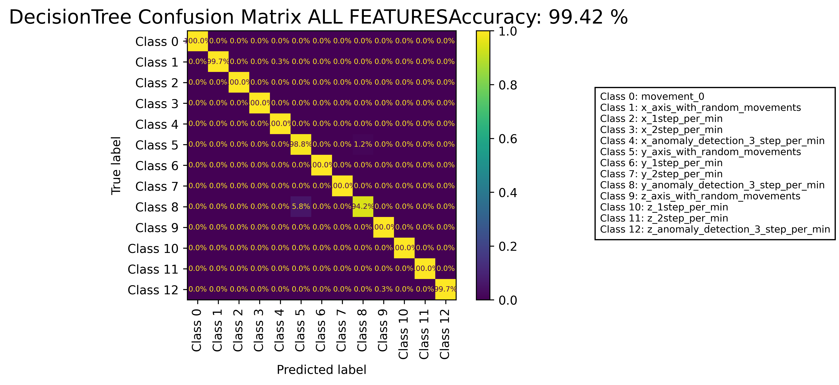

======================================================================

======================= CLASSIFICATION RESULTS =======================  
CLASSIFIER: DecisionTree  
Accuracy: 99.63 %   
Feature used : RELIFF FEATURES 10 Best  
Classification Time: 0.037 seconds

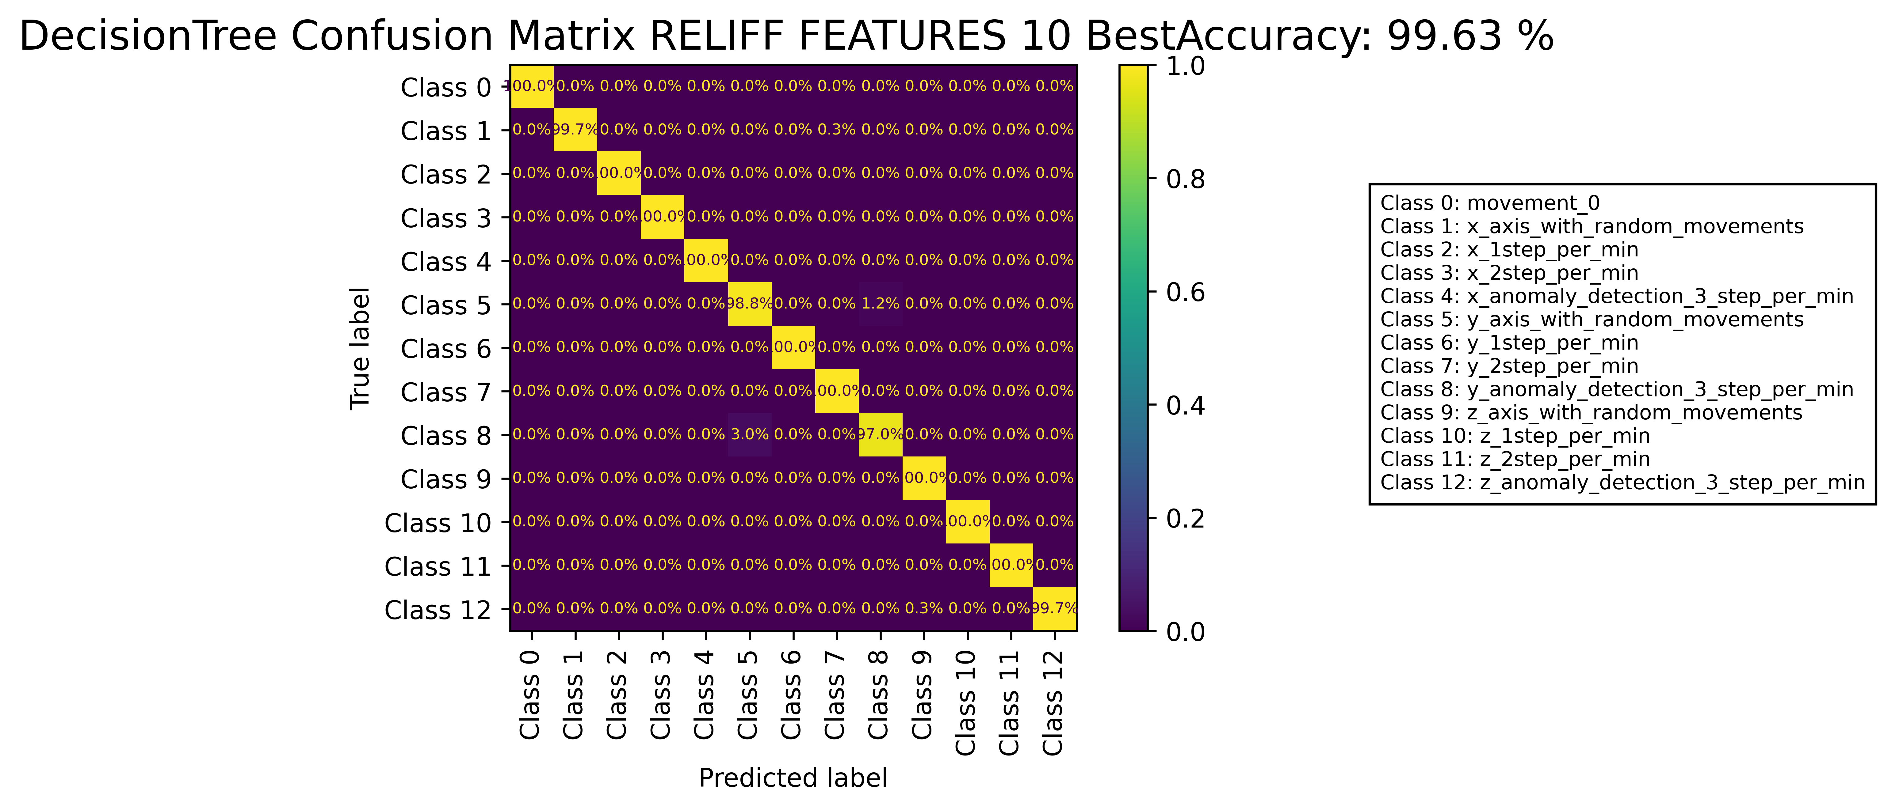

======================================================================

======================= CLASSIFICATION RESULTS =======================  
CLASSIFIER: RandomForest  
Accuracy: 99.95 %   
Feature used : ALL FEATURES  
Classification Time: 0.77 seconds

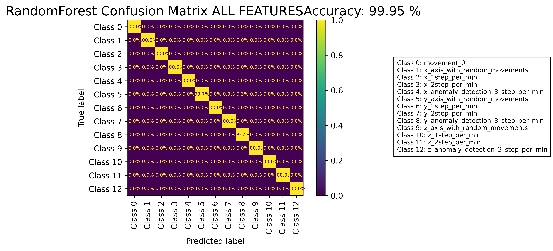

======================================================================

======================= CLASSIFICATION RESULTS =======================  
CLASSIFIER: RandomForest  
Accuracy: 99.95 %   
Feature used : RELIFF FEATURES 10 Best  
Classification Time: 0.495 seconds

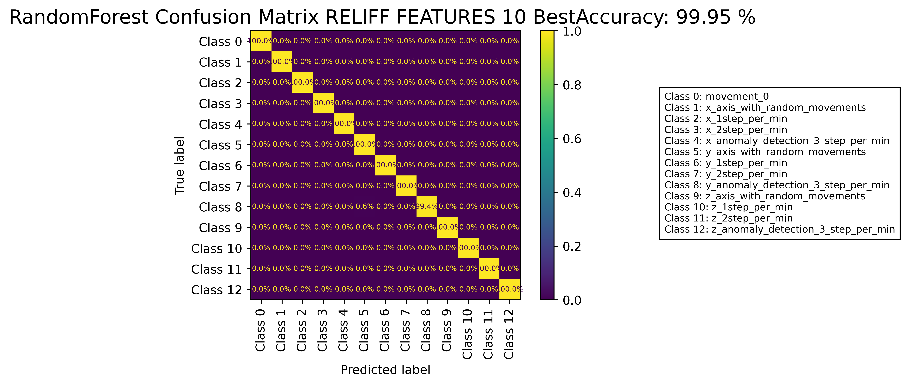

======================================================================

======================= CLASSIFICATION RESULTS =======================  
CLASSIFIER: DecisionTree  
Accuracy: 99.46 %   
Feature used : ALL FEATURES  
Classification Time: 0.158 seconds

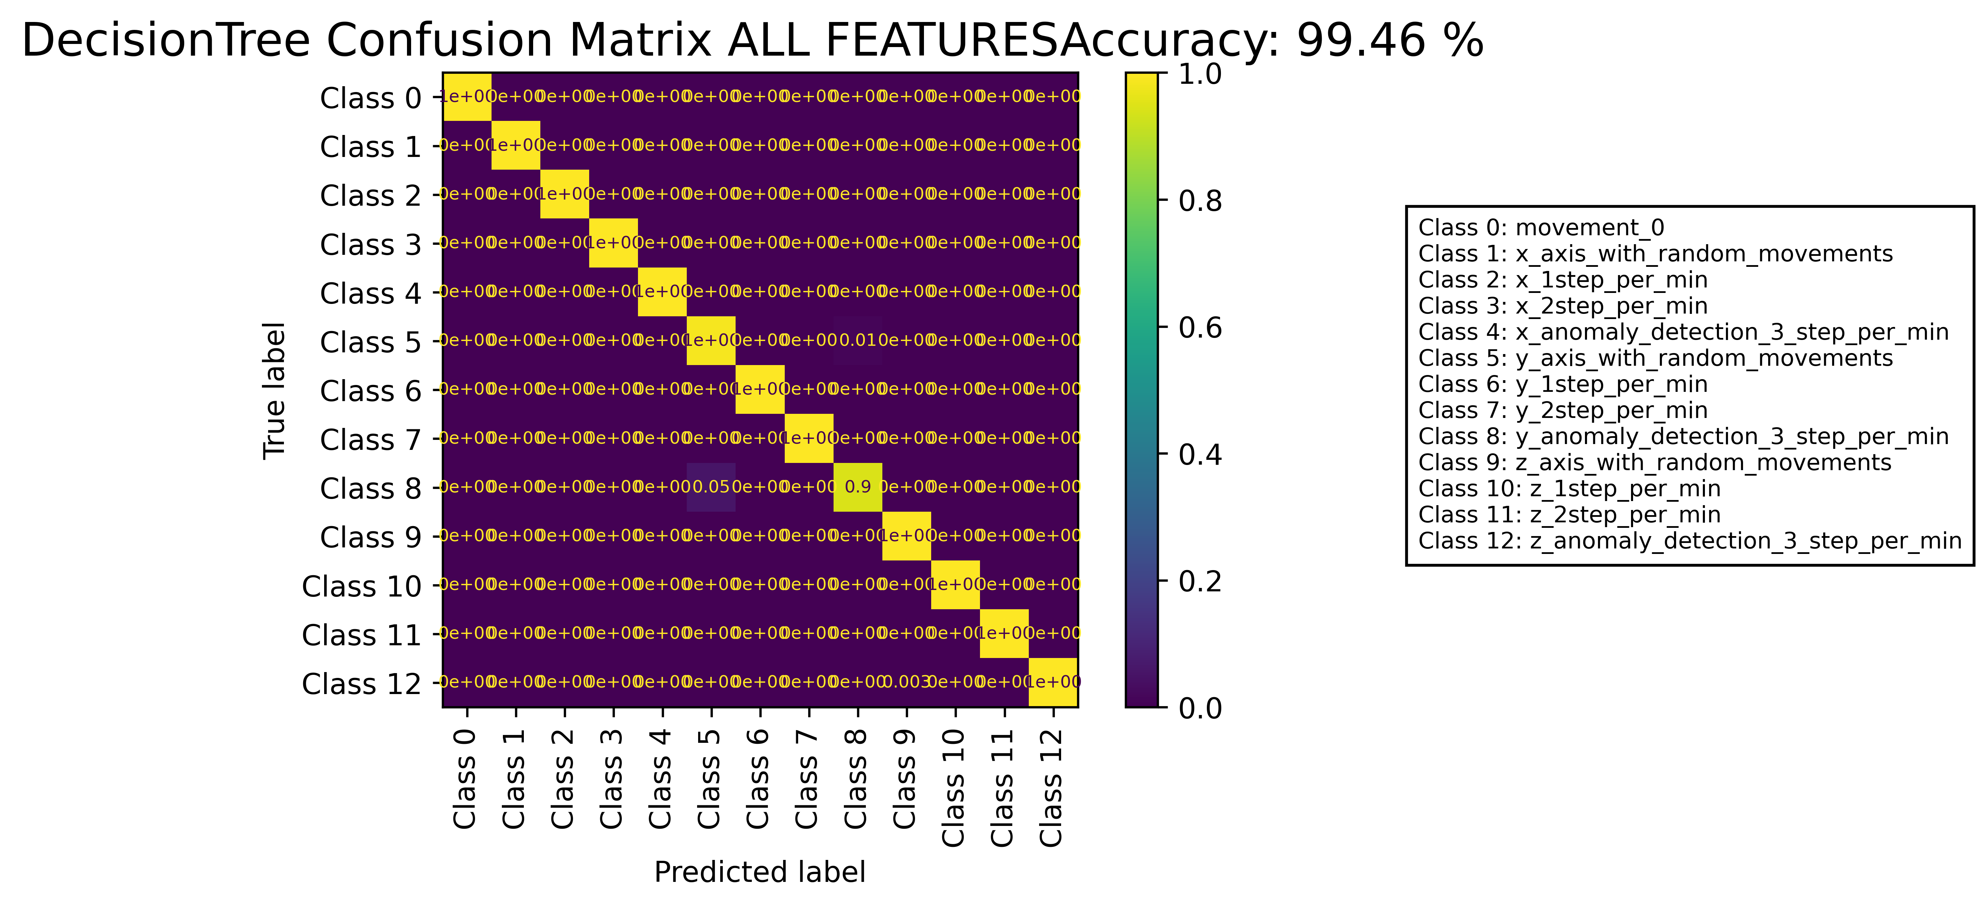

======================================================================

======================= CLASSIFICATION RESULTS =======================  
CLASSIFIER: DecisionTree  
Accuracy: 99.65 %   
Feature used : RELIFF FEATURES 10 Best  
Classification Time: 0.049 seconds

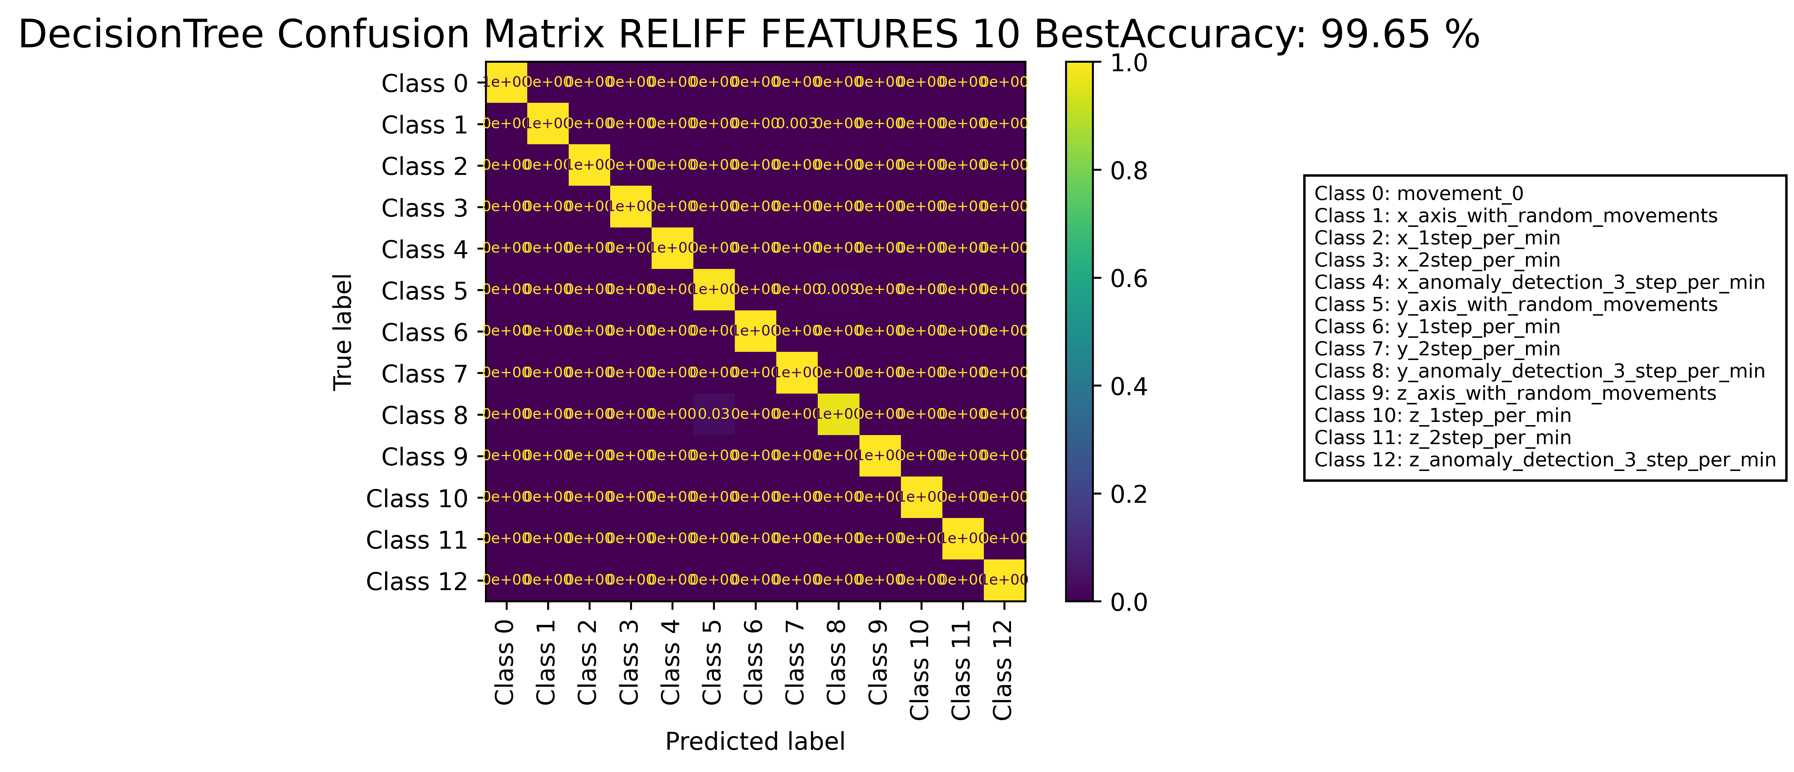

======================================================================

======================= CLASSIFICATION RESULTS =======================  
CLASSIFIER: RandomForest  
Accuracy: 99.93 %   
Feature used : ALL FEATURES  
Classification Time: 0.862 seconds

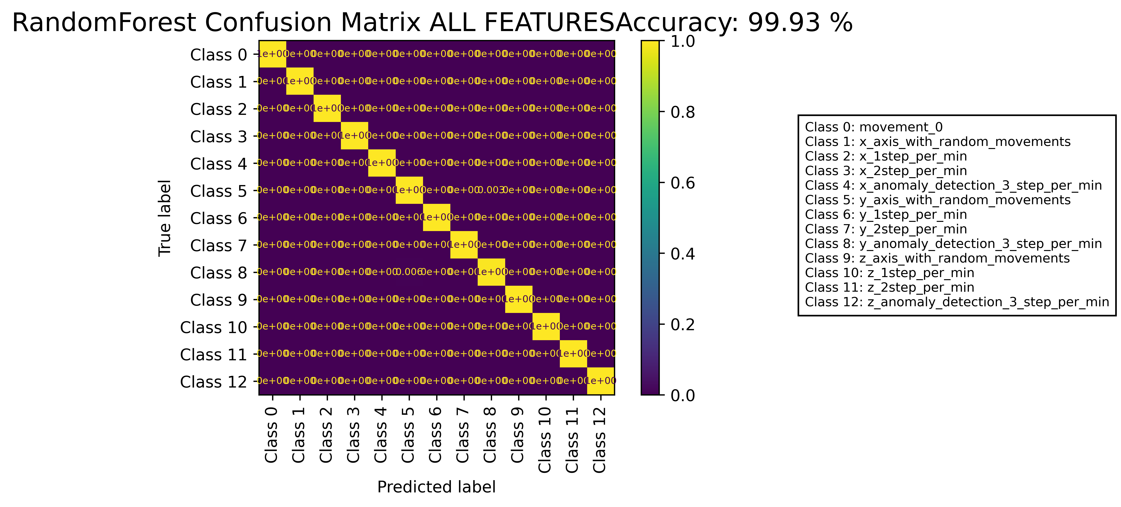

======================================================================

======================= CLASSIFICATION RESULTS =======================  
CLASSIFIER: RandomForest  
Accuracy: 99.95 %   
Feature used : RELIFF FEATURES 10 Best  
Classification Time: 0.505 seconds

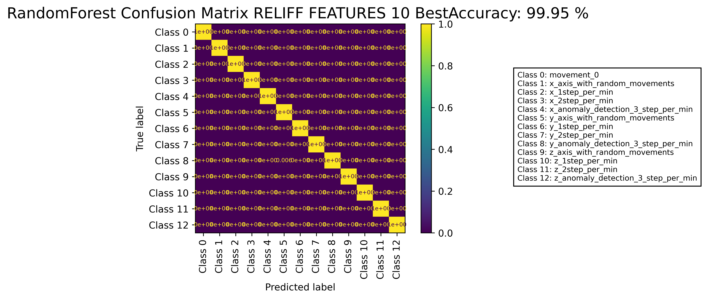

======================================================================

======================= CLASSIFICATION RESULTS =======================  
CLASSIFIER: DecisionTree  
Accuracy: 99.42 %   
Feature used : ALL FEATURES  
Classification Time: 0.125 seconds

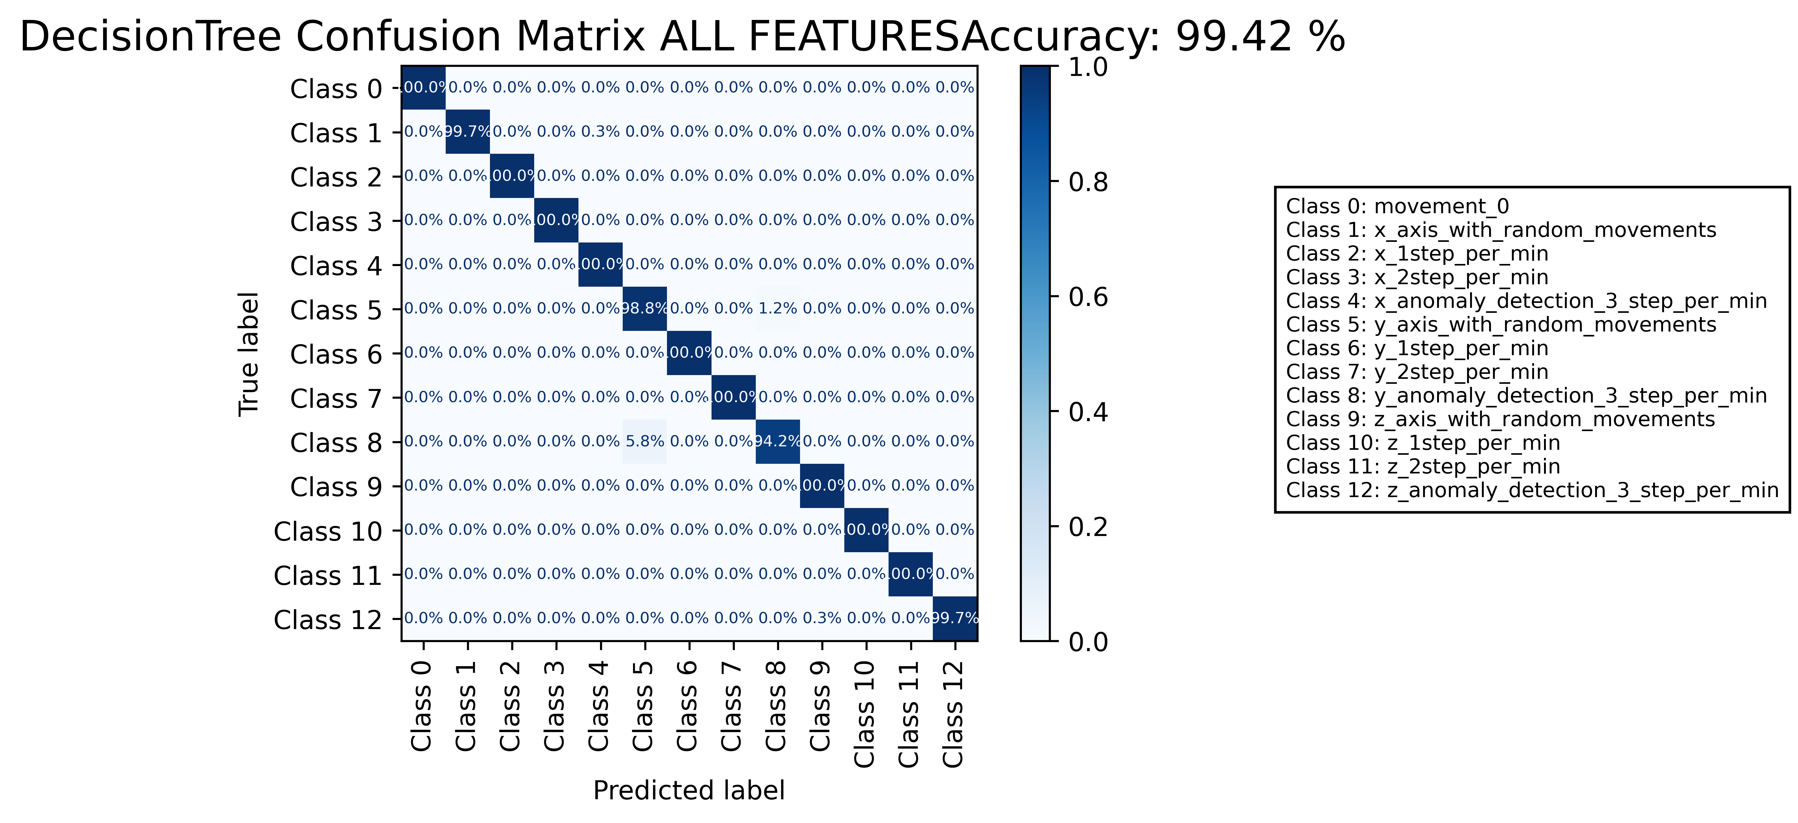

======================================================================

======================= CLASSIFICATION RESULTS =======================  
CLASSIFIER: DecisionTree  
Accuracy: 99.65 %   
Feature used : RELIFF FEATURES 10 Best  
Classification Time: 0.039 seconds

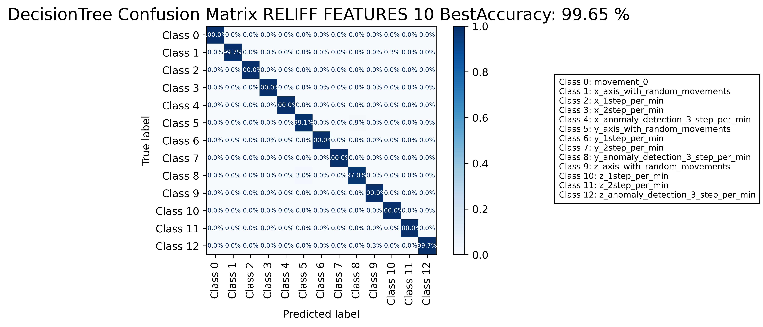

======================================================================

======================= CLASSIFICATION RESULTS =======================  
CLASSIFIER: RandomForest  
Accuracy: 99.95 %   
Feature used : ALL FEATURES  
Classification Time: 0.73 seconds

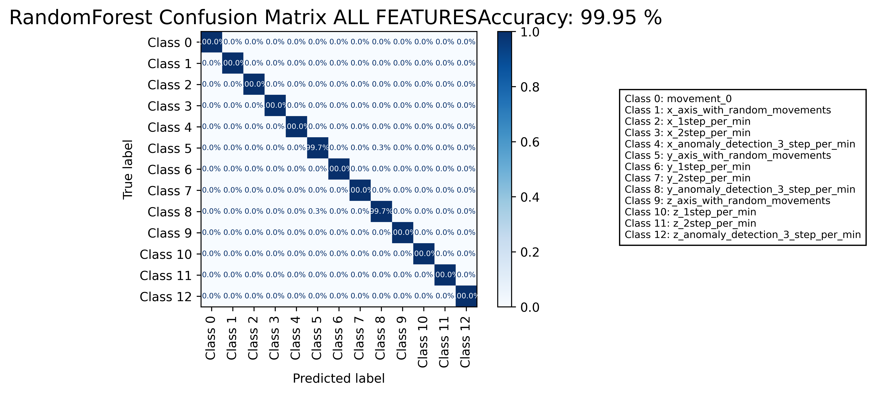

======================================================================

======================= CLASSIFICATION RESULTS =======================  
CLASSIFIER: RandomForest  
Accuracy: 99.98 %   
Feature used : RELIFF FEATURES 10 Best  
Classification Time: 0.449 seconds

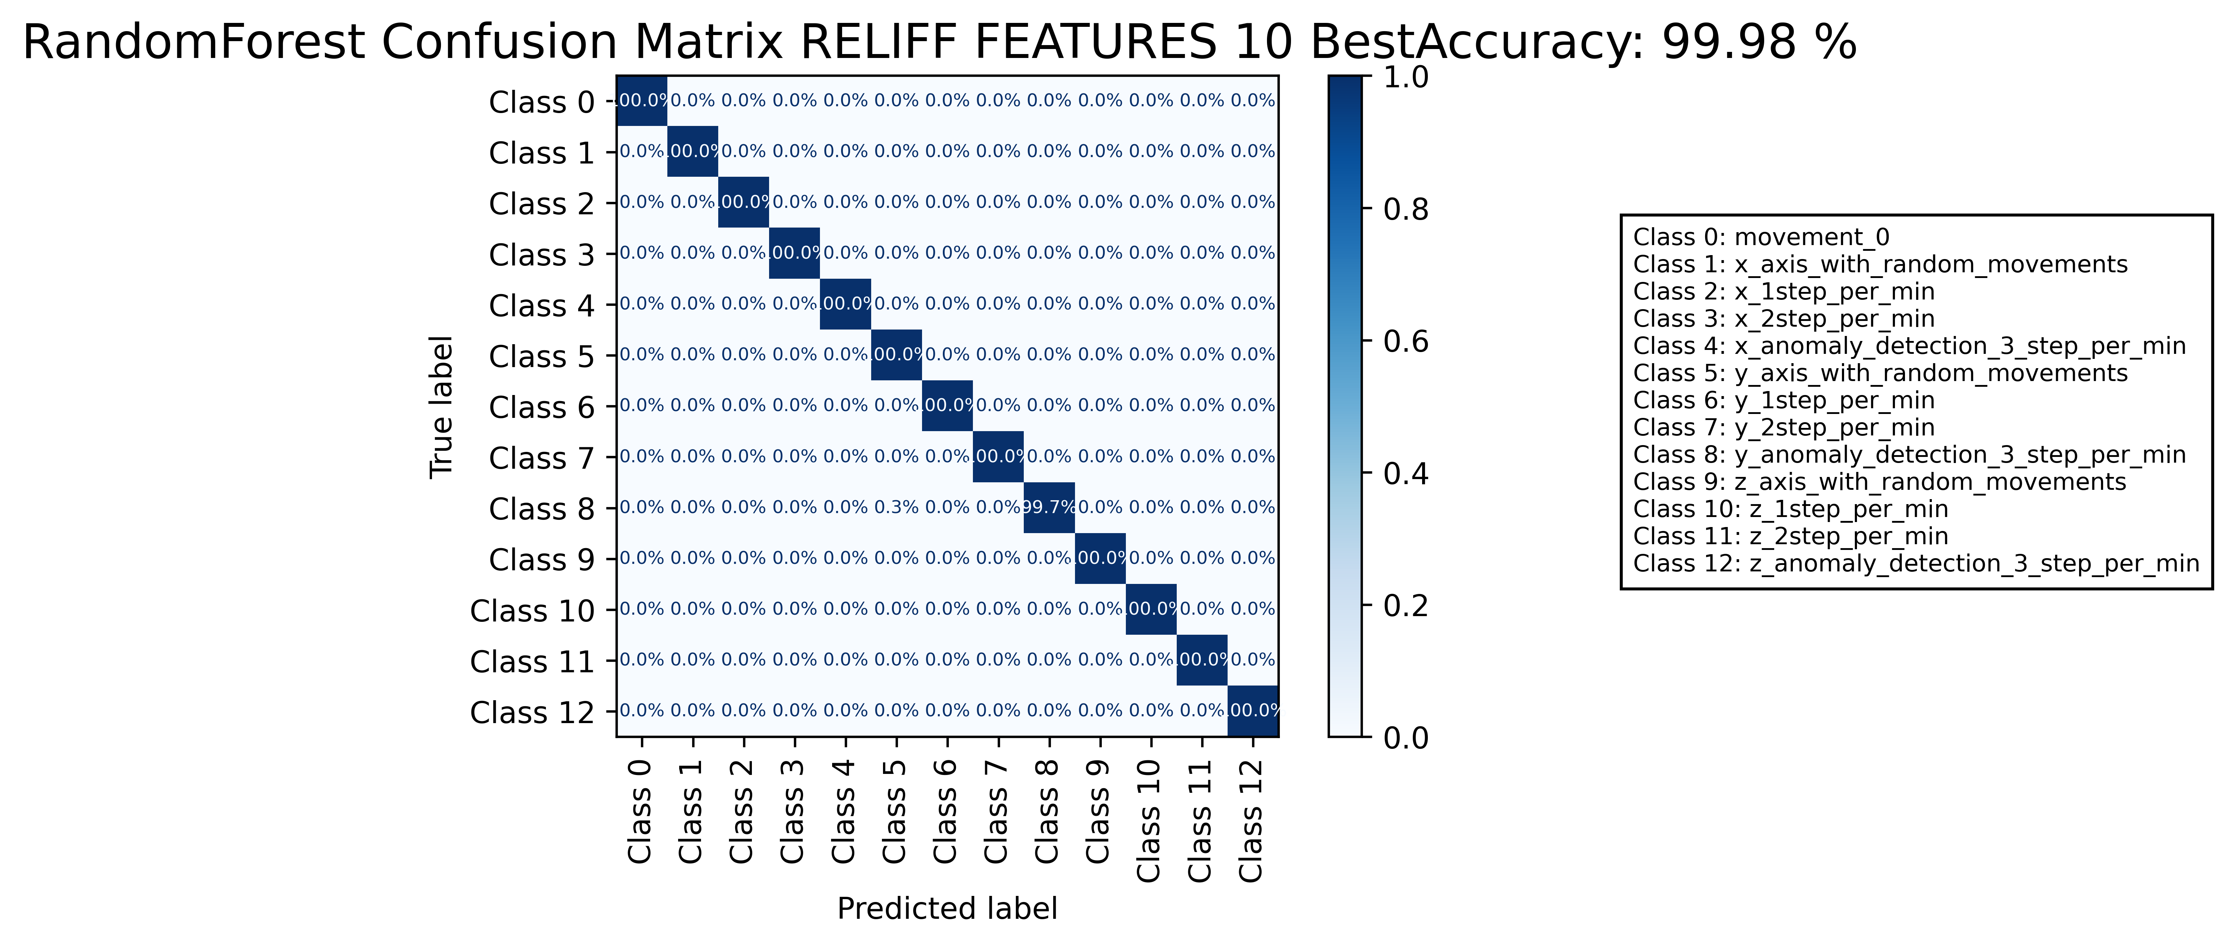

======================================================================

======================= CLASSIFICATION RESULTS =======================  
CLASSIFIER: DecisionTree  
Accuracy: 99.49 %   
Feature used : ALL FEATURES  
Classification Time: 0.132 seconds

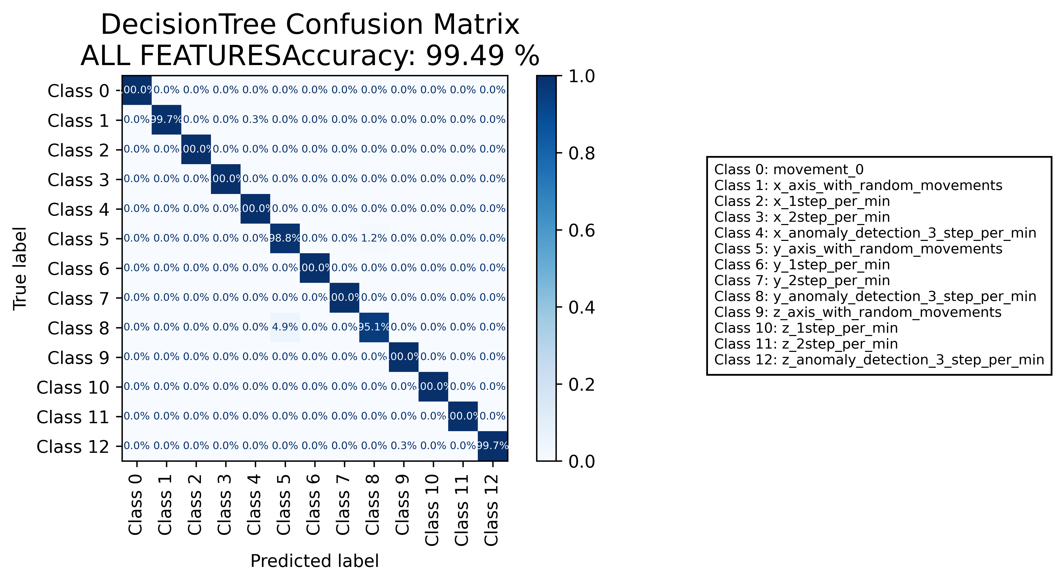

======================================================================

======================= CLASSIFICATION RESULTS =======================  
CLASSIFIER: DecisionTree  
Accuracy: 99.72 %   
Feature used : RELIFF FEATURES 10 Best  
Classification Time: 0.033 seconds

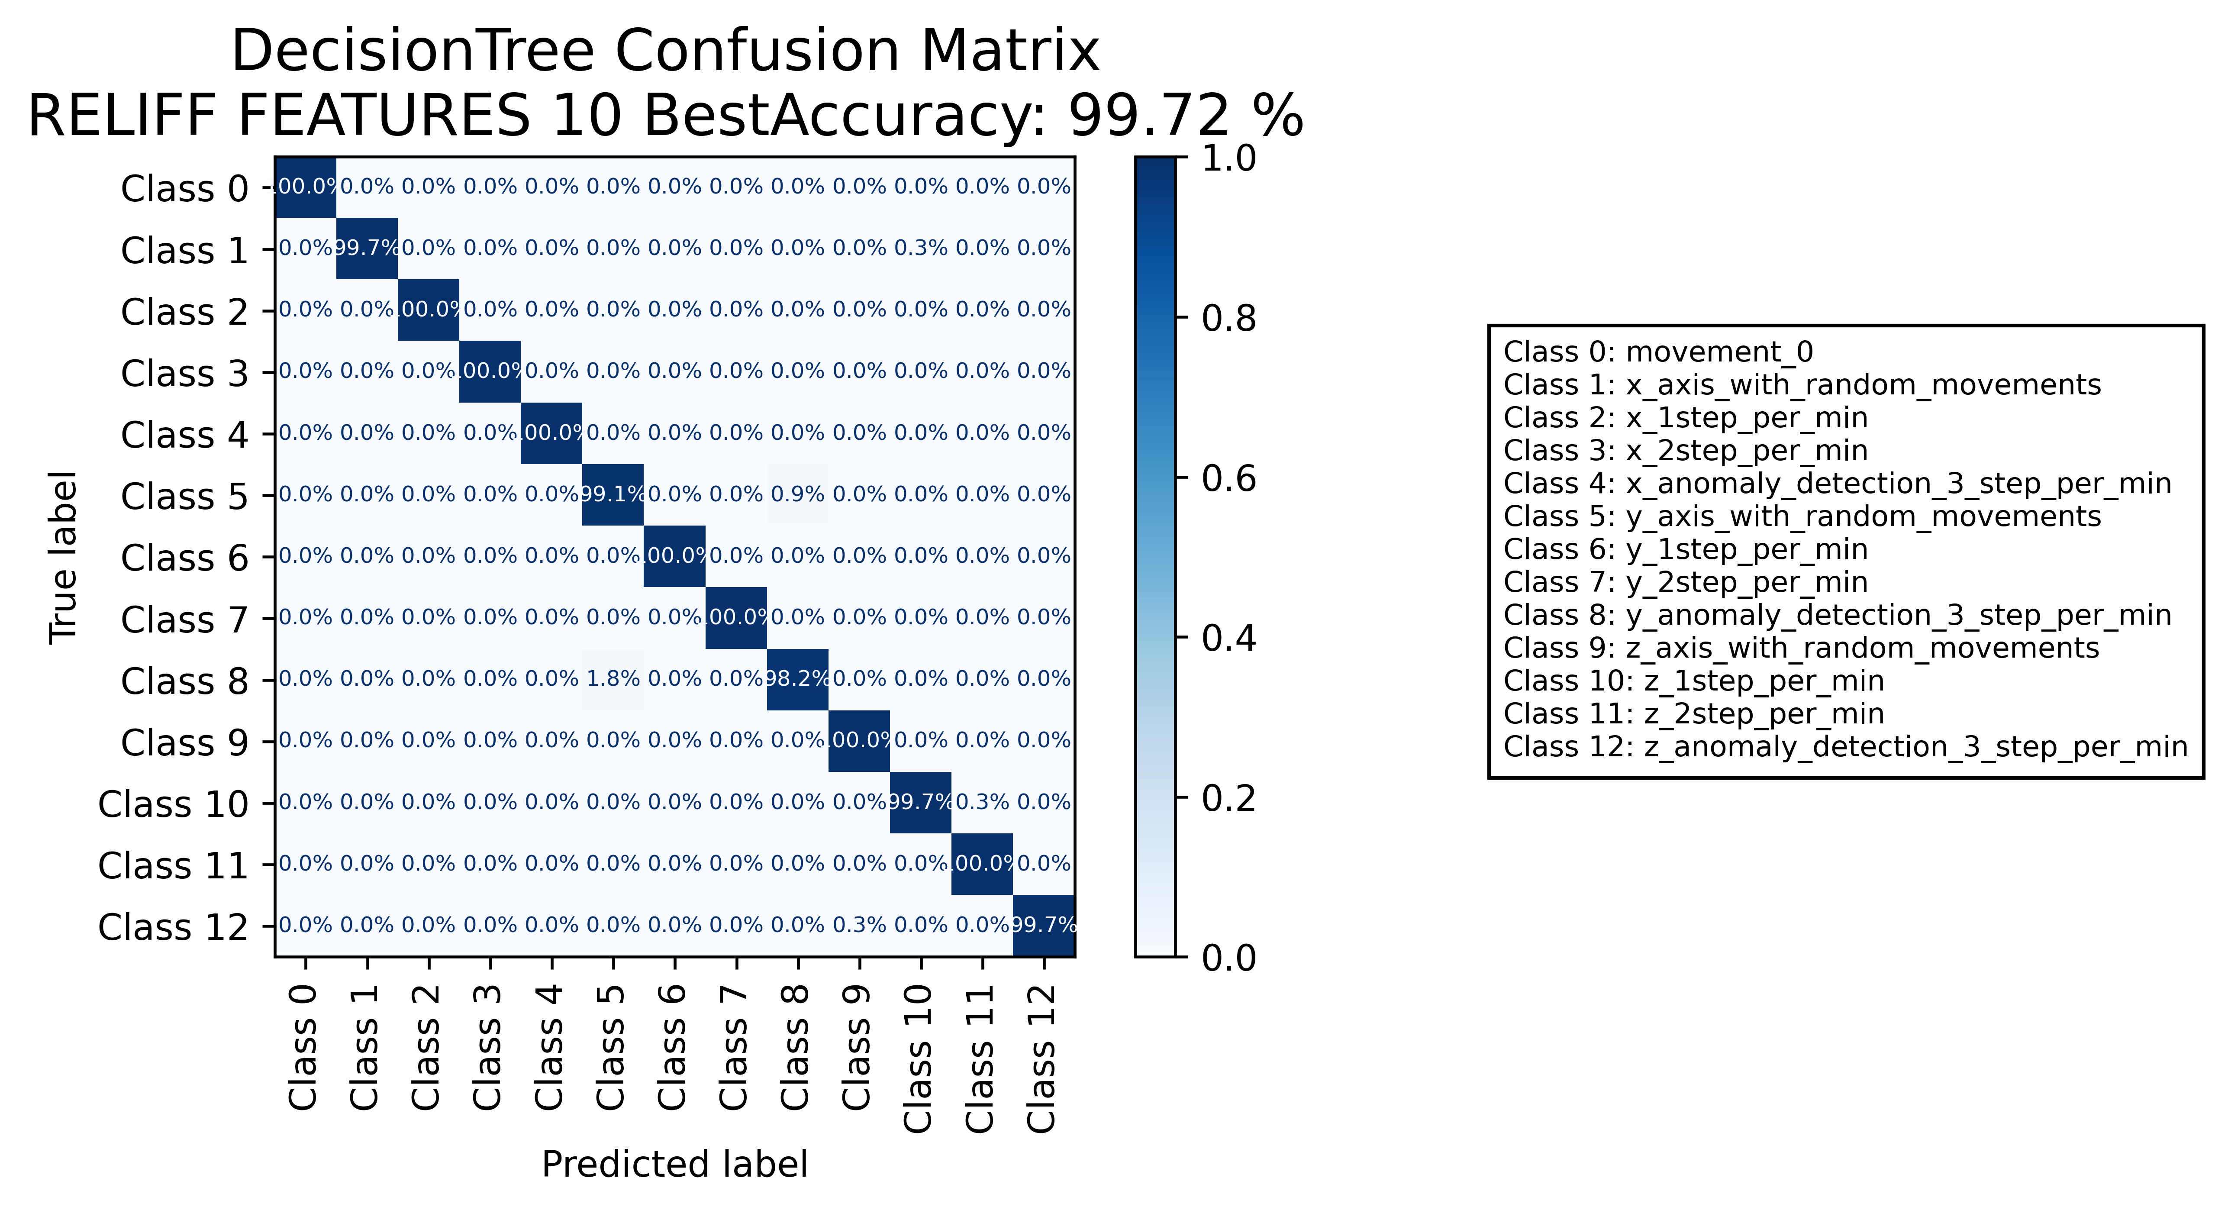

======================================================================

======================= CLASSIFICATION RESULTS =======================  
CLASSIFIER: RandomForest  
Accuracy: 99.91 %   
Feature used : ALL FEATURES  
Classification Time: 0.685 seconds

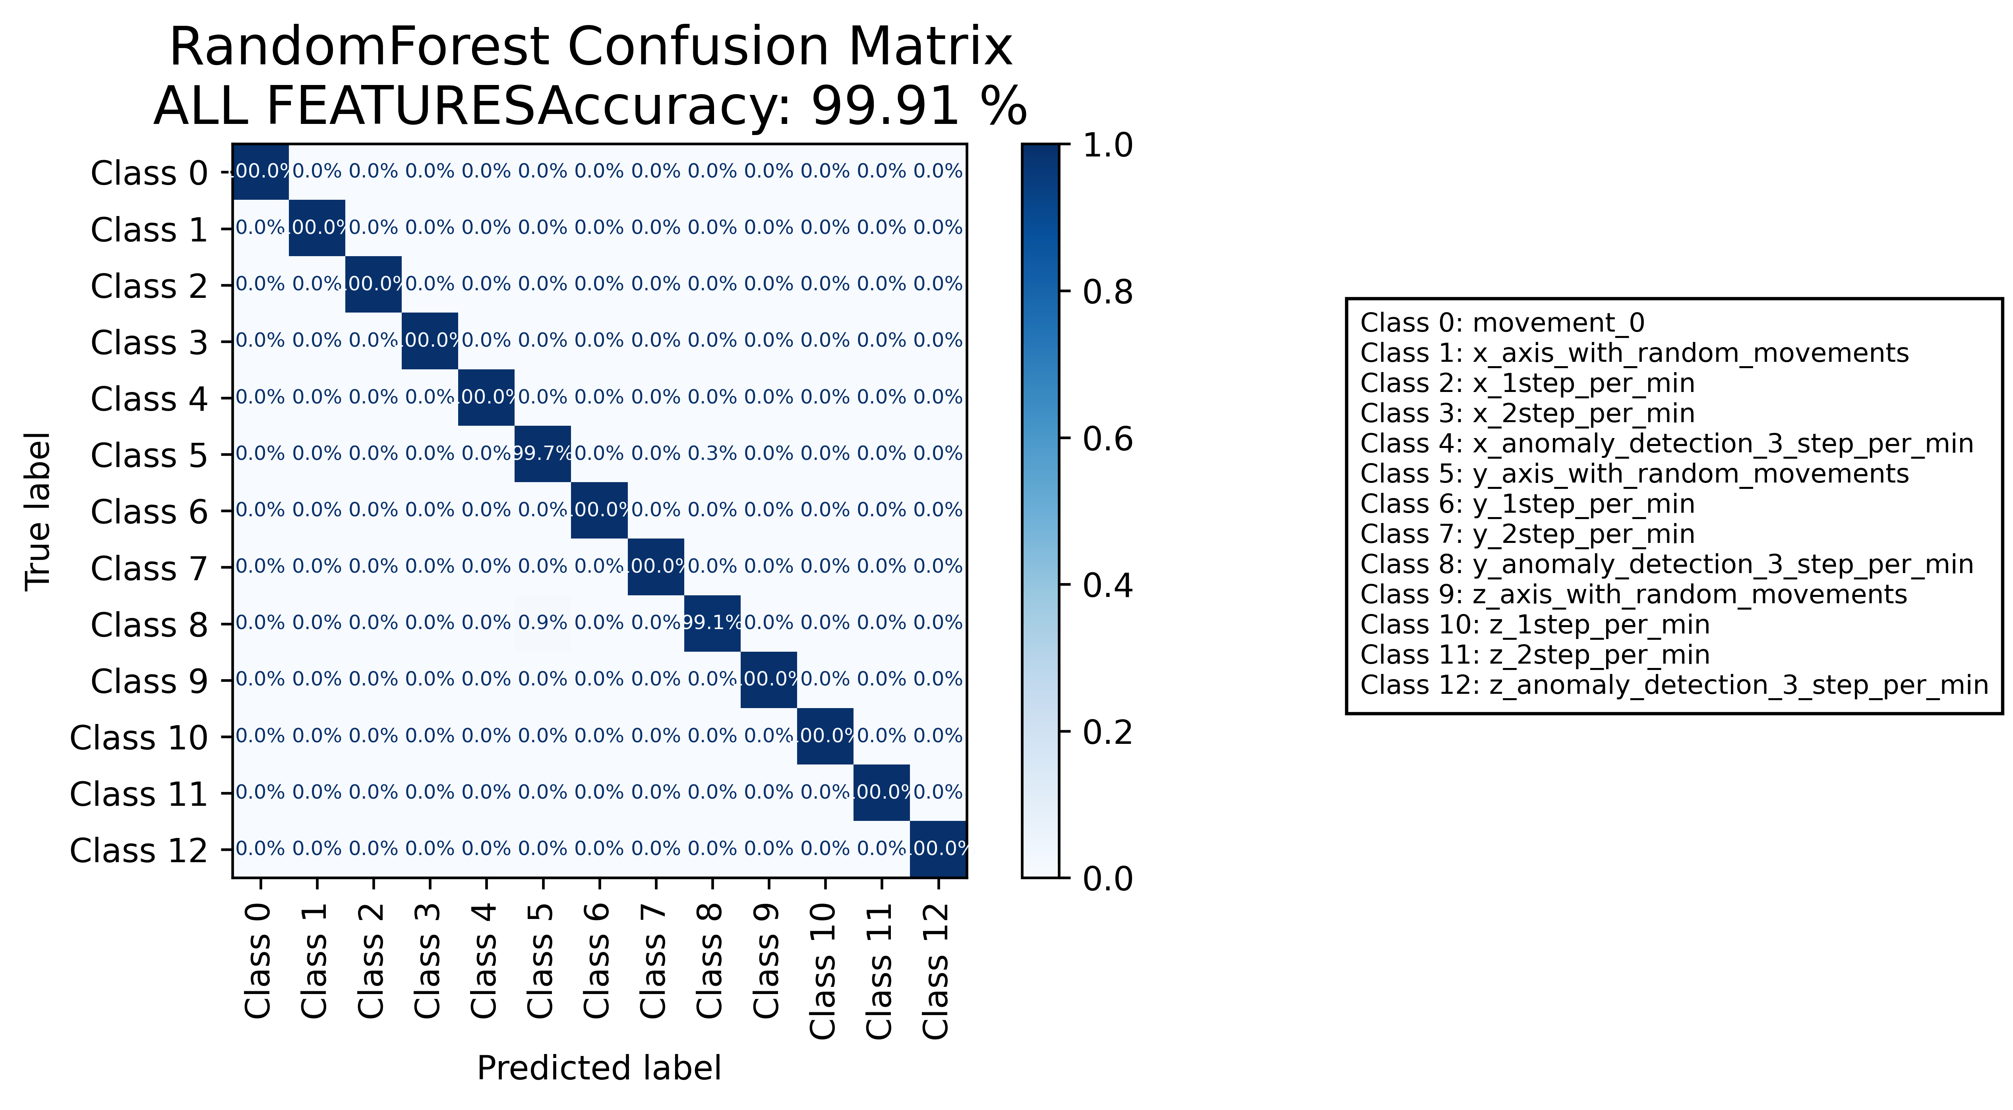

======================================================================

======================= CLASSIFICATION RESULTS =======================  
CLASSIFIER: RandomForest  
Accuracy: 99.98 %   
Feature used : RELIFF FEATURES 10 Best  
Classification Time: 0.48 seconds

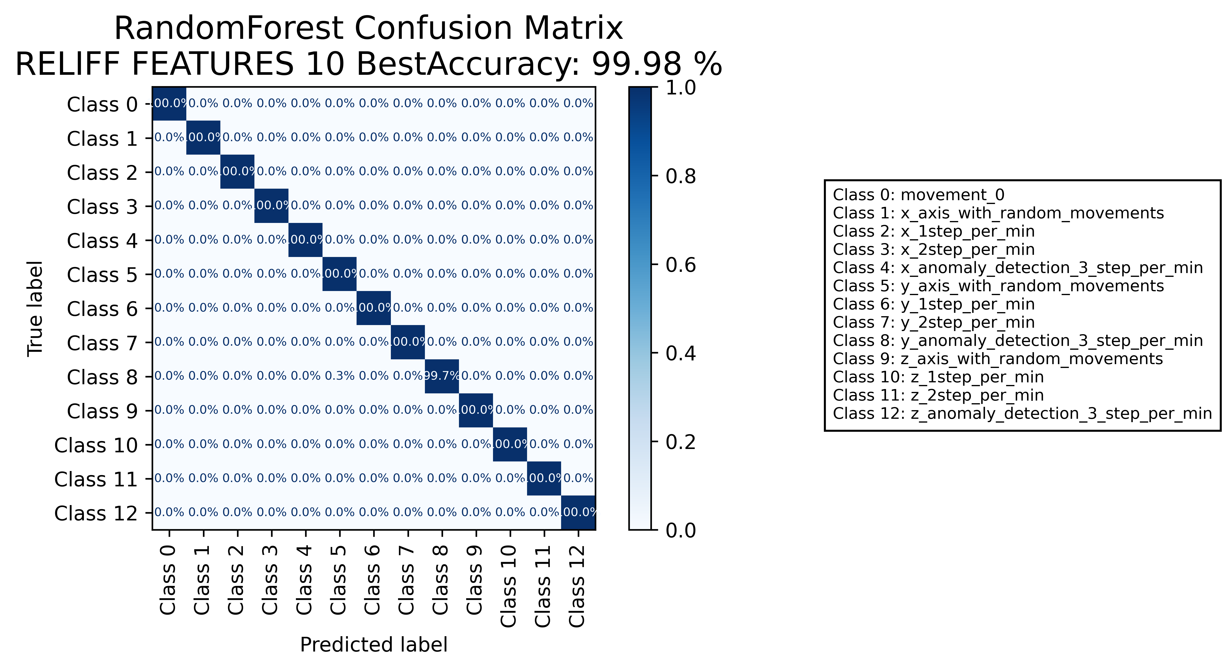

======================================================================

======================= CLASSIFICATION RESULTS =======================  
CLASSIFIER: DecisionTree  
Accuracy: 99.49 %   
Feature used : ALL FEATURES  
Classification Time: 0.118 seconds

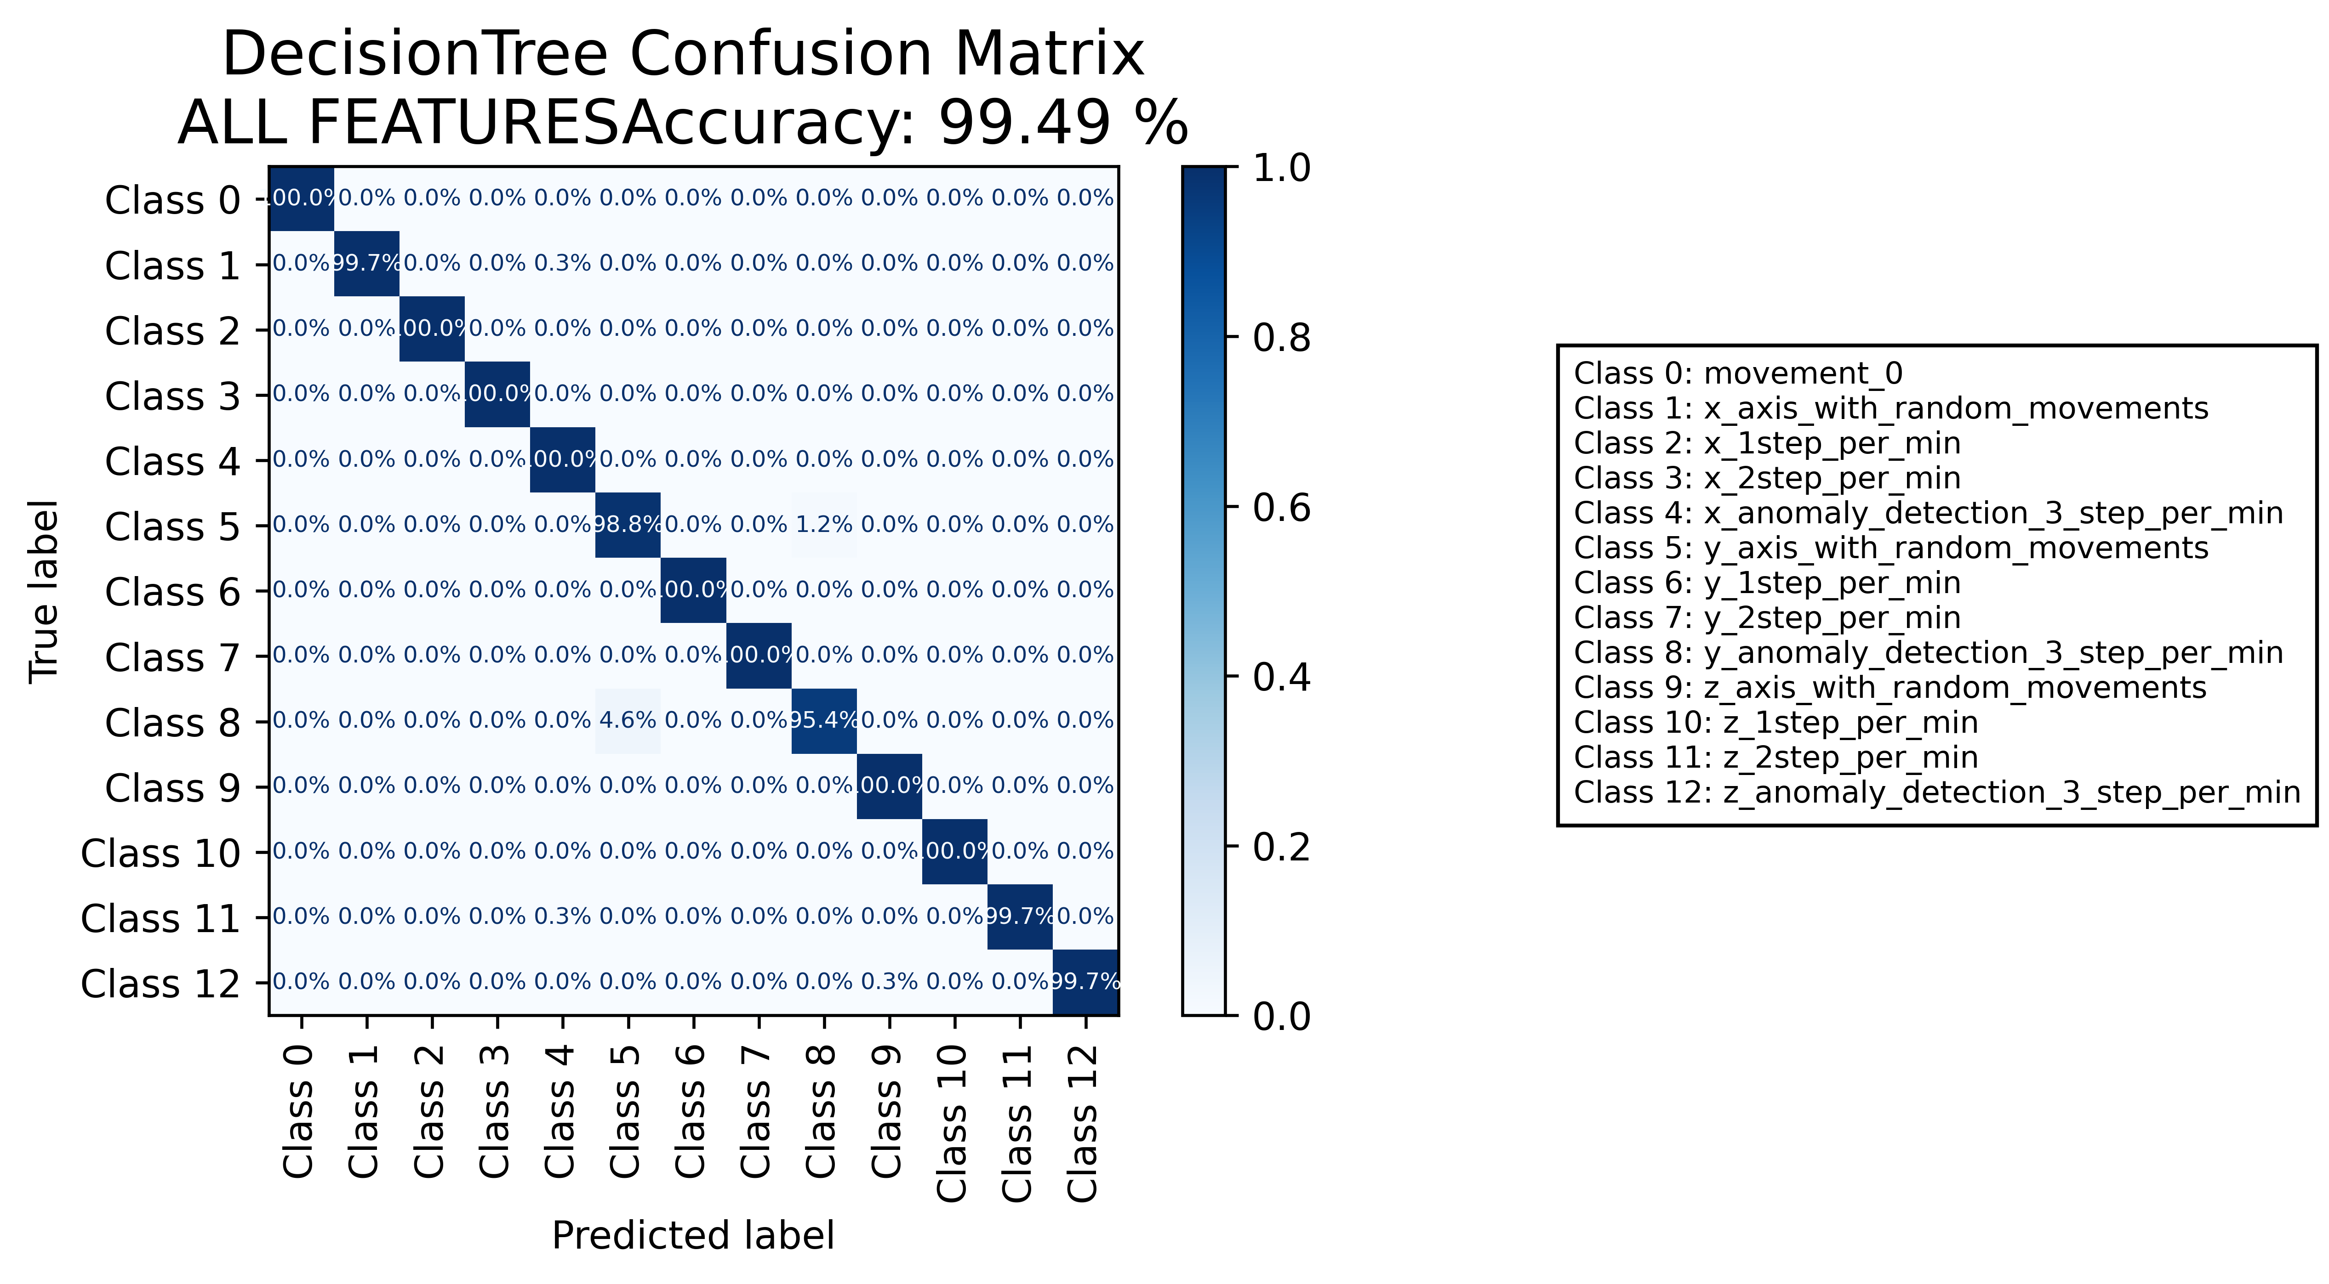

======================================================================

======================= CLASSIFICATION RESULTS =======================  
CLASSIFIER: DecisionTree  
Accuracy: 99.70 %   
Feature used : RELIFF FEATURES 10 Best  
Classification Time: 0.046 seconds

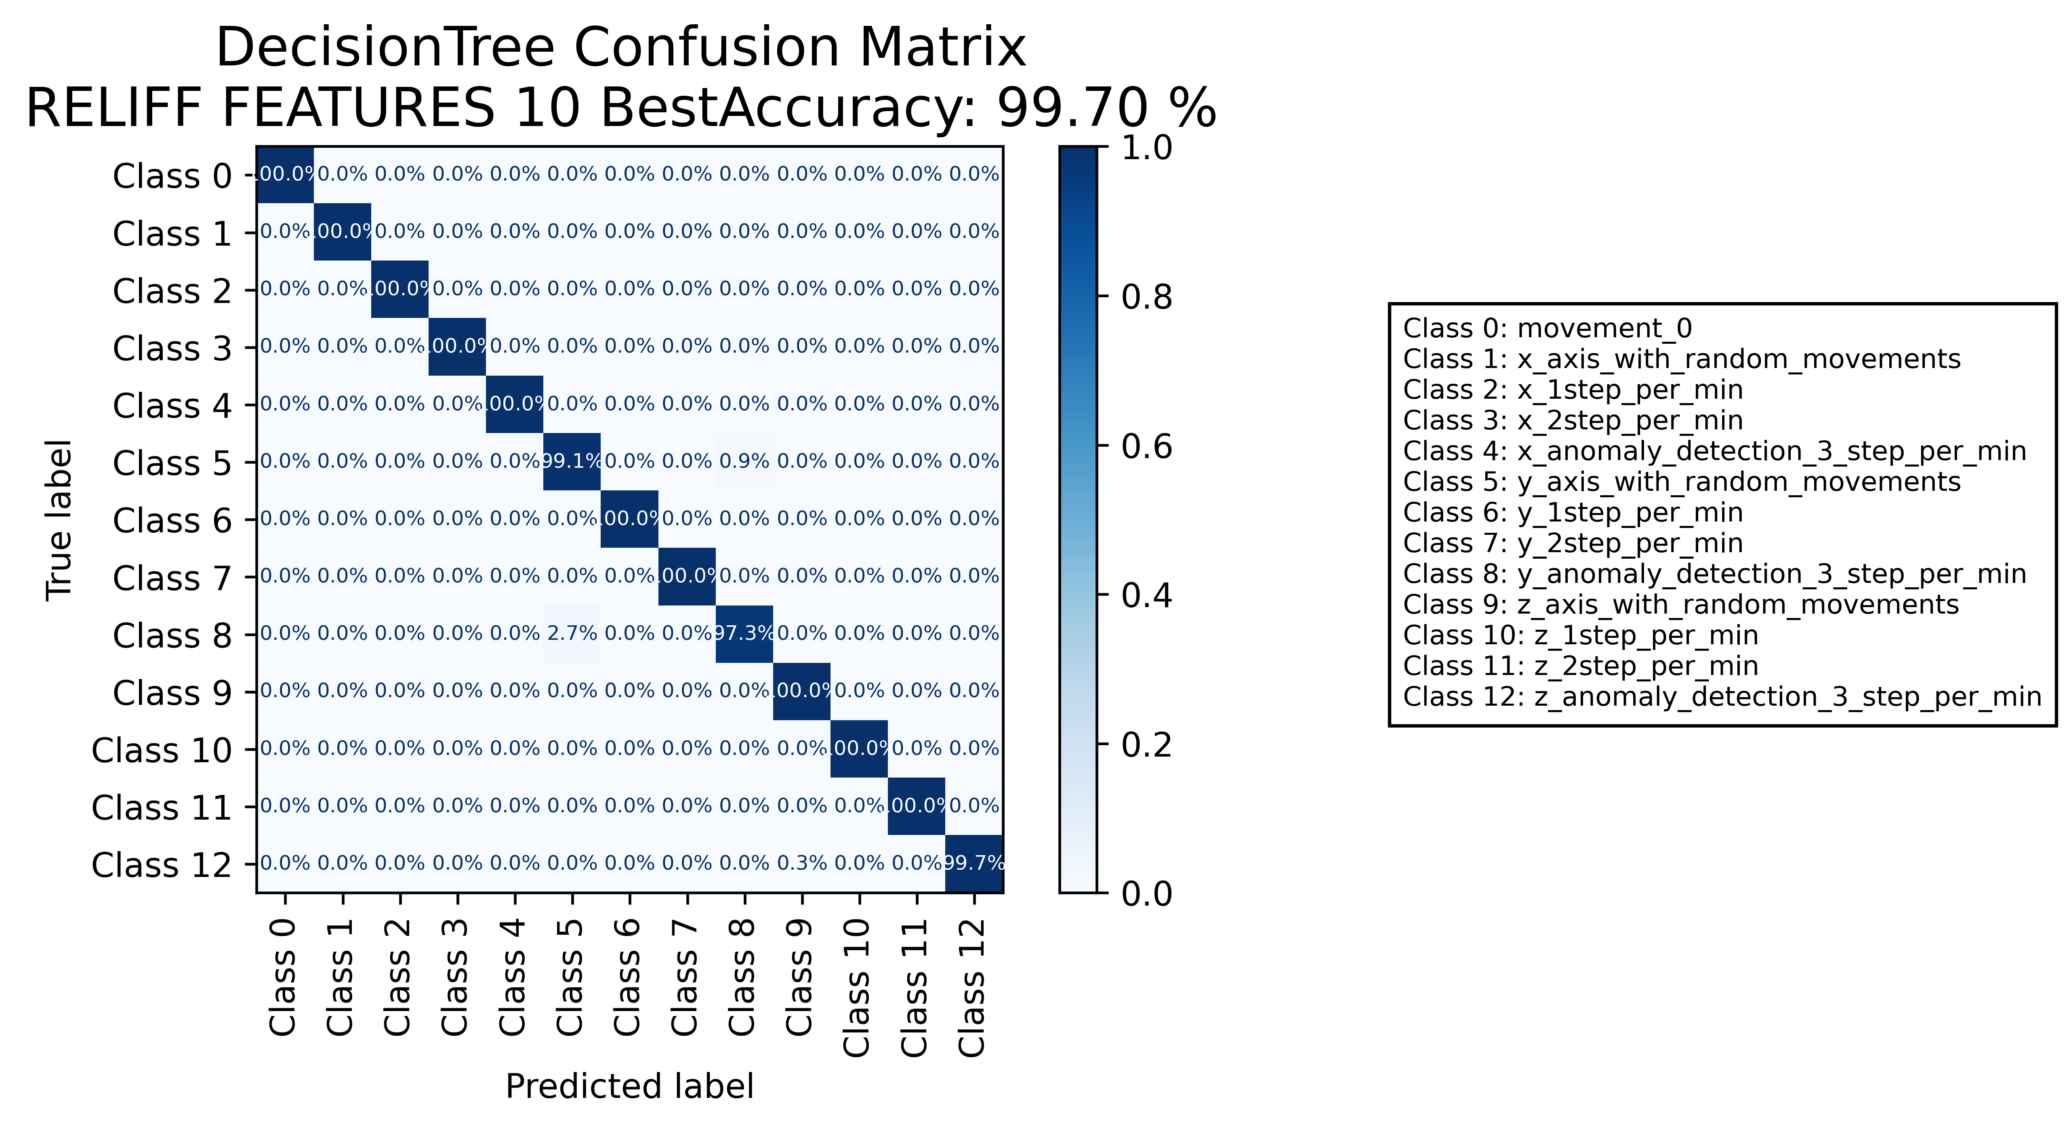

======================================================================

======================= CLASSIFICATION RESULTS =======================  
CLASSIFIER: RandomForest  
Accuracy: 99.95 %   
Feature used : ALL FEATURES  
Classification Time: 0.63 seconds

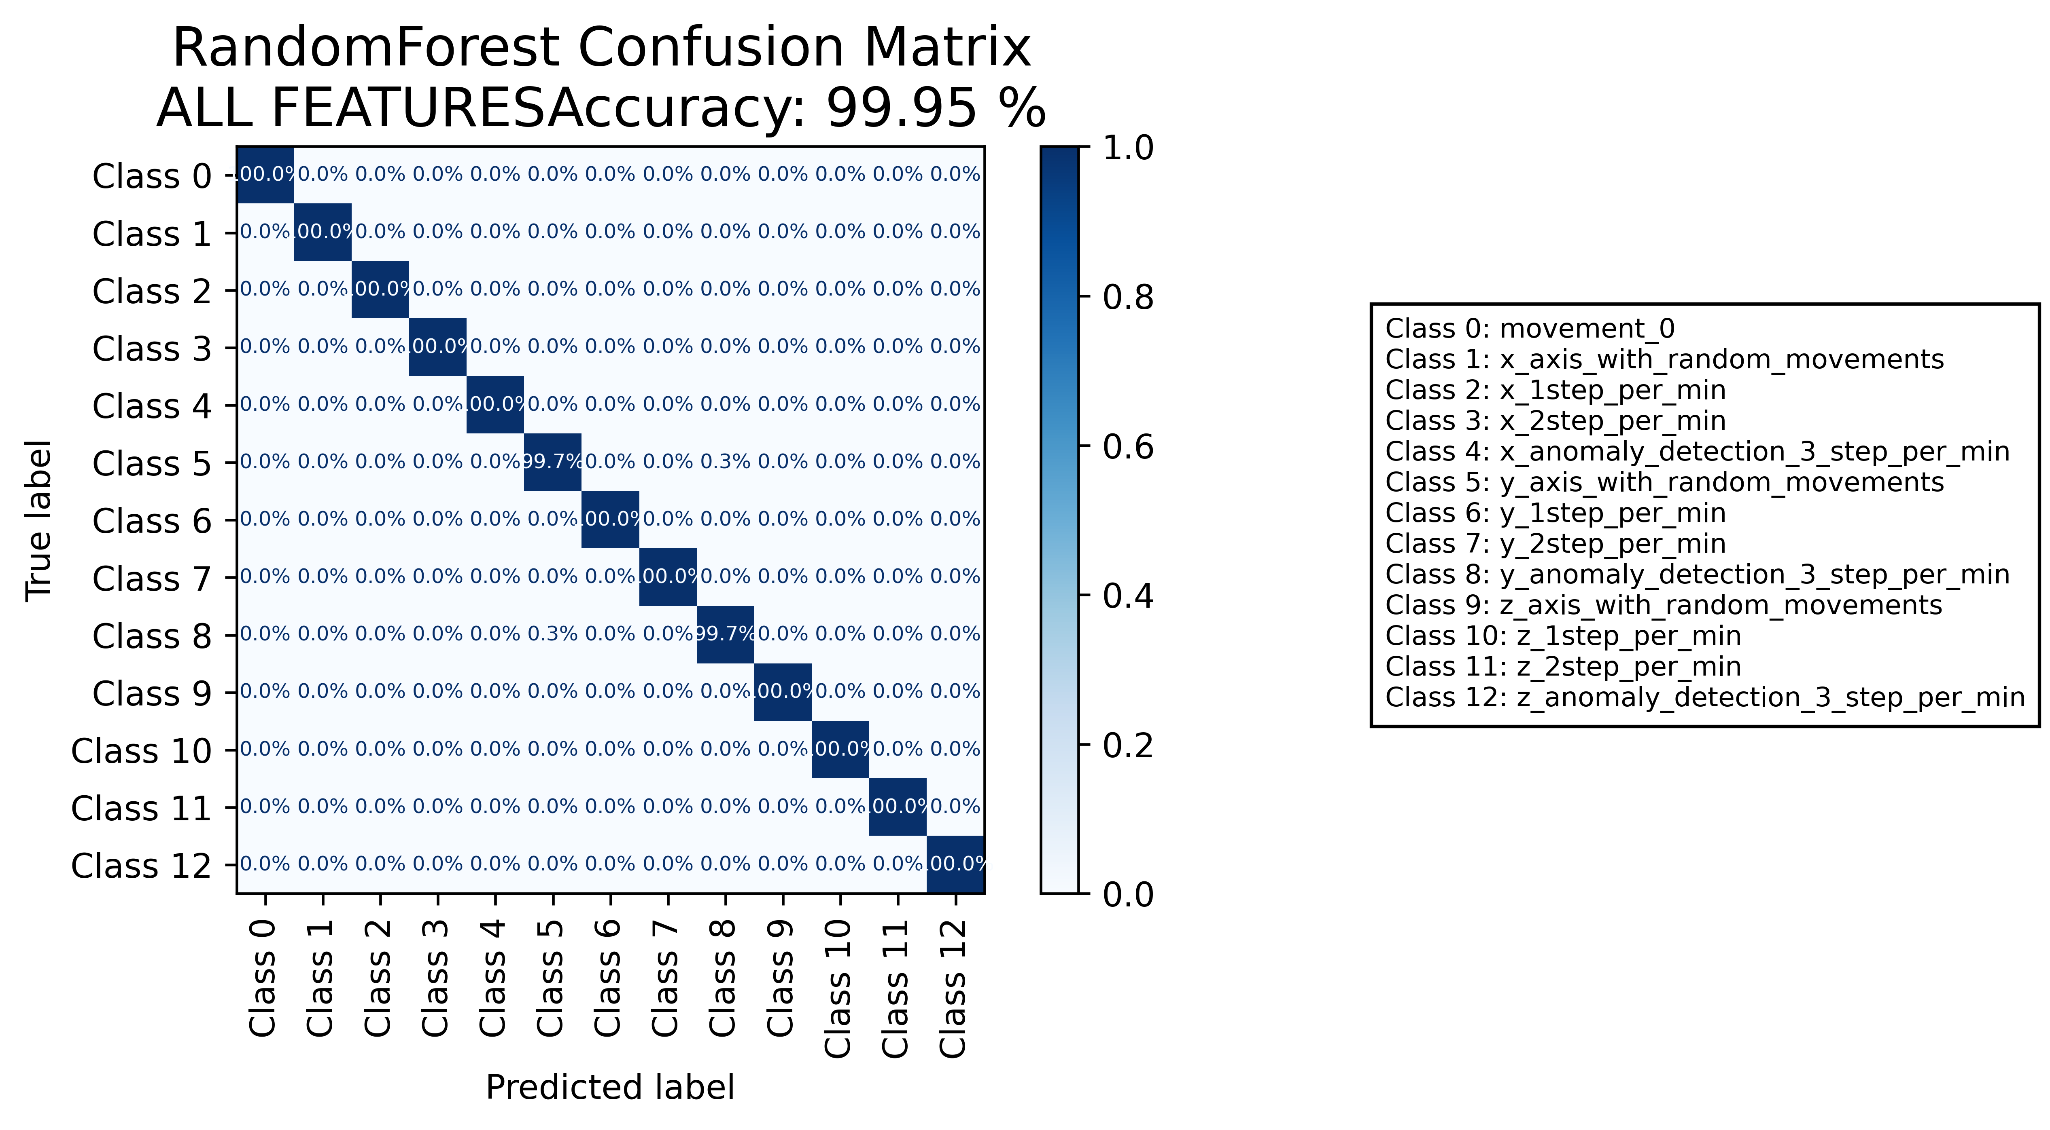

======================================================================

======================= CLASSIFICATION RESULTS =======================  
CLASSIFIER: RandomForest  
Accuracy: 99.95 %   
Feature used : RELIFF FEATURES 10 Best  
Classification Time: 0.461 seconds

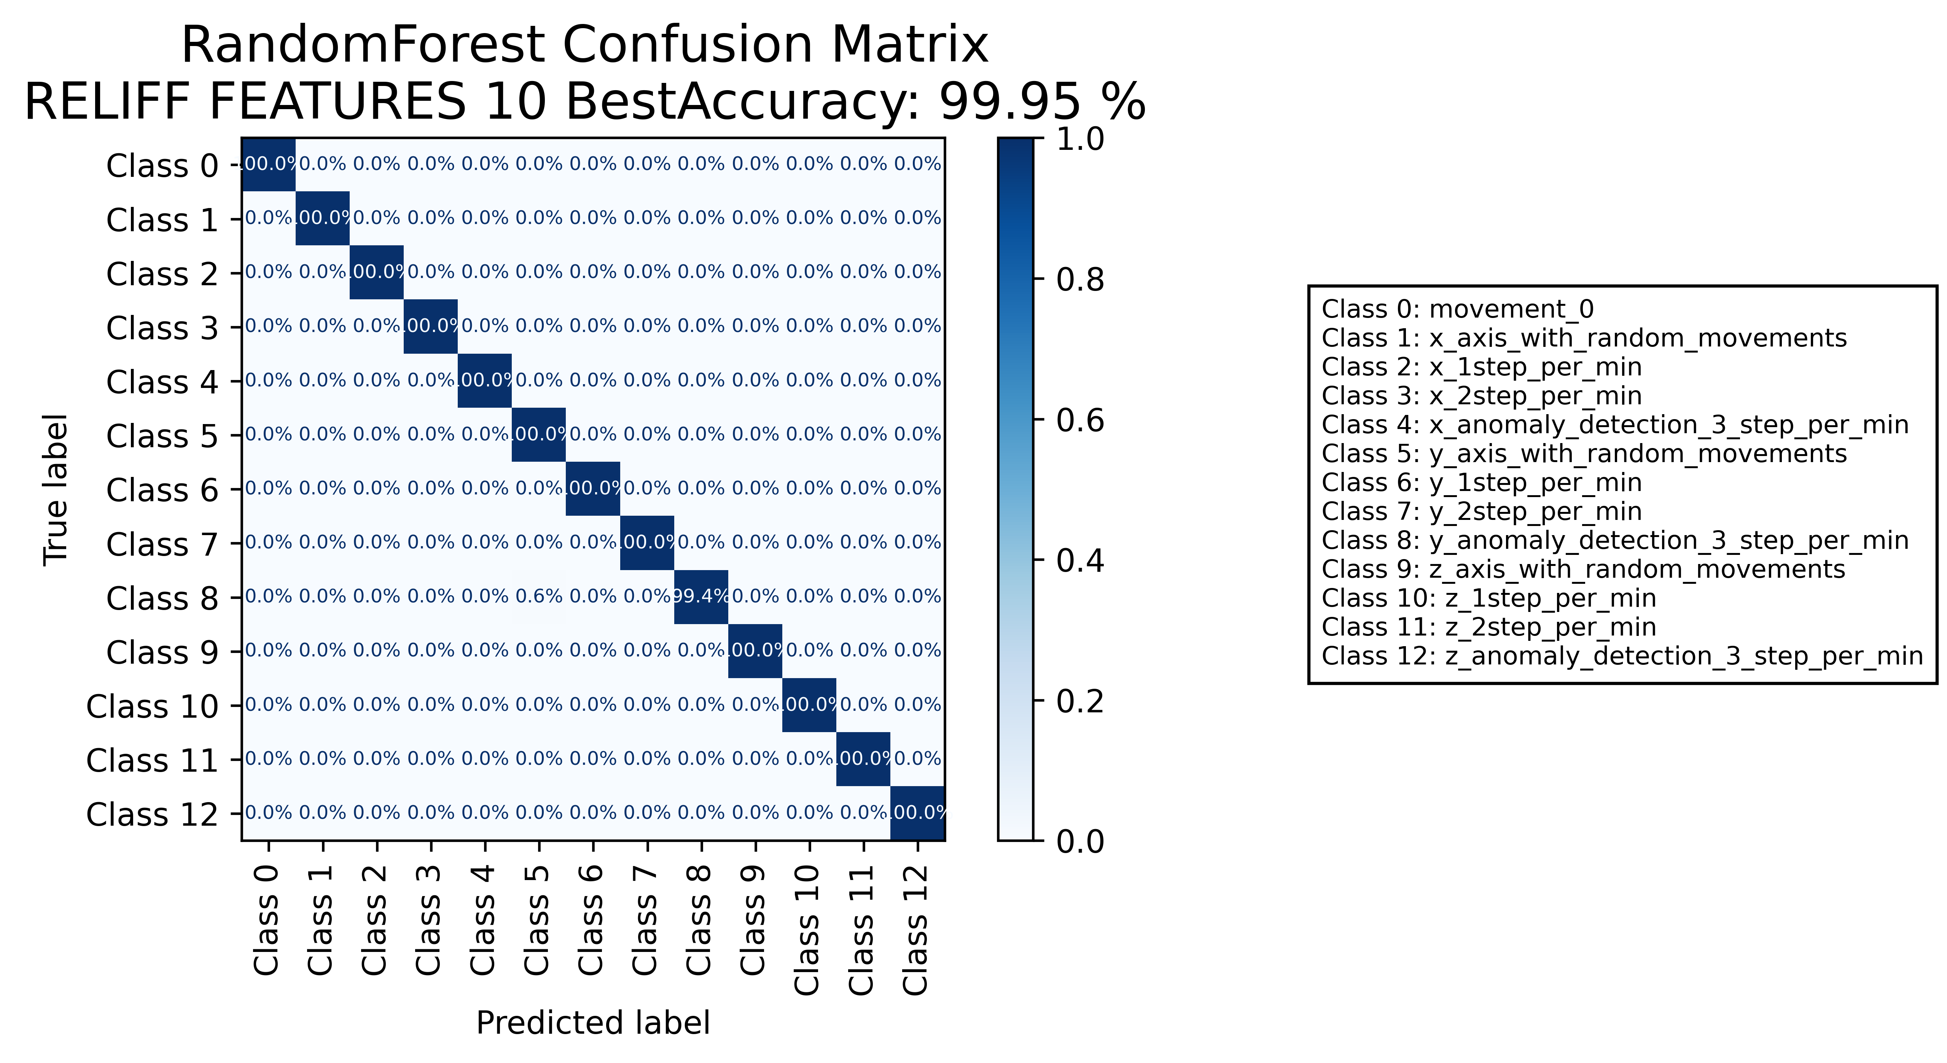

======================================================================

======================= CLASSIFICATION RESULTS =======================  
CLASSIFIER: DecisionTree  
Accuracy: 99.42 %   
Feature used : ALL FEATURES  
Classification Time: 0.127 seconds

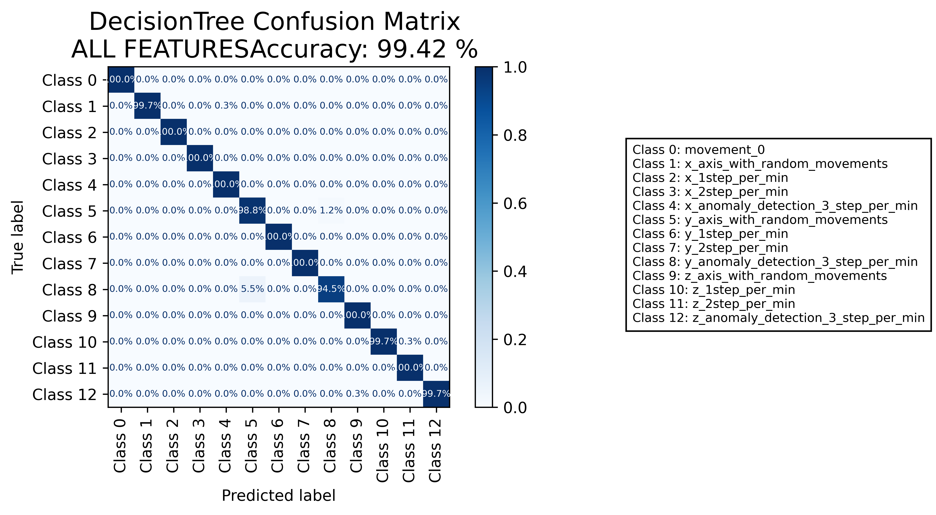

======================================================================

======================= CLASSIFICATION RESULTS =======================  
CLASSIFIER: DecisionTree  
Accuracy: 99.60 %   
Feature used : RELIFF FEATURES 10 Best  
Classification Time: 0.037 seconds

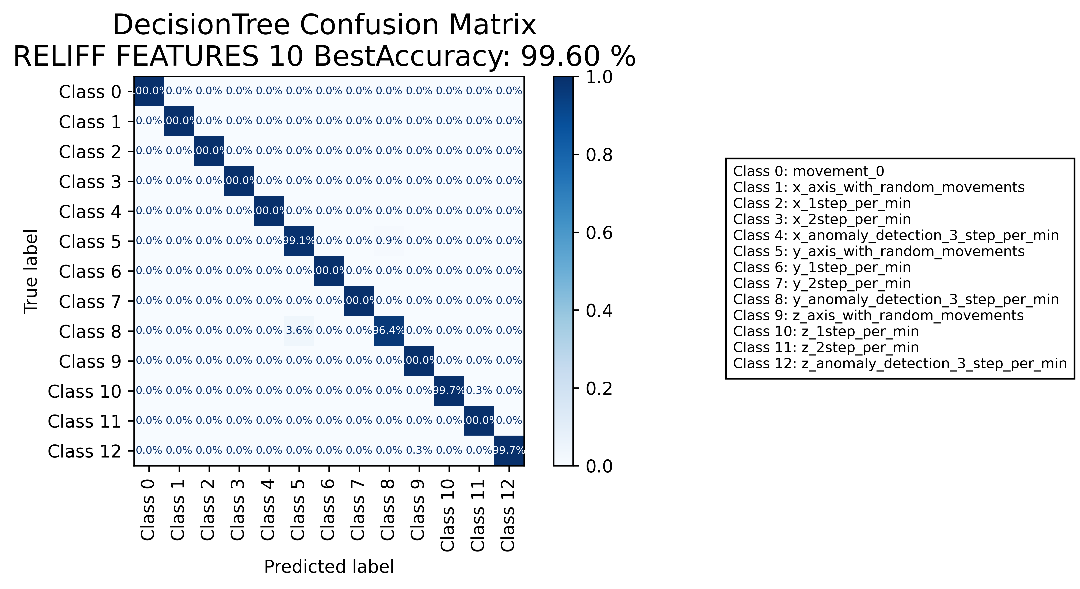

======================================================================

======================= CLASSIFICATION RESULTS =======================  
CLASSIFIER: RandomForest  
Accuracy: 99.93 %   
Feature used : ALL FEATURES  
Classification Time: 0.64 seconds

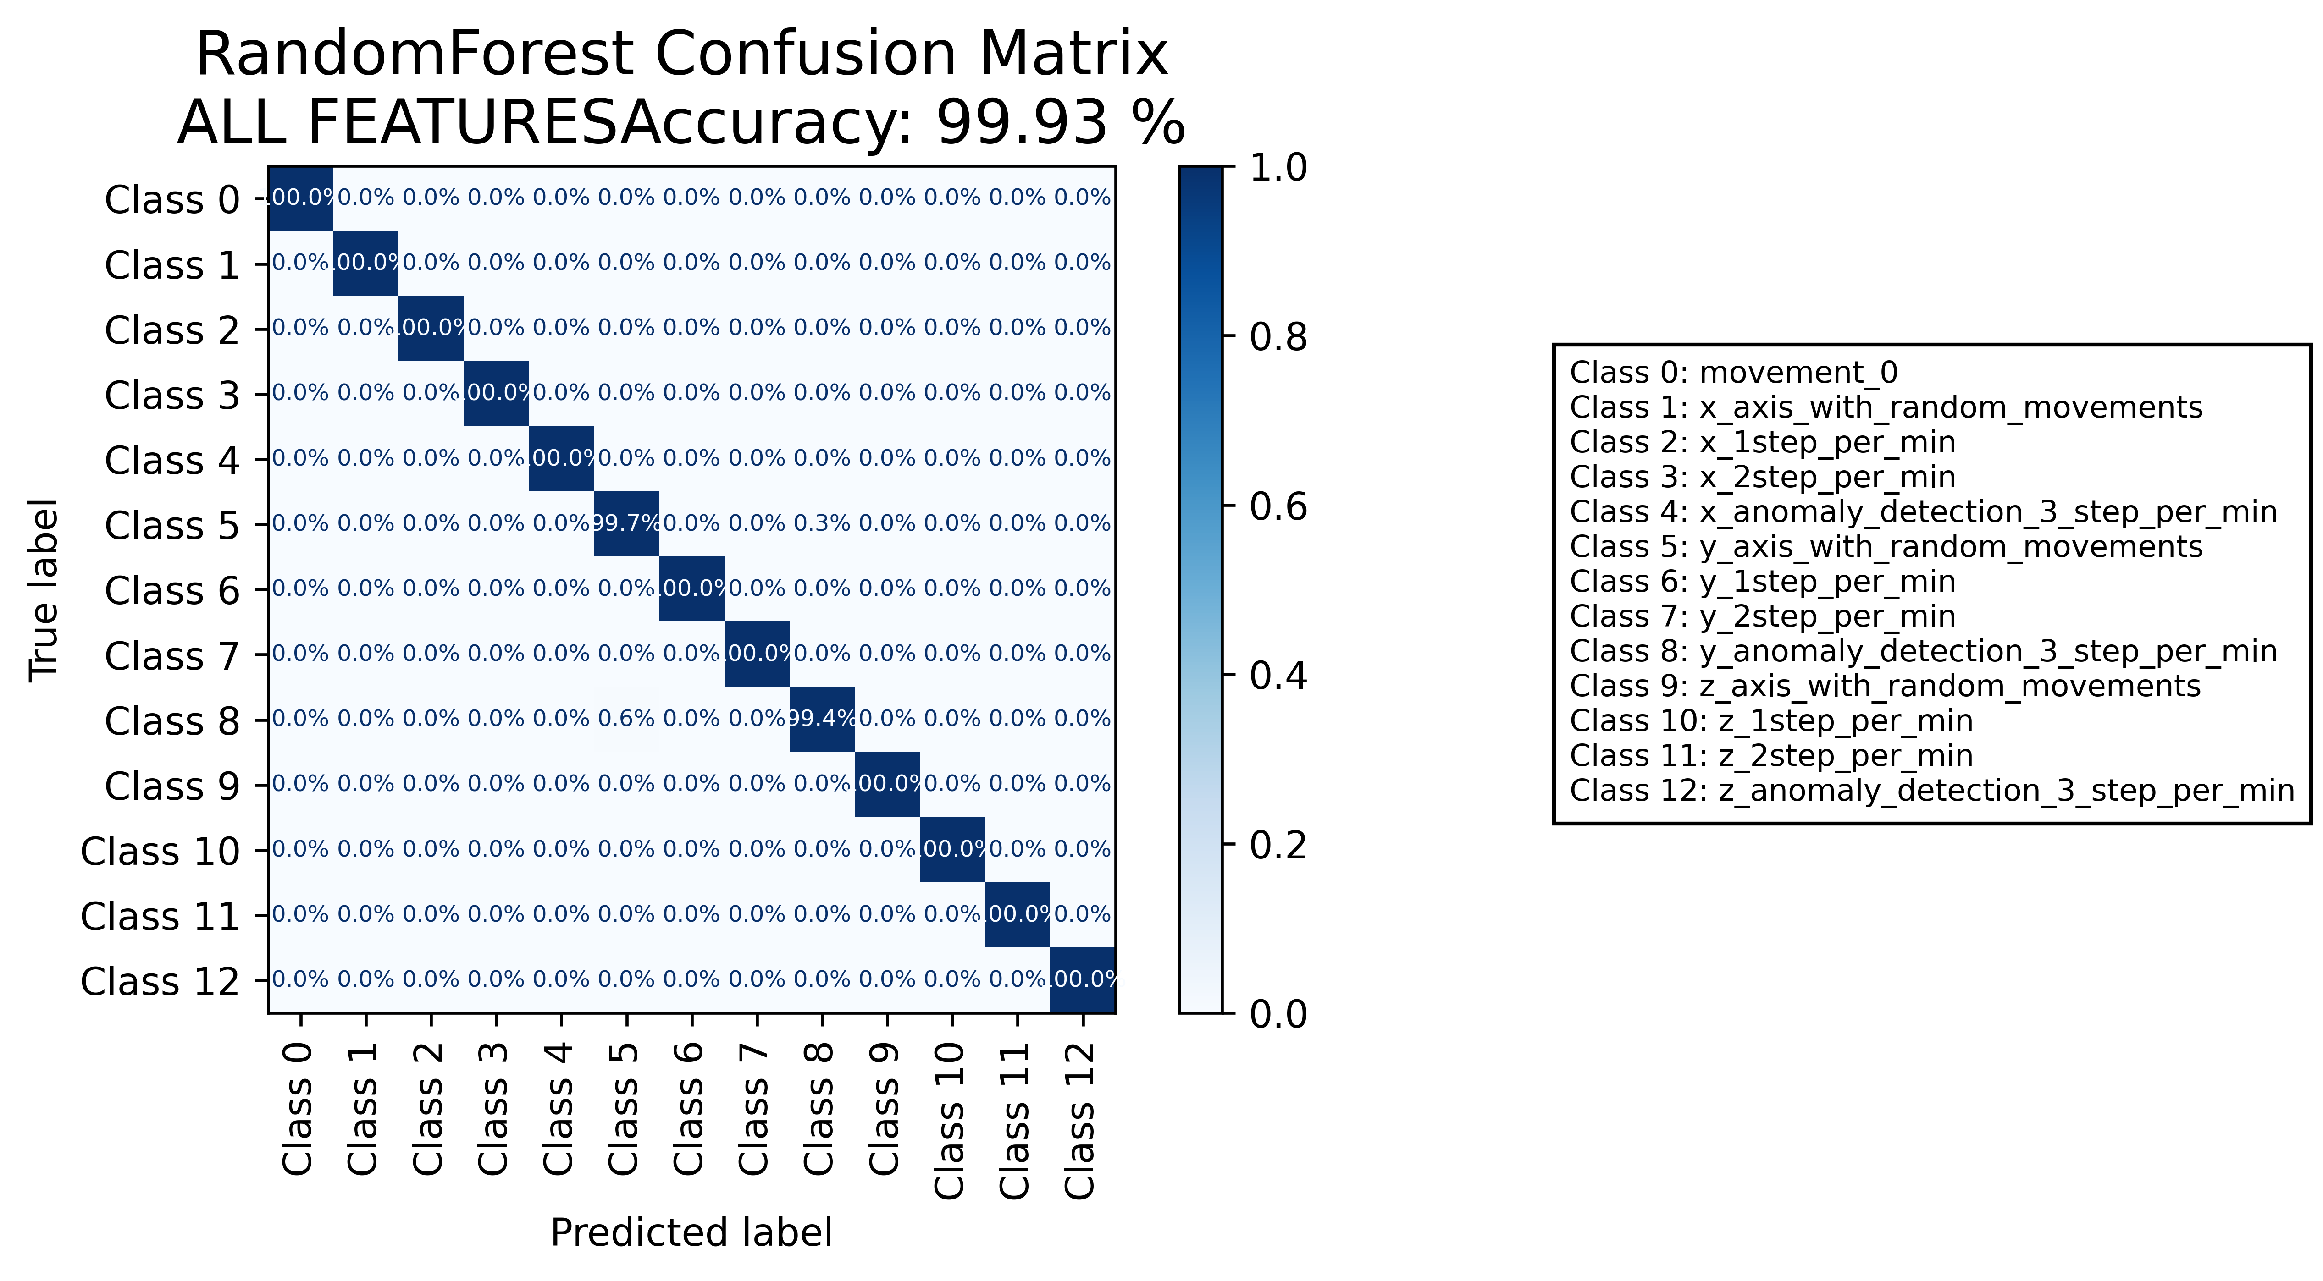

======================================================================

======================= CLASSIFICATION RESULTS =======================  
CLASSIFIER: RandomForest  
Accuracy: 99.98 %   
Feature used : RELIFF FEATURES 10 Best  
Classification Time: 0.476 seconds



======================================================================

======================= CLASSIFICATION RESULTS =======================  
CLASSIFIER: DecisionTree  
Accuracy: 99.51 %   
Feature used : ALL FEATURES  
Classification Time: 0.143 seconds

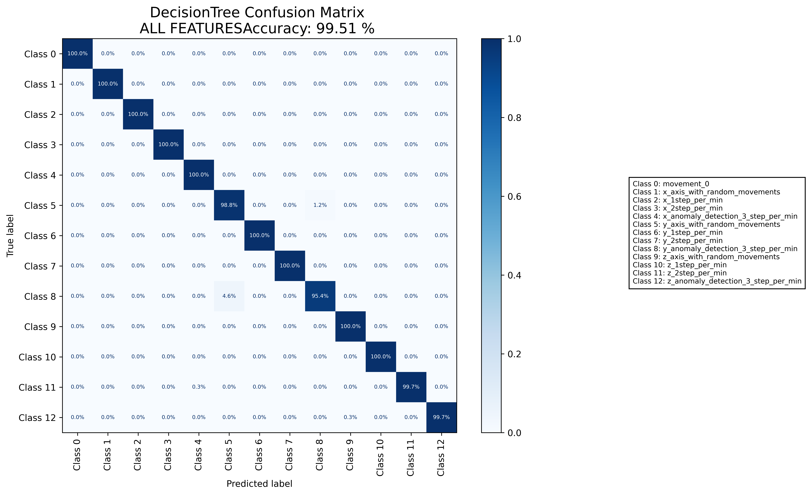

======================================================================

======================= CLASSIFICATION RESULTS =======================  
CLASSIFIER: DecisionTree  
Accuracy: 99.60 %   
Feature used : RELIFF FEATURES 10 Best  
Classification Time: 0.021 seconds

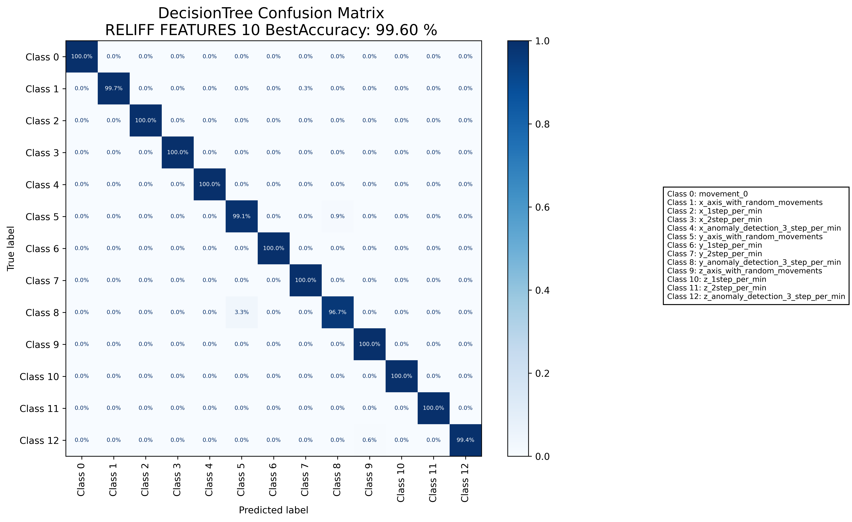

======================================================================

======================= CLASSIFICATION RESULTS =======================  
CLASSIFIER: RandomForest  
Accuracy: 99.91 %   
Feature used : ALL FEATURES  
Classification Time: 0.65 seconds

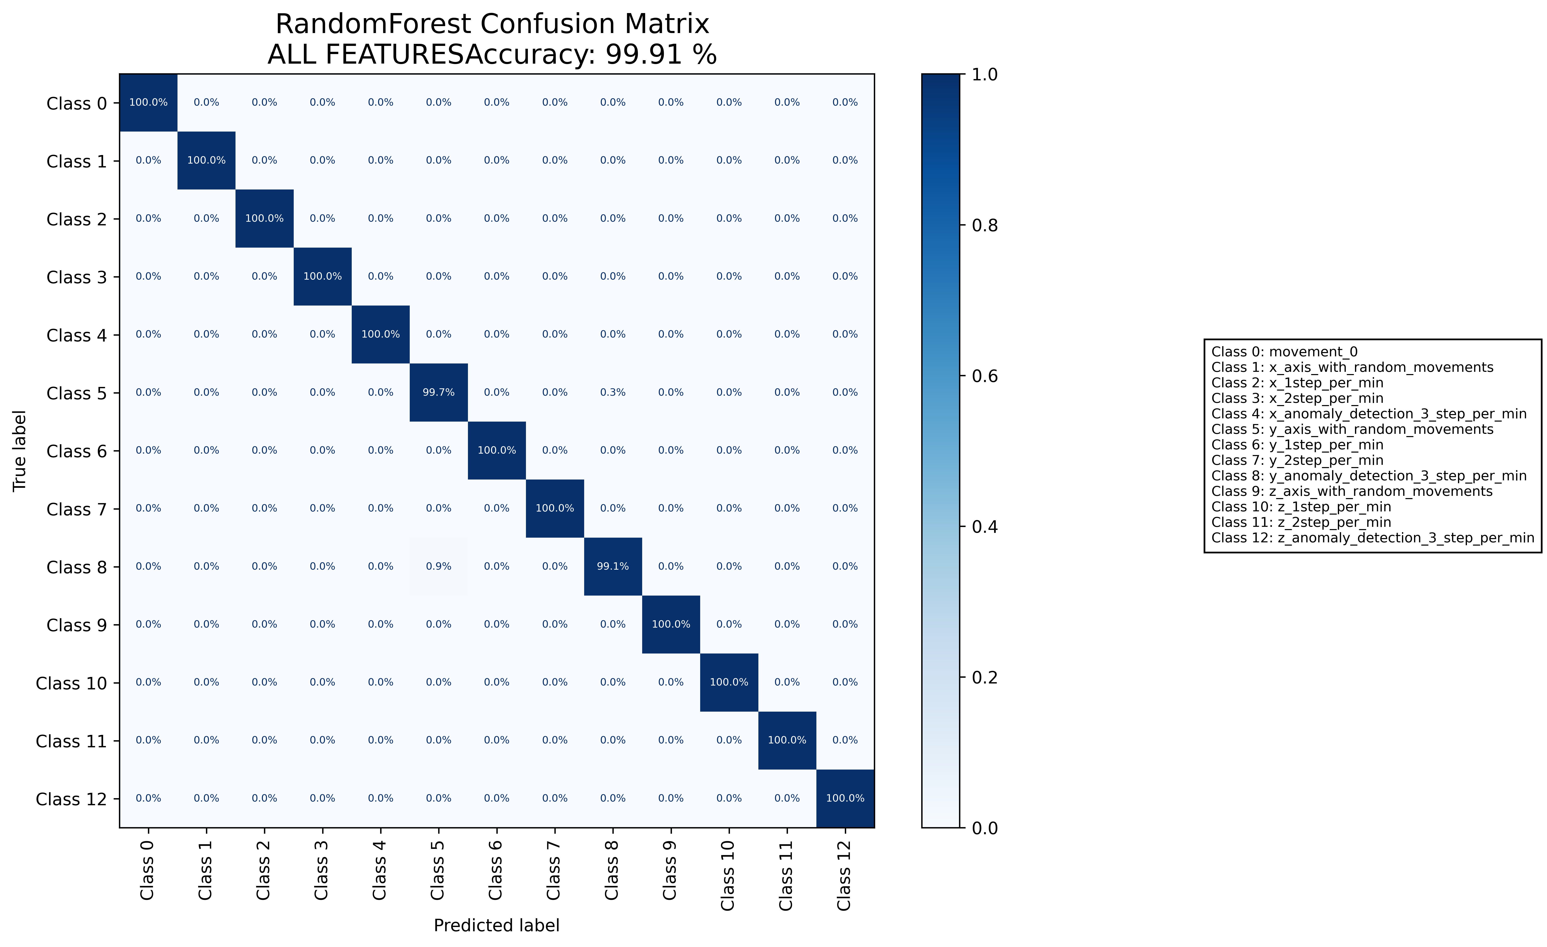

======================================================================

======================= CLASSIFICATION RESULTS =======================  
CLASSIFIER: RandomForest  
Accuracy: 99.91 %   
Feature used : RELIFF FEATURES 10 Best  
Classification Time: 0.458 seconds

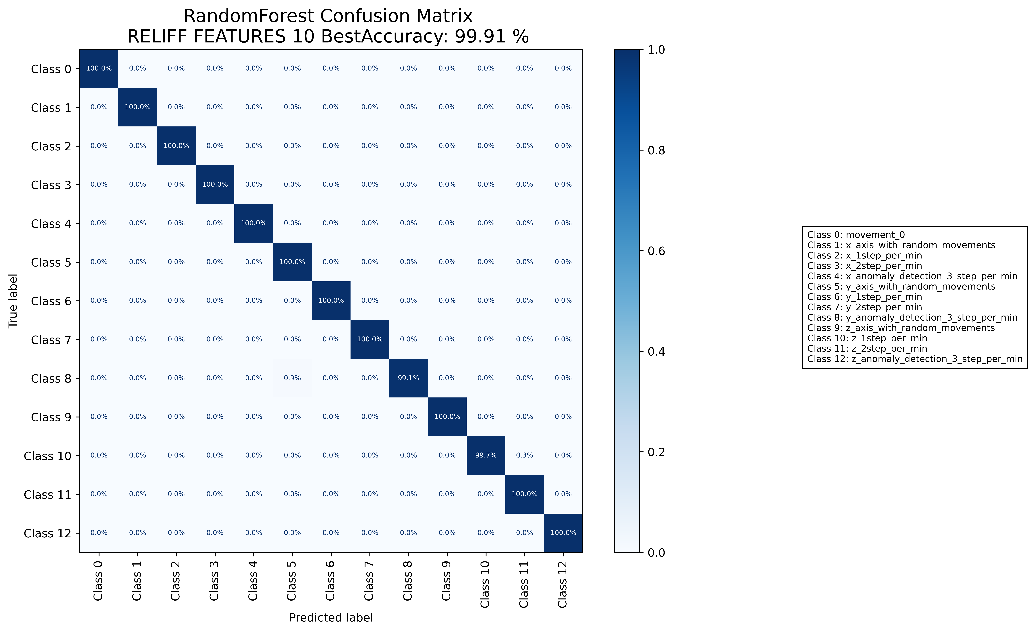

======================================================================

======================= CLASSIFICATION RESULTS =======================  
CLASSIFIER: DecisionTree  
Accuracy: 99.42 %   
Feature used : ALL FEATURES  
Classification Time: 0.125 seconds

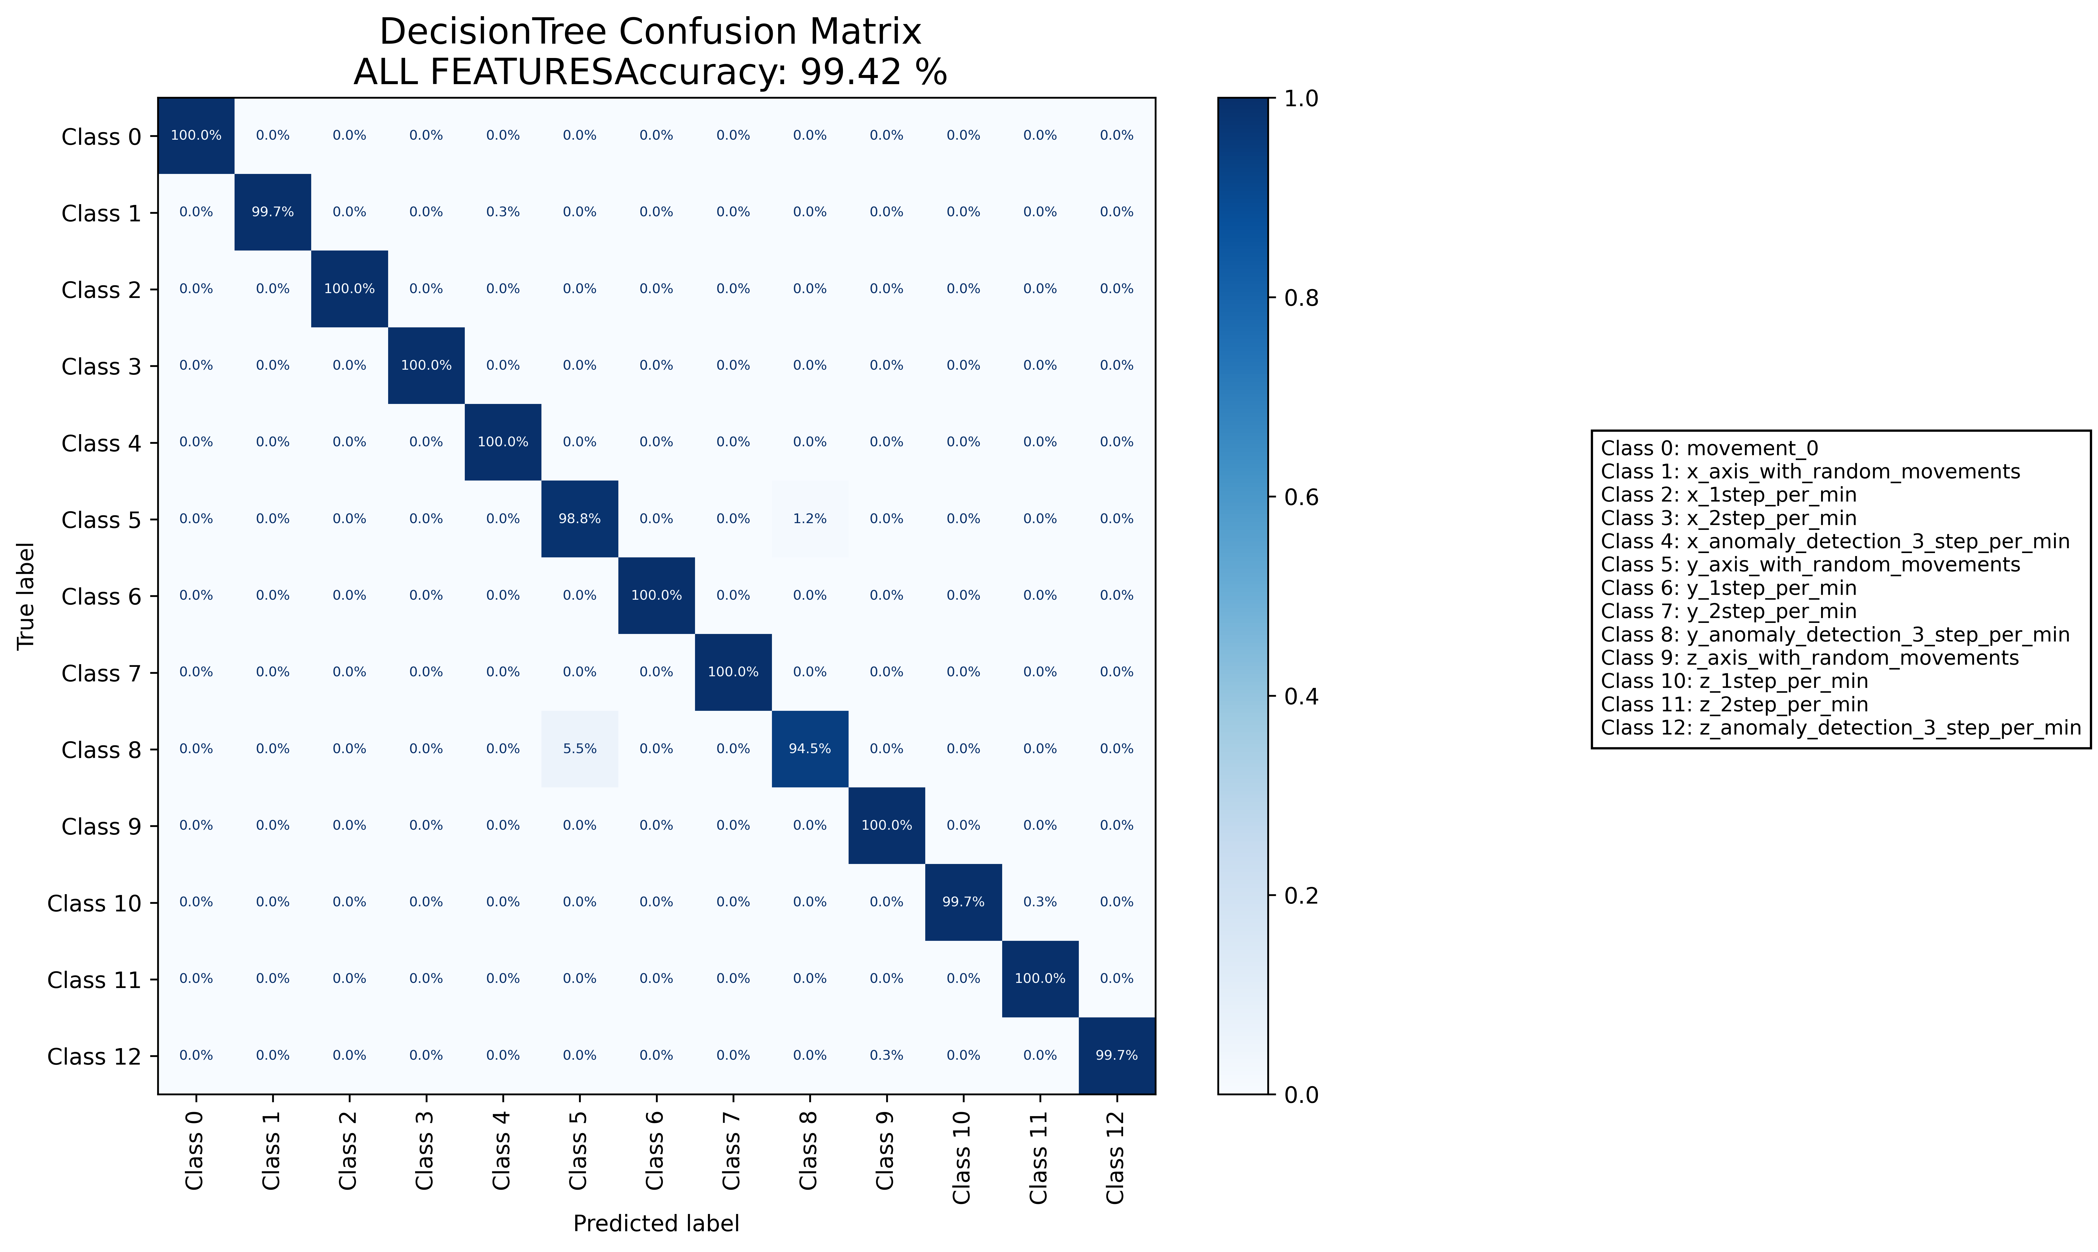

======================================================================

======================= CLASSIFICATION RESULTS =======================  
CLASSIFIER: DecisionTree  
Accuracy: 99.70 %   
Feature used : RELIFF FEATURES 10 Best  
Classification Time: 0.036 seconds

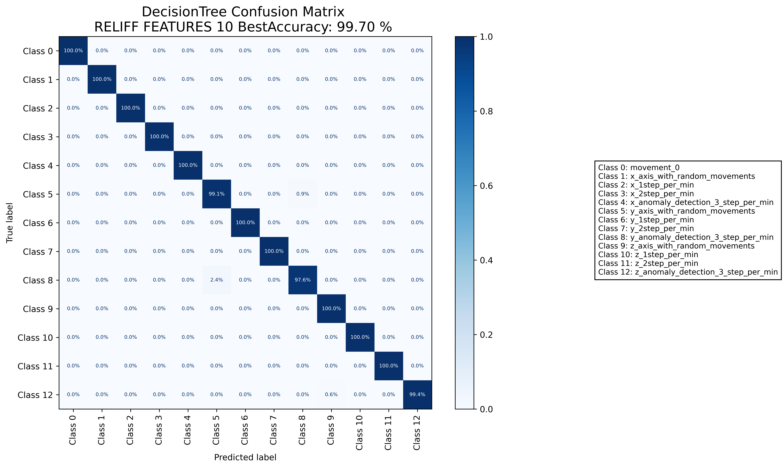

======================================================================

======================= CLASSIFICATION RESULTS =======================  
CLASSIFIER: RandomForest  
Accuracy: 99.88 %   
Feature used : ALL FEATURES  
Classification Time: 0.657 seconds

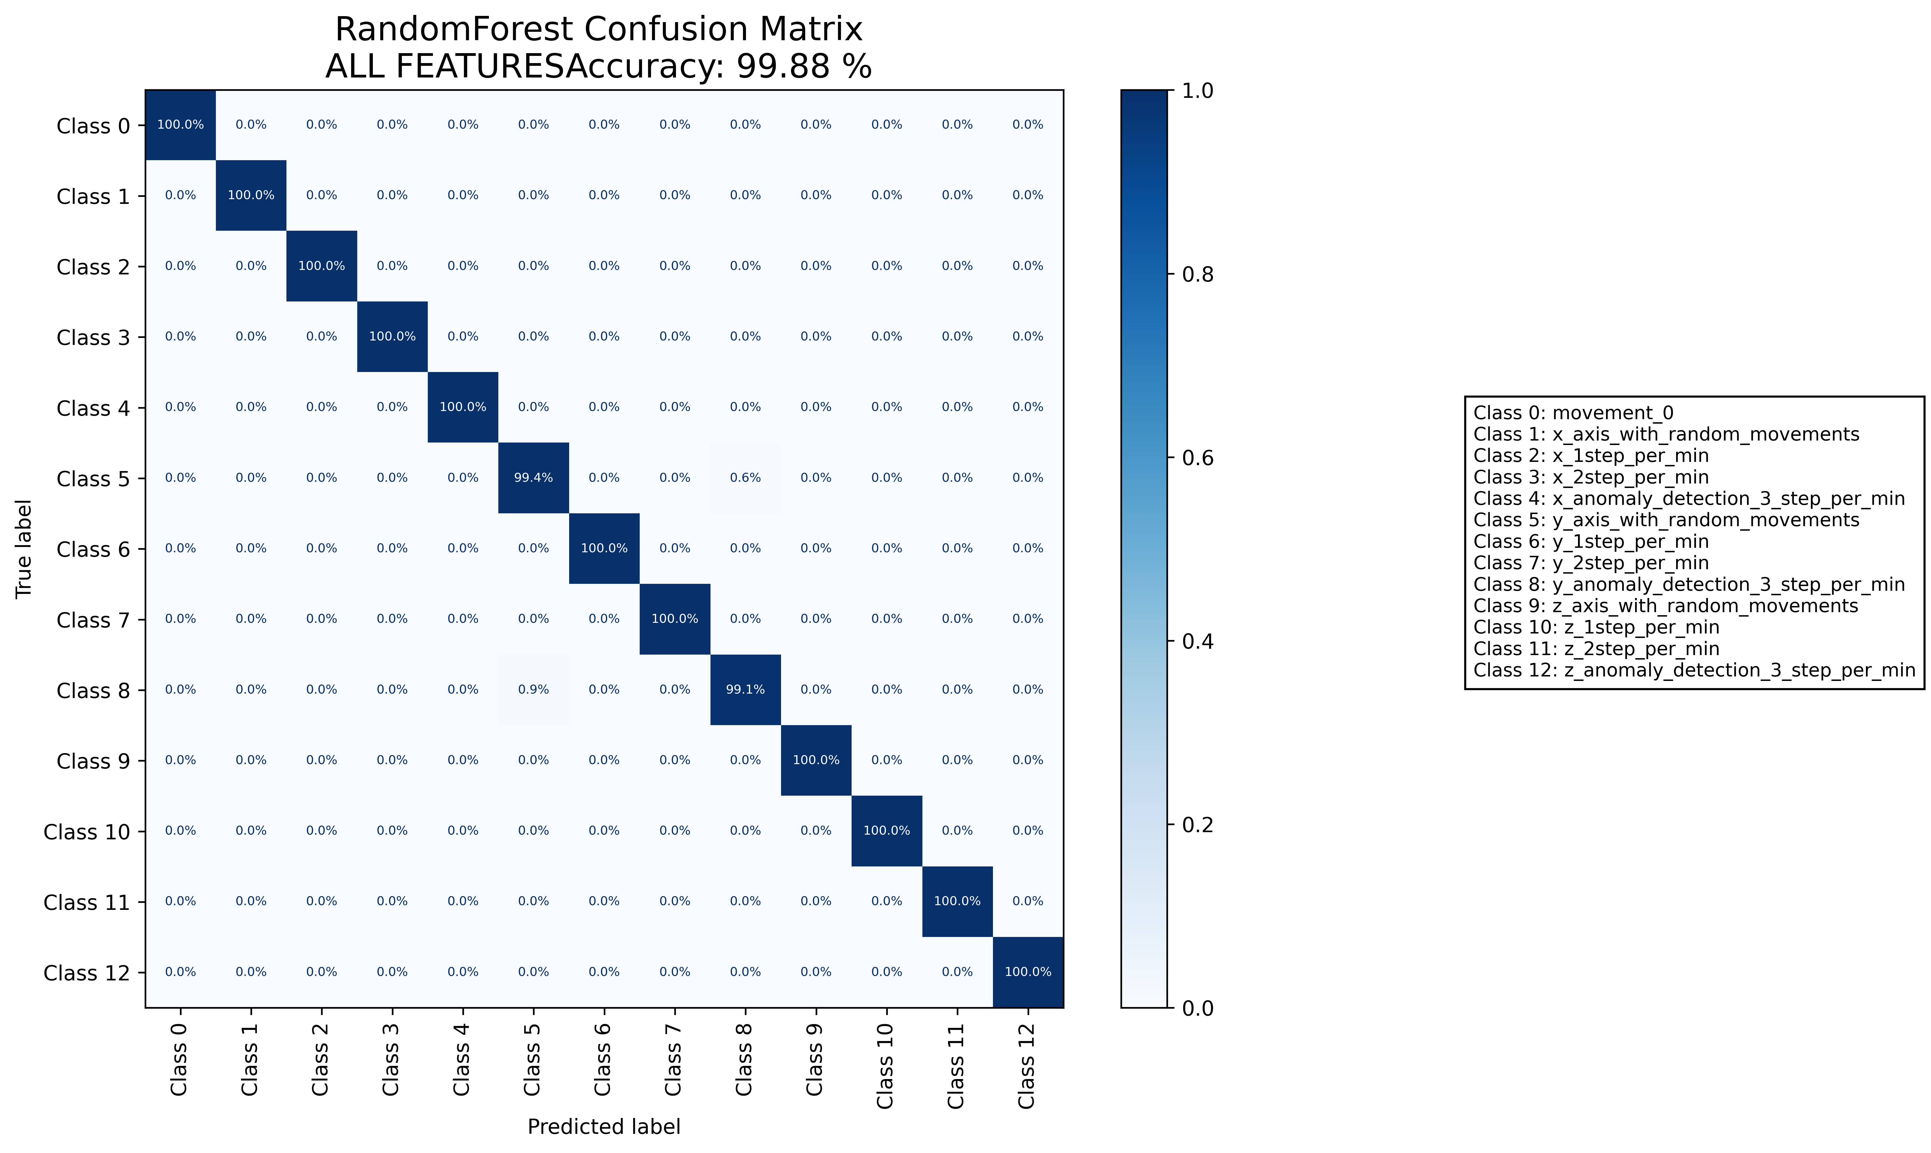

======================================================================

======================= CLASSIFICATION RESULTS =======================  
CLASSIFIER: RandomForest  
Accuracy: 99.93 %   
Feature used : RELIFF FEATURES 10 Best  
Classification Time: 0.488 seconds

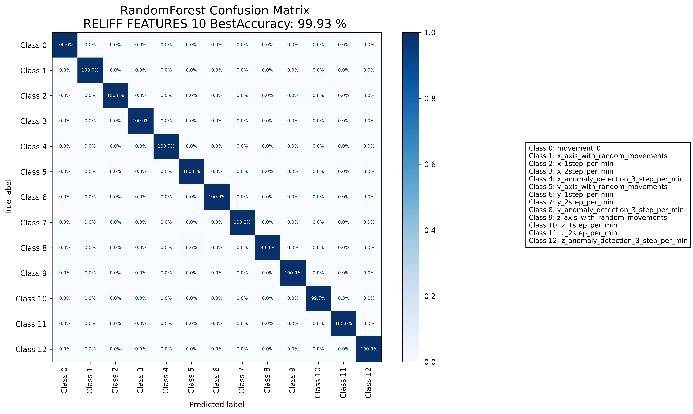

======================================================================

======================= CLASSIFICATION RESULTS =======================  
CLASSIFIER: DecisionTree  
Accuracy: 99.46 %   
Feature used : ALL FEATURES  
Classification Time: 0.154 seconds

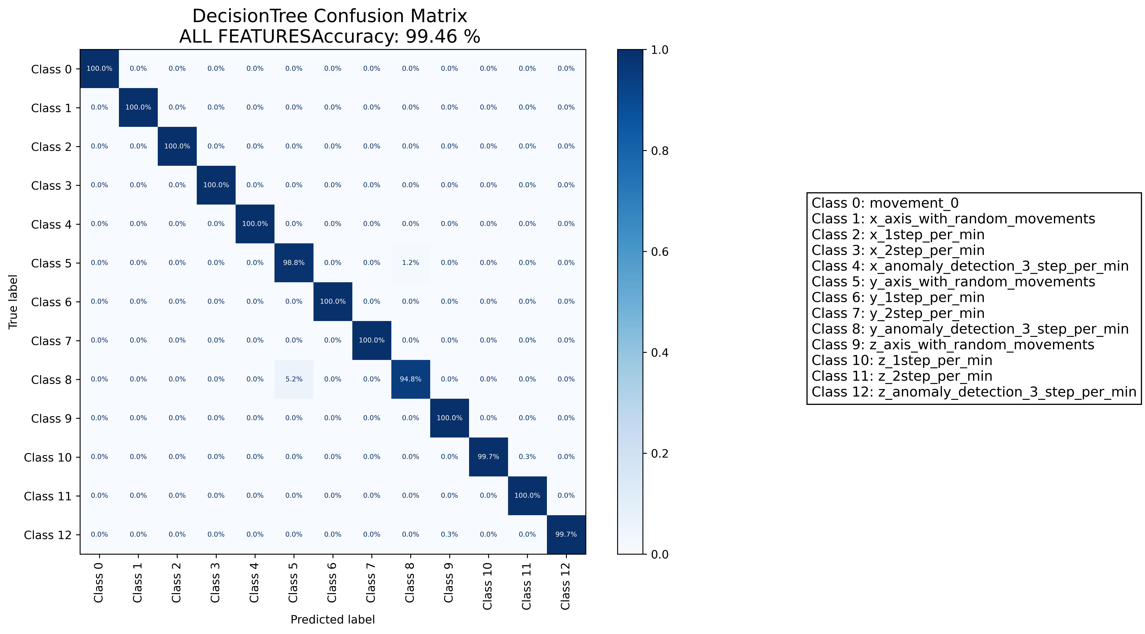

======================================================================

======================= CLASSIFICATION RESULTS =======================  
CLASSIFIER: DecisionTree  
Accuracy: 99.63 %   
Feature used : RELIFF FEATURES 10 Best  
Classification Time: 0.038 seconds

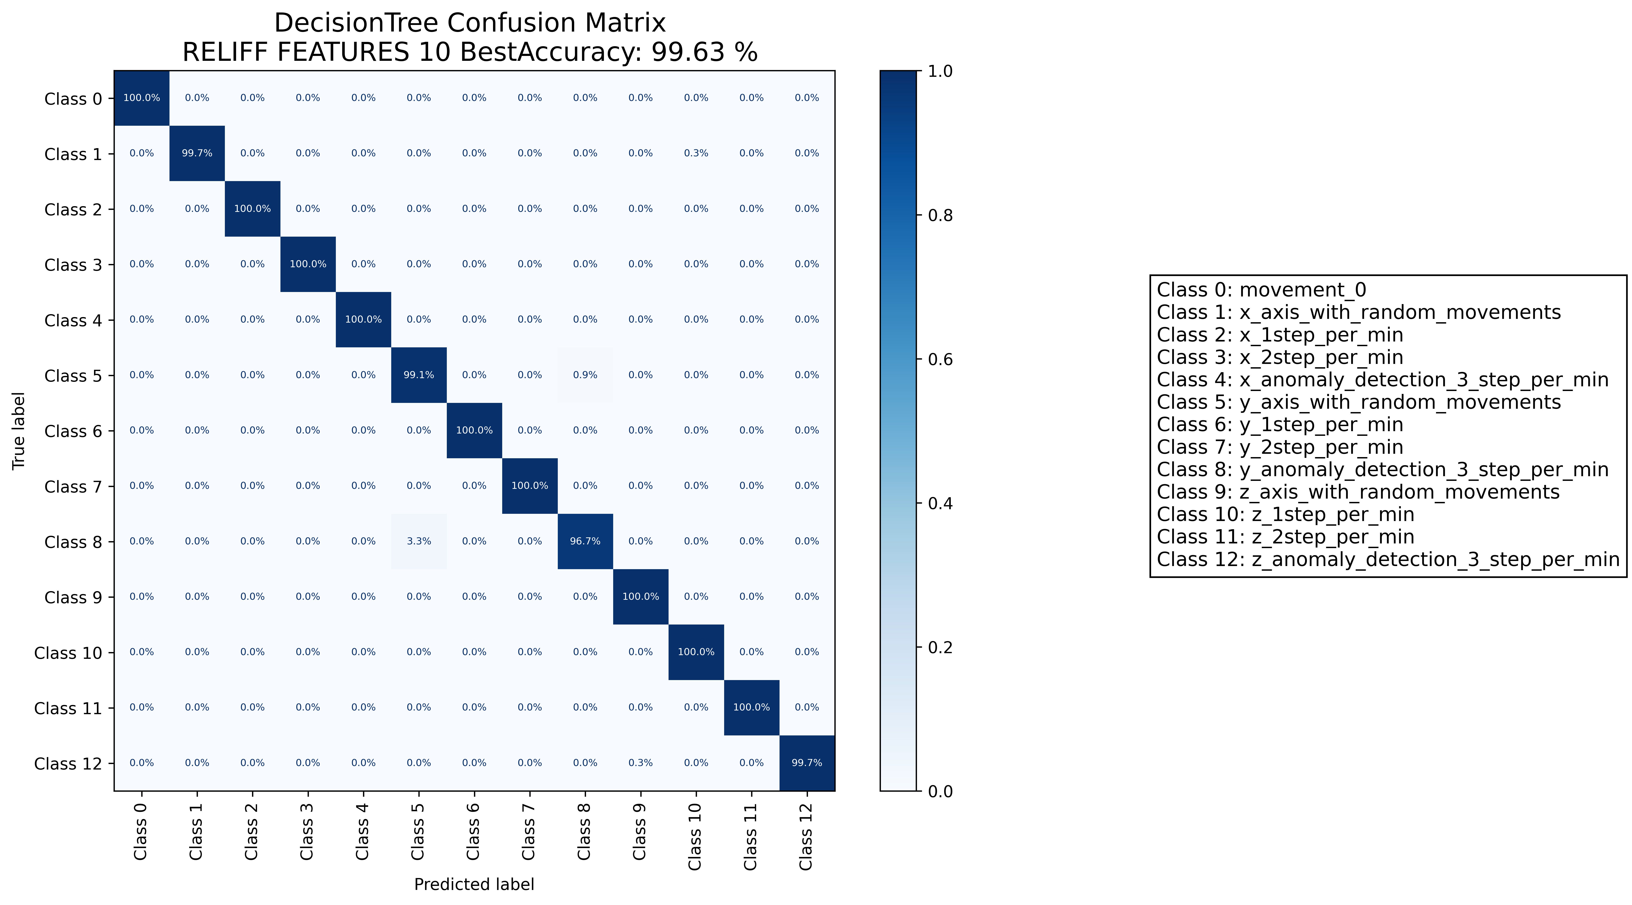

======================================================================

======================= CLASSIFICATION RESULTS =======================  
CLASSIFIER: RandomForest  
Accuracy: 99.88 %   
Feature used : ALL FEATURES  
Classification Time: 0.781 seconds

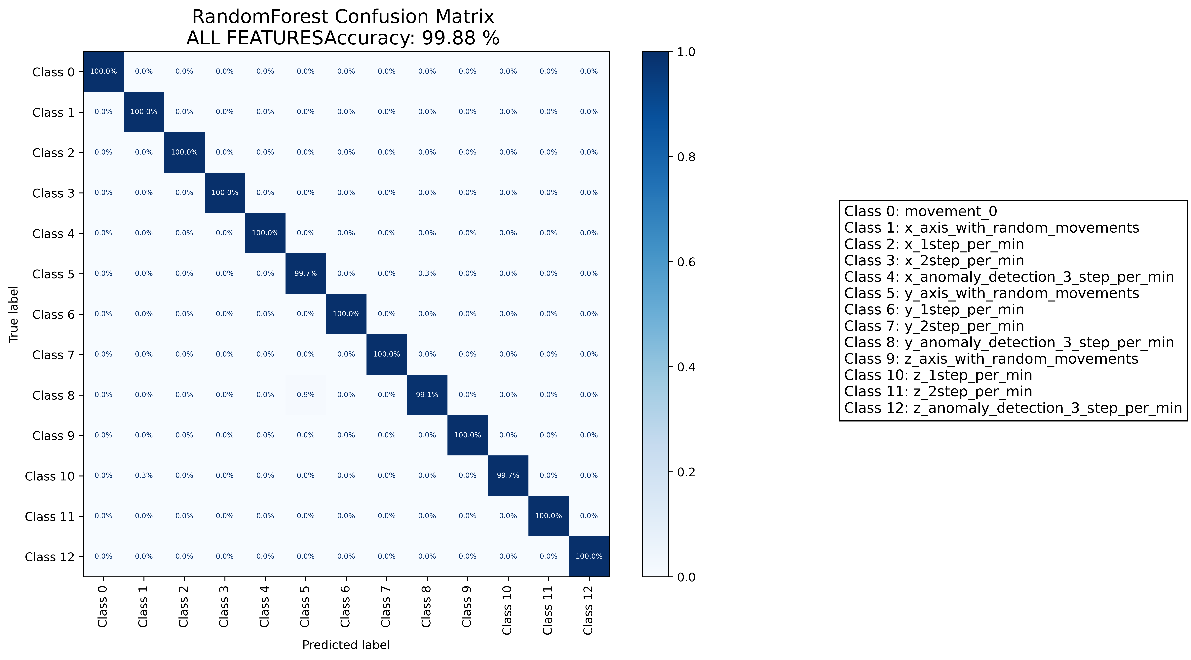

======================================================================

======================= CLASSIFICATION RESULTS =======================  
CLASSIFIER: RandomForest  
Accuracy: 100.00 %   
Feature used : RELIFF FEATURES 10 Best  
Classification Time: 0.462 seconds

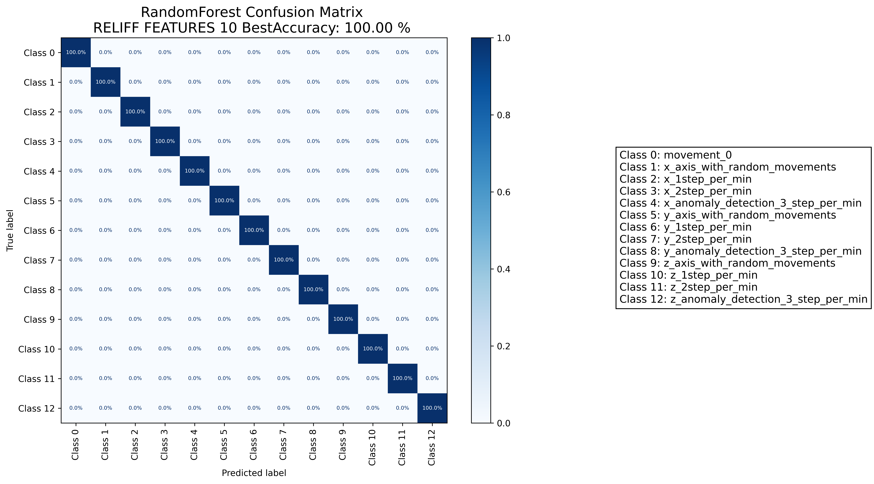

======================================================================

======================= CLASSIFICATION RESULTS =======================  
CLASSIFIER: DecisionTree  
Accuracy: 99.20 %   
Feature used : ALL FEATURES  
Classification Time: 0.324 seconds

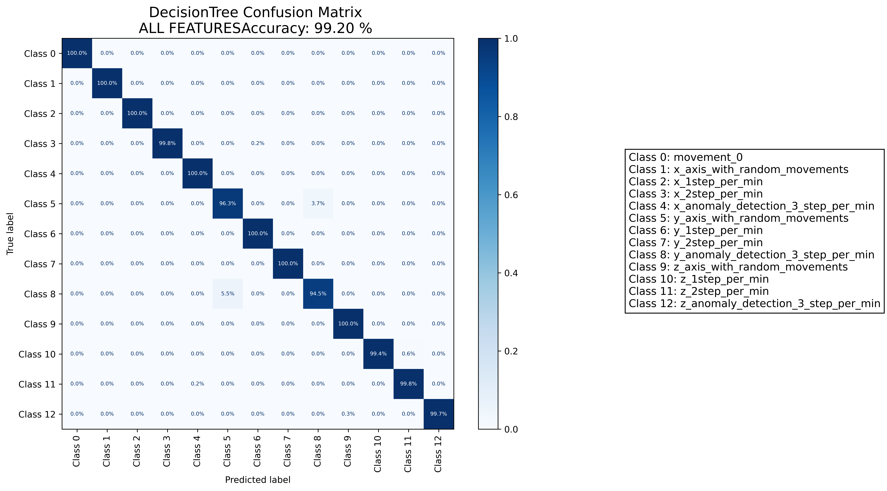

======================================================================

======================= CLASSIFICATION RESULTS =======================  
CLASSIFIER: DecisionTree  
Accuracy: 98.57 %   
Feature used : RELIFF FEATURES 10 Best  
Classification Time: 0.066 seconds

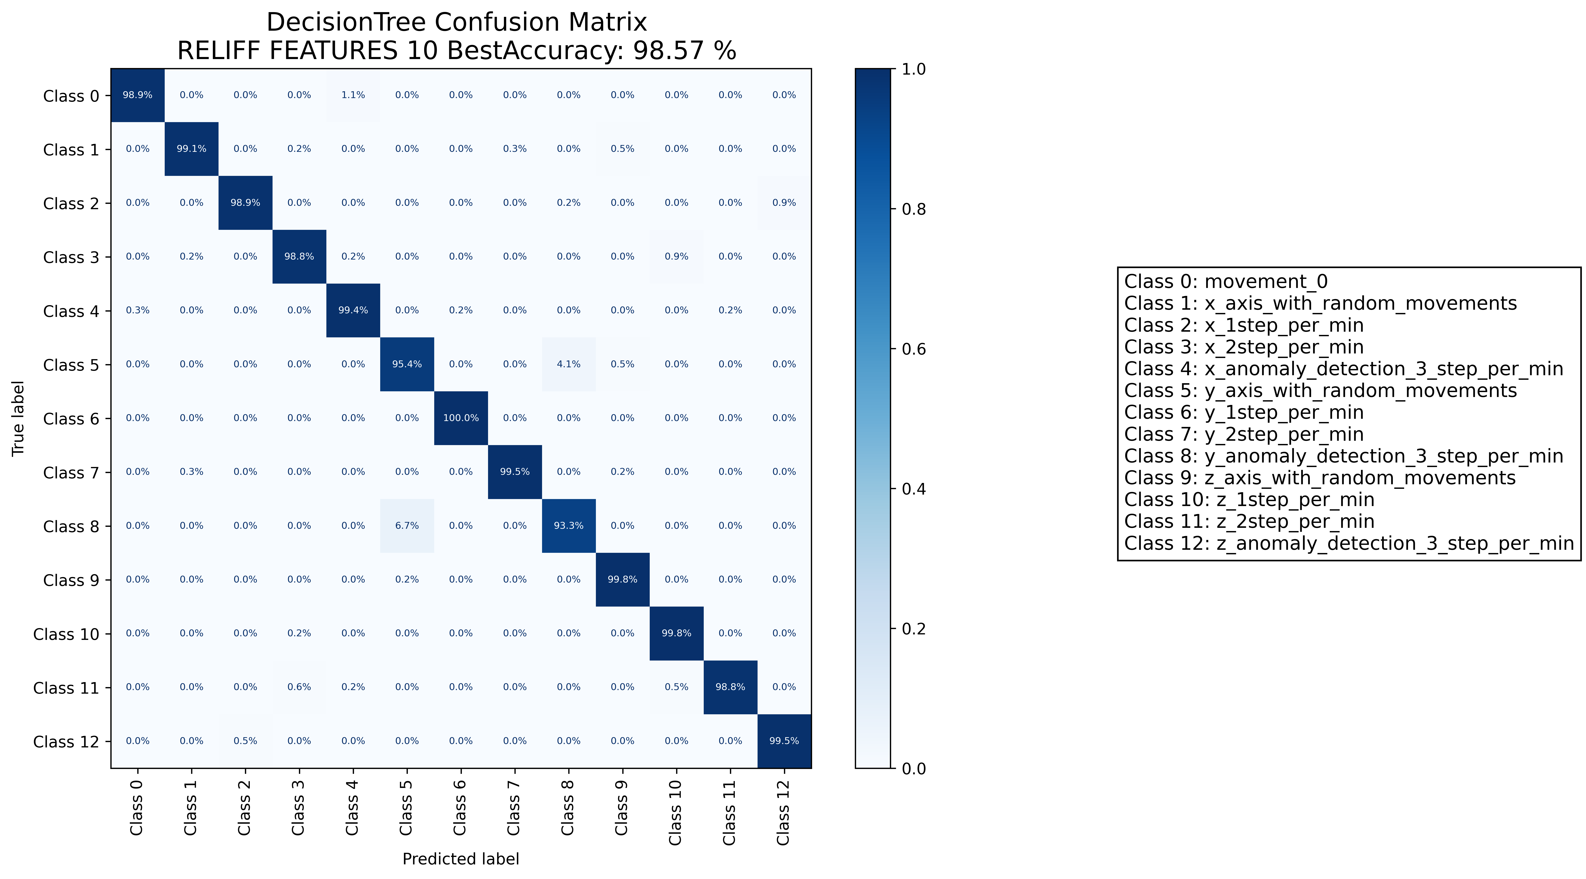

======================================================================

======================= CLASSIFICATION RESULTS =======================  
CLASSIFIER: RandomForest  
Accuracy: 99.66 %   
Feature used : ALL FEATURES  
Classification Time: 1.273 seconds

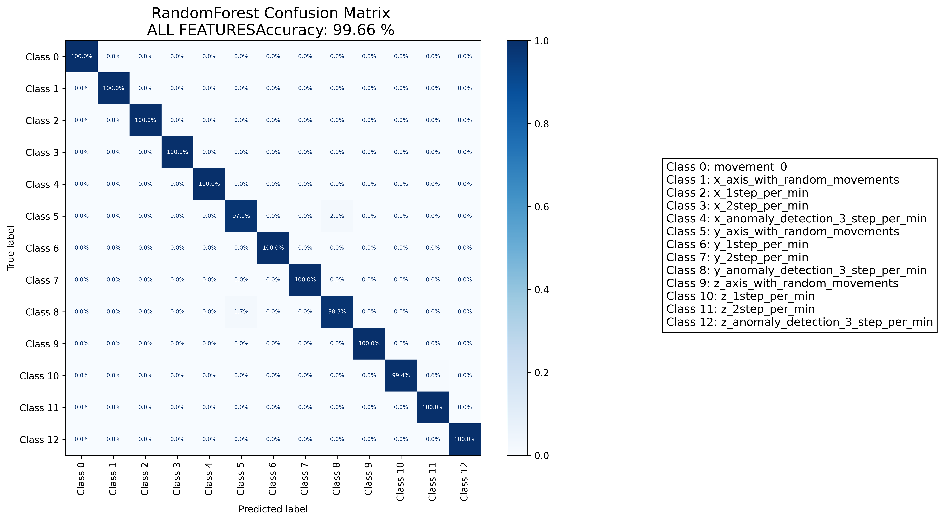

======================================================================

======================= CLASSIFICATION RESULTS =======================  
CLASSIFIER: RandomForest  
Accuracy: 98.51 %   
Feature used : RELIFF FEATURES 10 Best  
Classification Time: 0.86 seconds

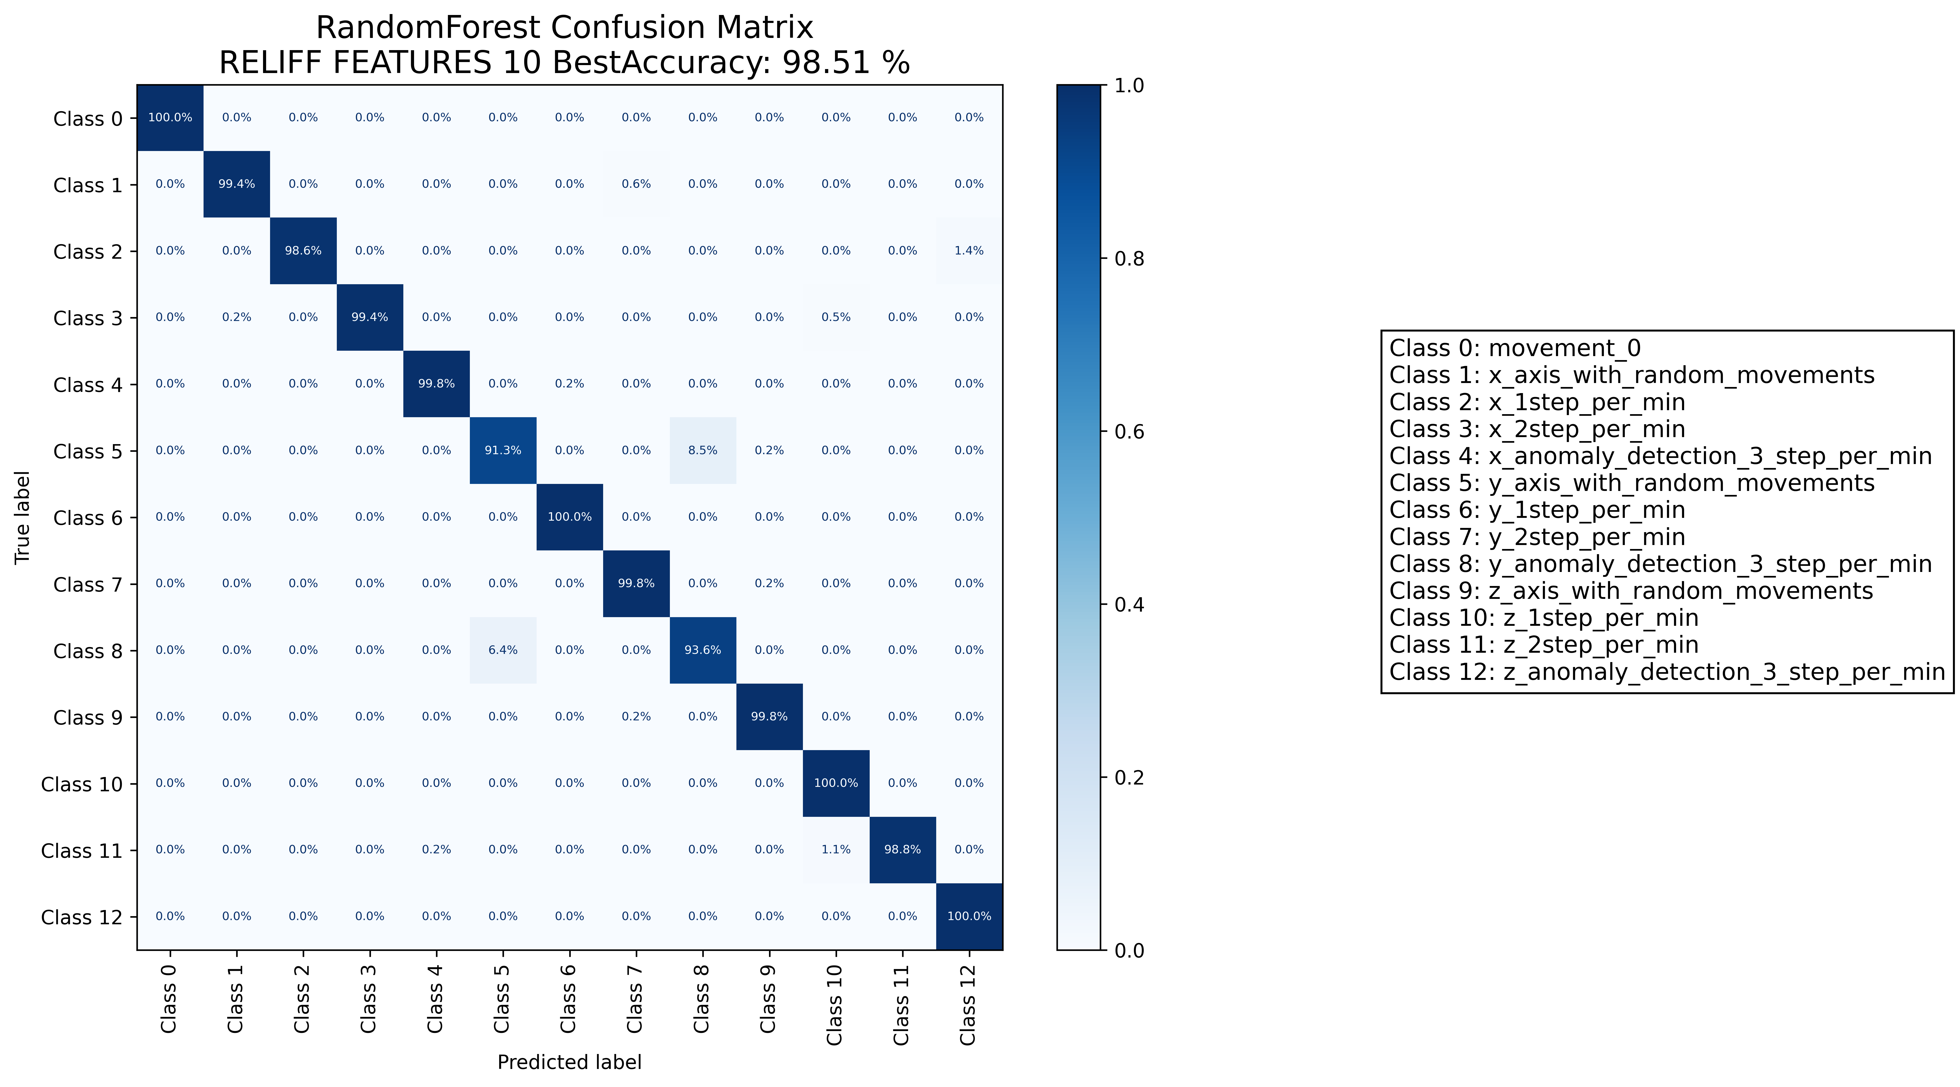

======================================================================

======================= CLASSIFICATION RESULTS =======================  
CLASSIFIER: DecisionTree  
Accuracy: 95.40 %   
Feature used : ALL FEATURES  
Classification Time: 0.422 seconds

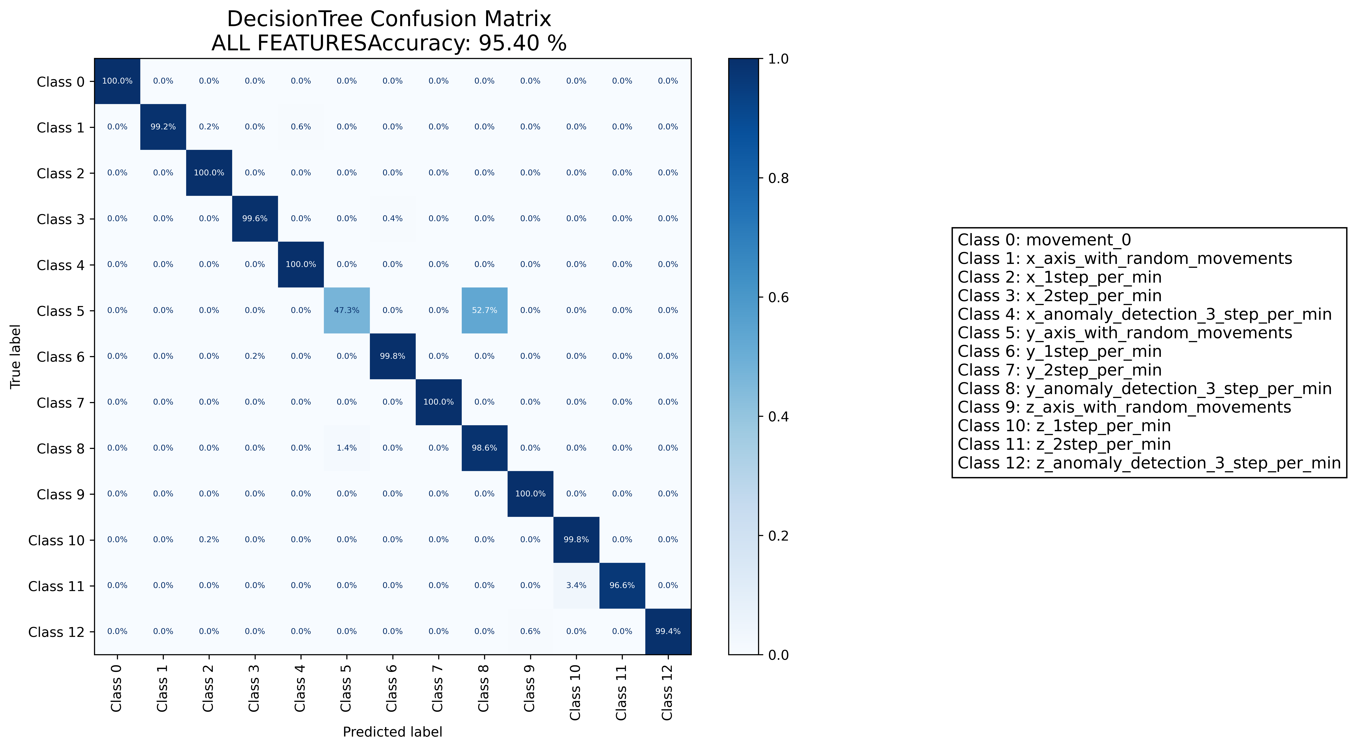

======================================================================

======================= CLASSIFICATION RESULTS =======================  
CLASSIFIER: DecisionTree  
Accuracy: 95.02 %   
Feature used : RELIFF FEATURES 10 Best  
Classification Time: 0.044 seconds

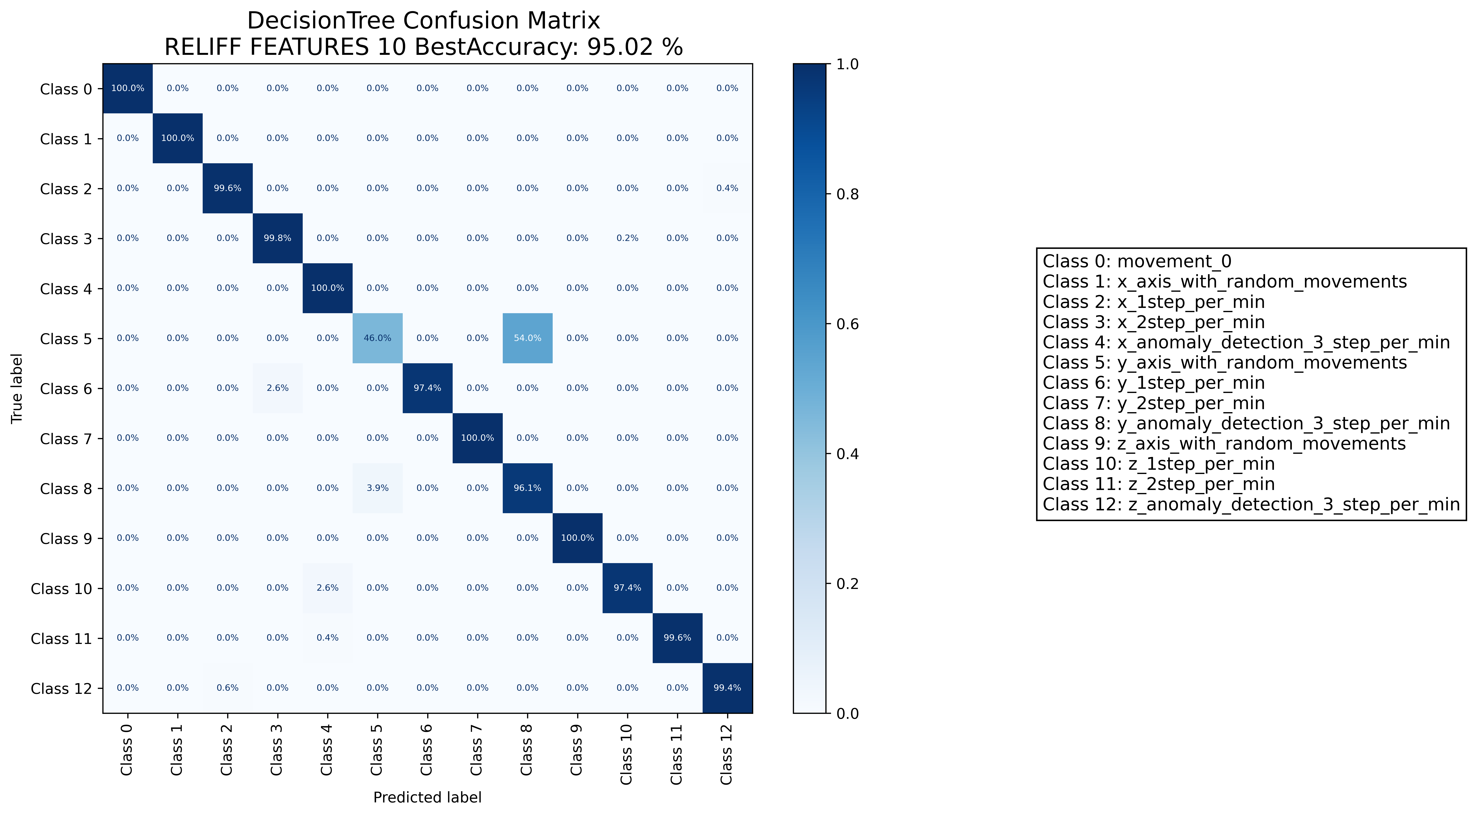

======================================================================

======================= CLASSIFICATION RESULTS =======================  
CLASSIFIER: RandomForest  
Accuracy: 95.91 %   
Feature used : ALL FEATURES  
Classification Time: 1.915 seconds

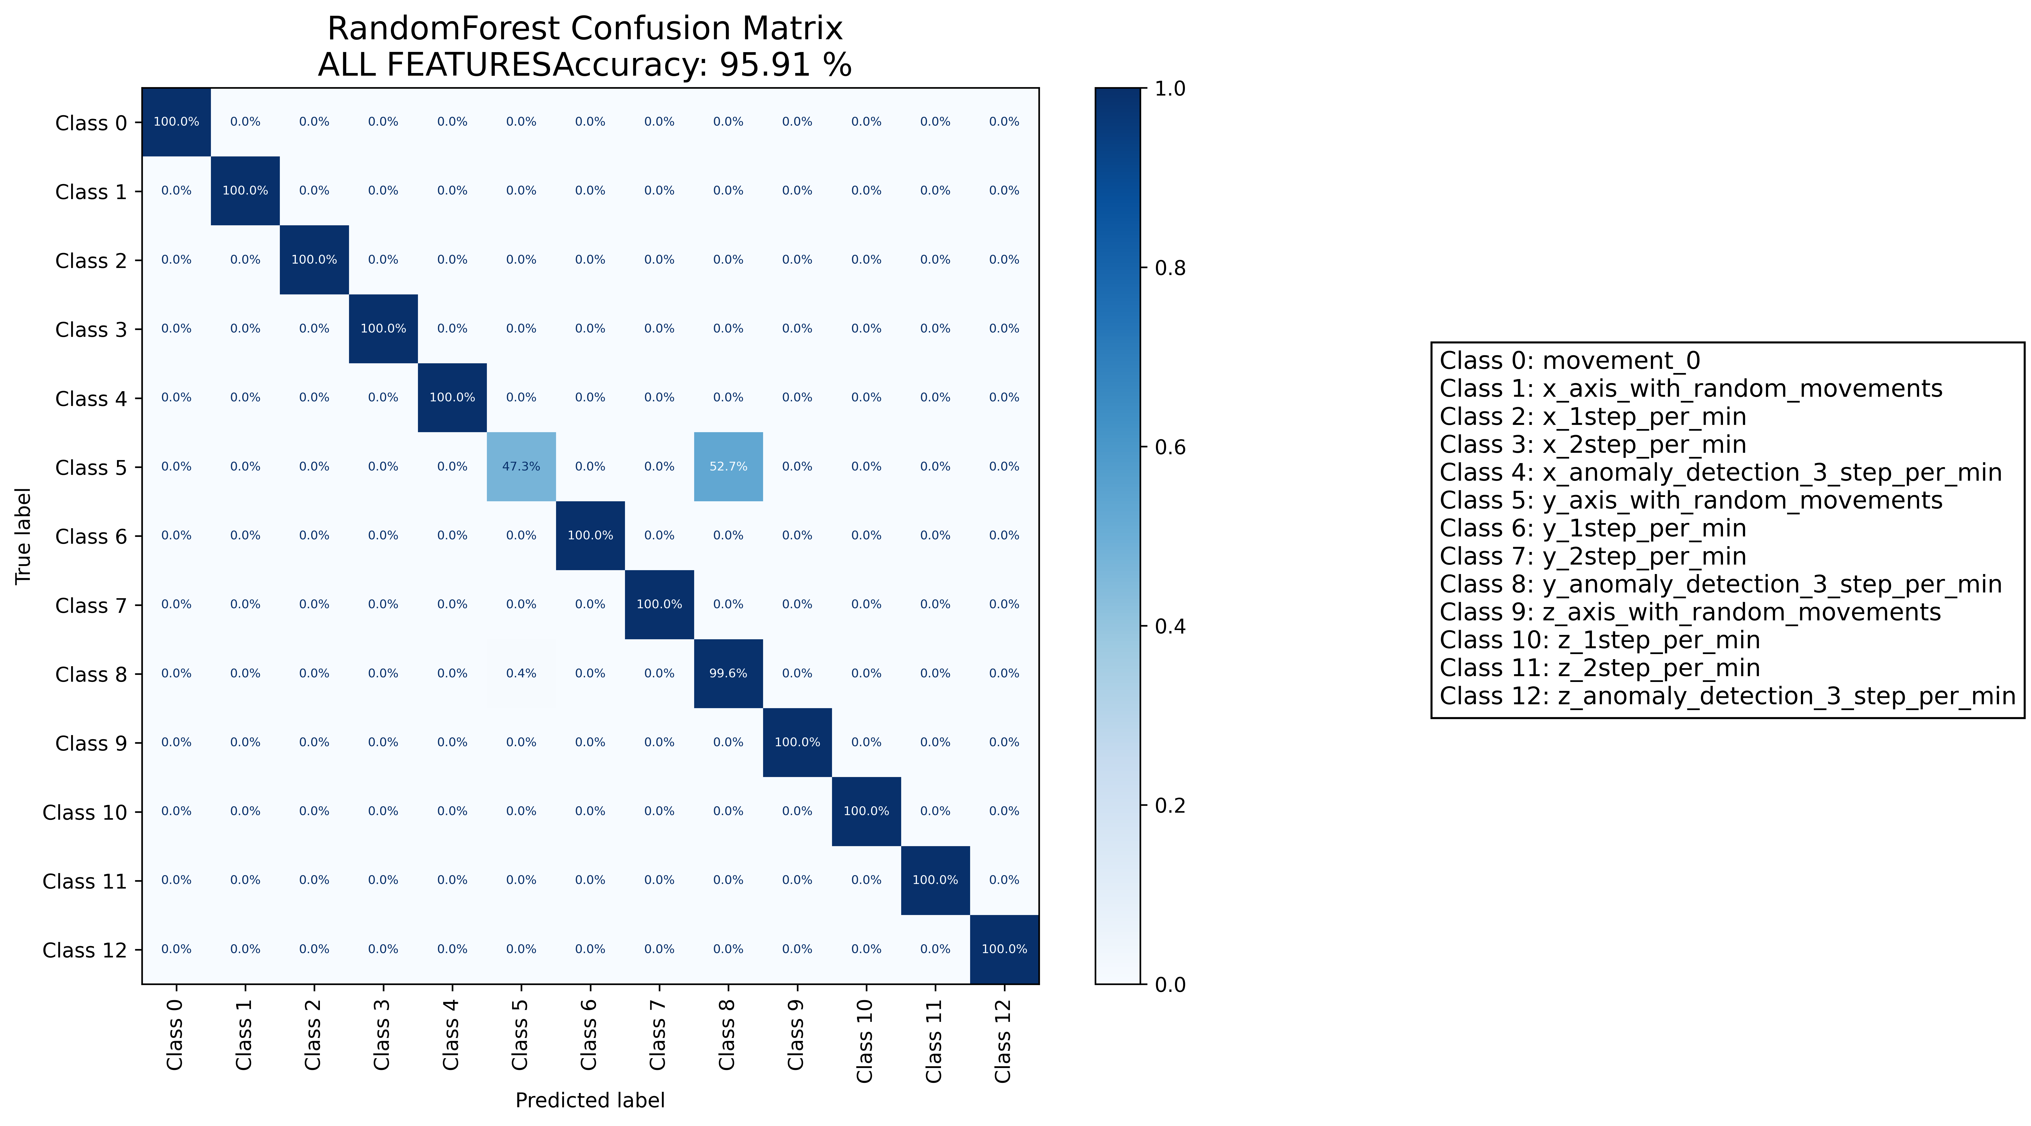

======================================================================

======================= CLASSIFICATION RESULTS =======================  
CLASSIFIER: RandomForest  
Accuracy: 95.09 %   
Feature used : RELIFF FEATURES 10 Best  
Classification Time: 0.736 seconds

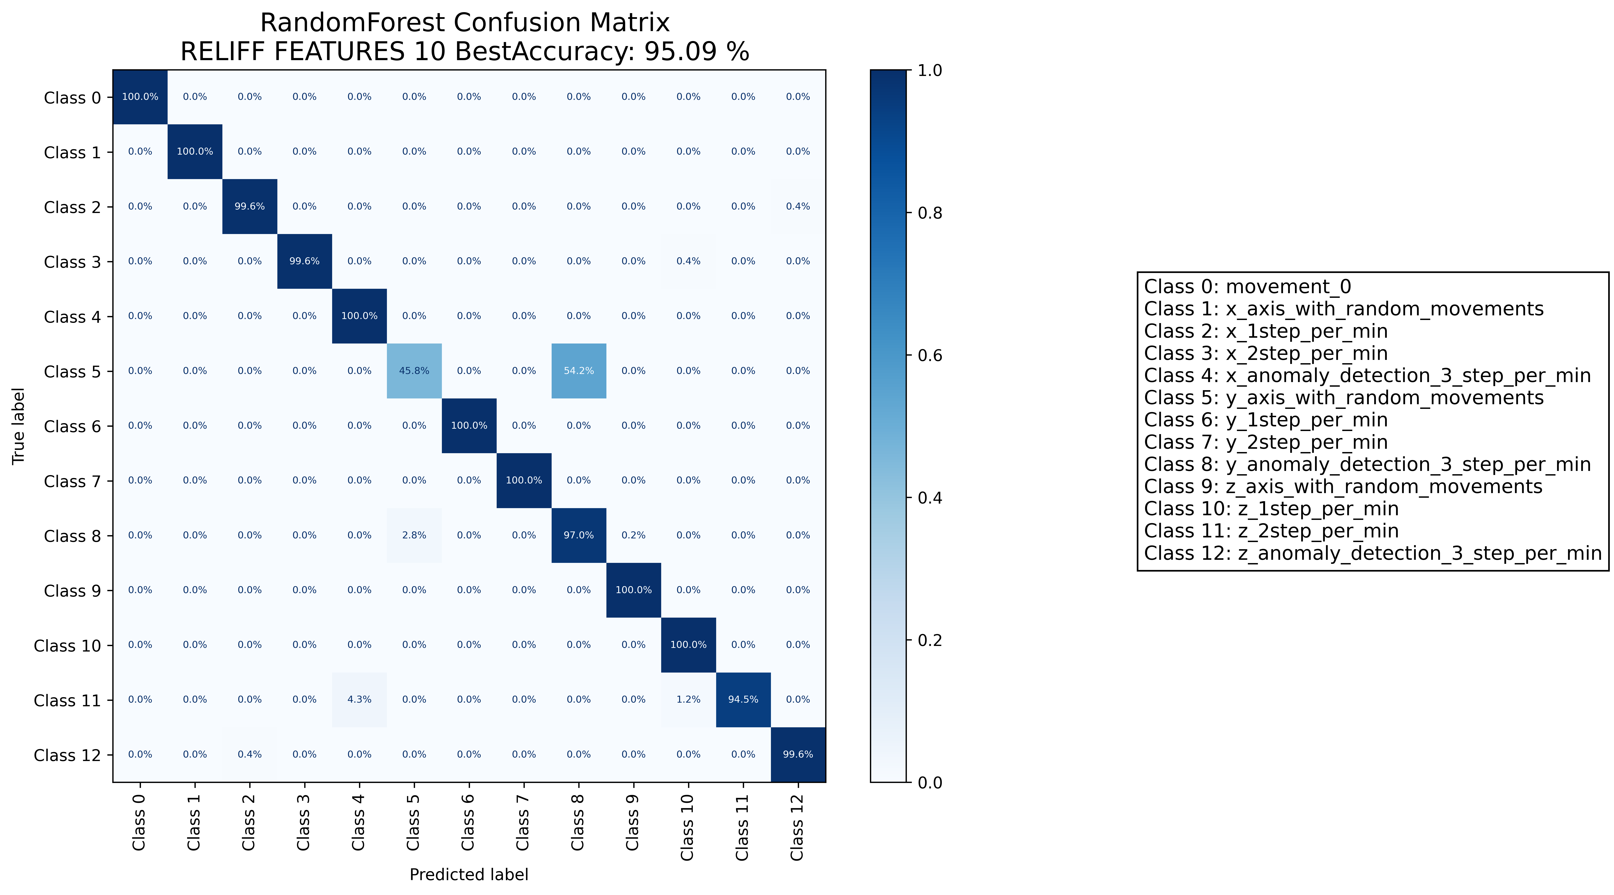

======================================================================

======================= CLASSIFICATION RESULTS =======================  
CLASSIFIER: DecisionTree  
Accuracy: 89.86 %   
Feature used : ALL FEATURES  
Classification Time: 0.221 seconds

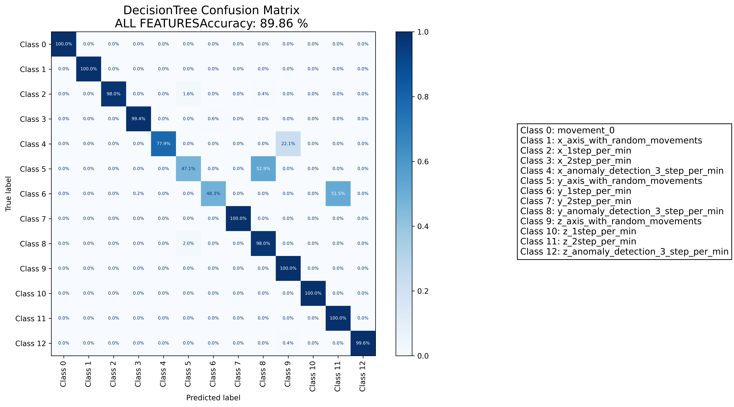

======================================================================

======================= CLASSIFICATION RESULTS =======================  
CLASSIFIER: DecisionTree  
Accuracy: 95.57 %   
Feature used : RELIFF FEATURES 10 Best  
Classification Time: 0.045 seconds

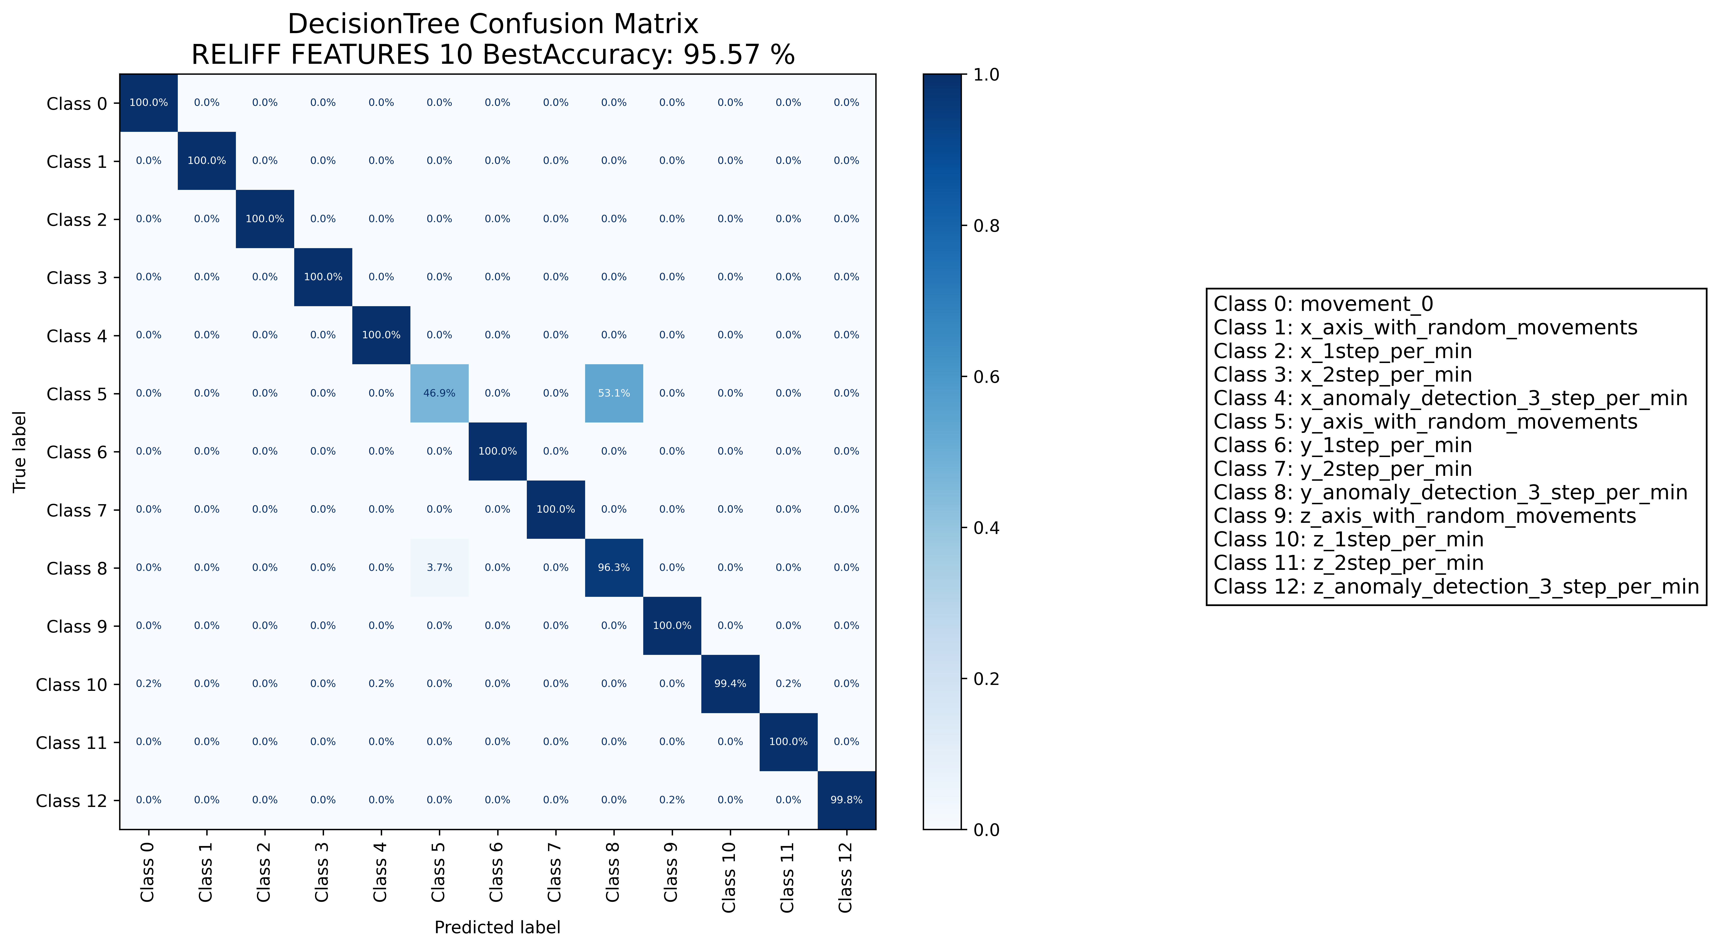

======================================================================

======================= CLASSIFICATION RESULTS =======================  
CLASSIFIER: RandomForest  
Accuracy: 95.93 %   
Feature used : ALL FEATURES  
Classification Time: 0.974 seconds

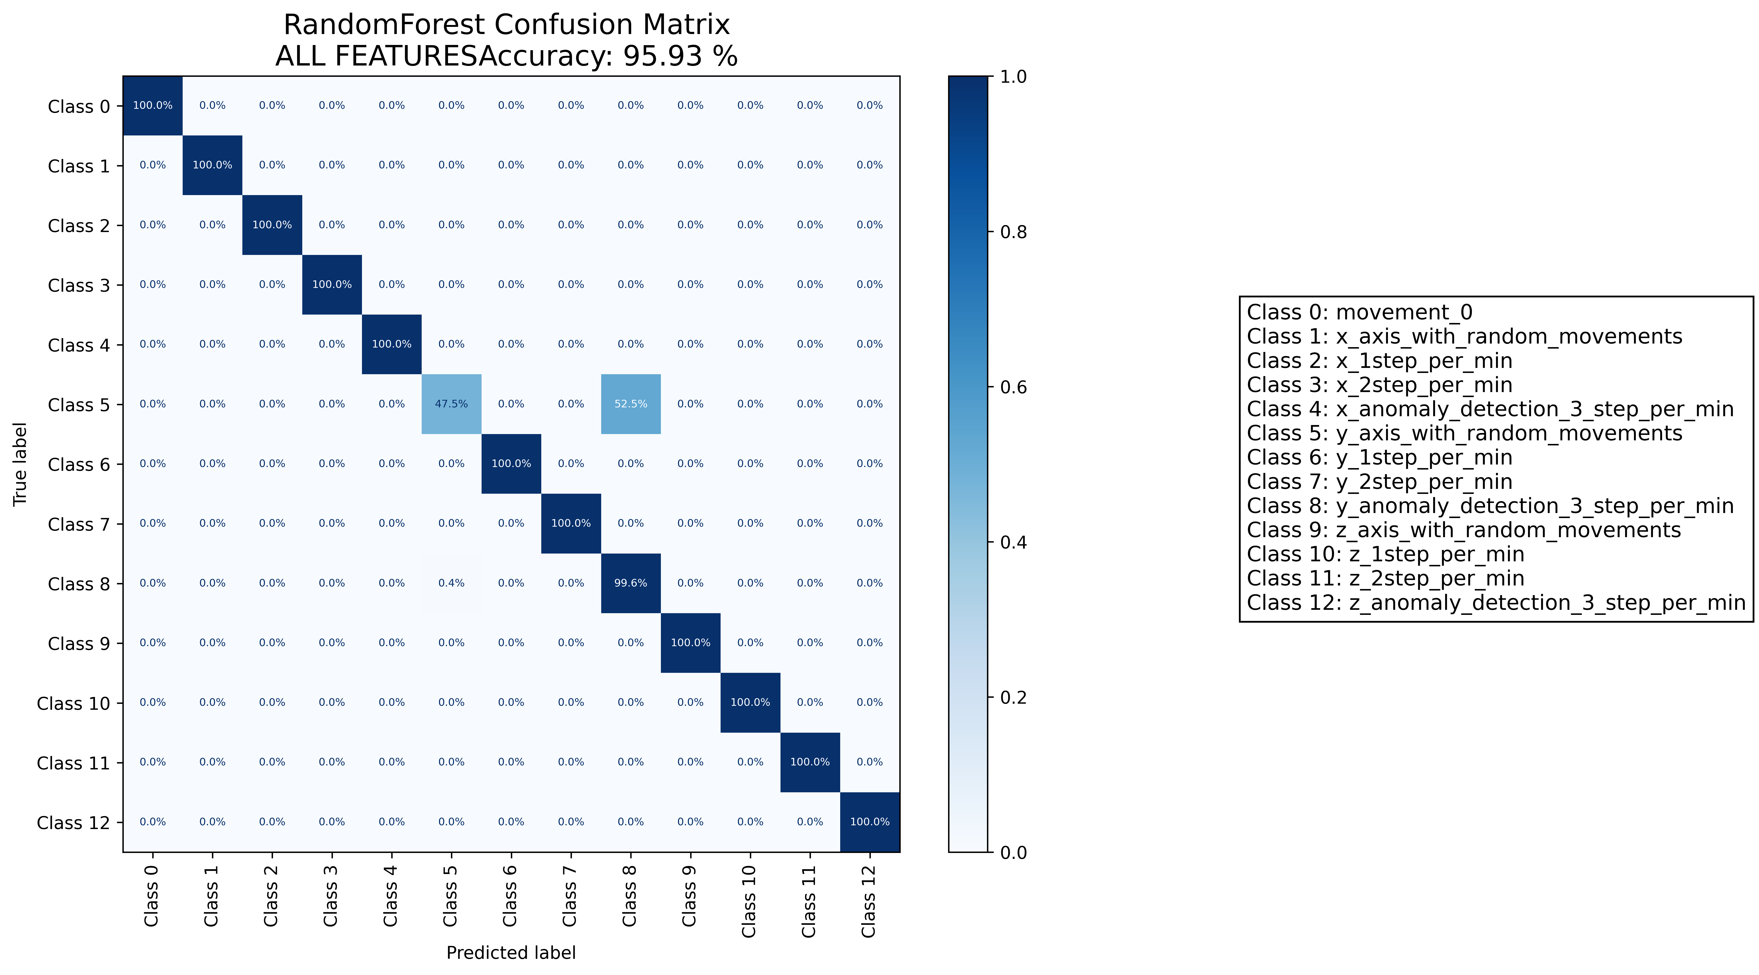

======================================================================

======================= CLASSIFICATION RESULTS =======================  
CLASSIFIER: RandomForest  
Accuracy: 95.65 %   
Feature used : RELIFF FEATURES 10 Best  
Classification Time: 0.571 seconds

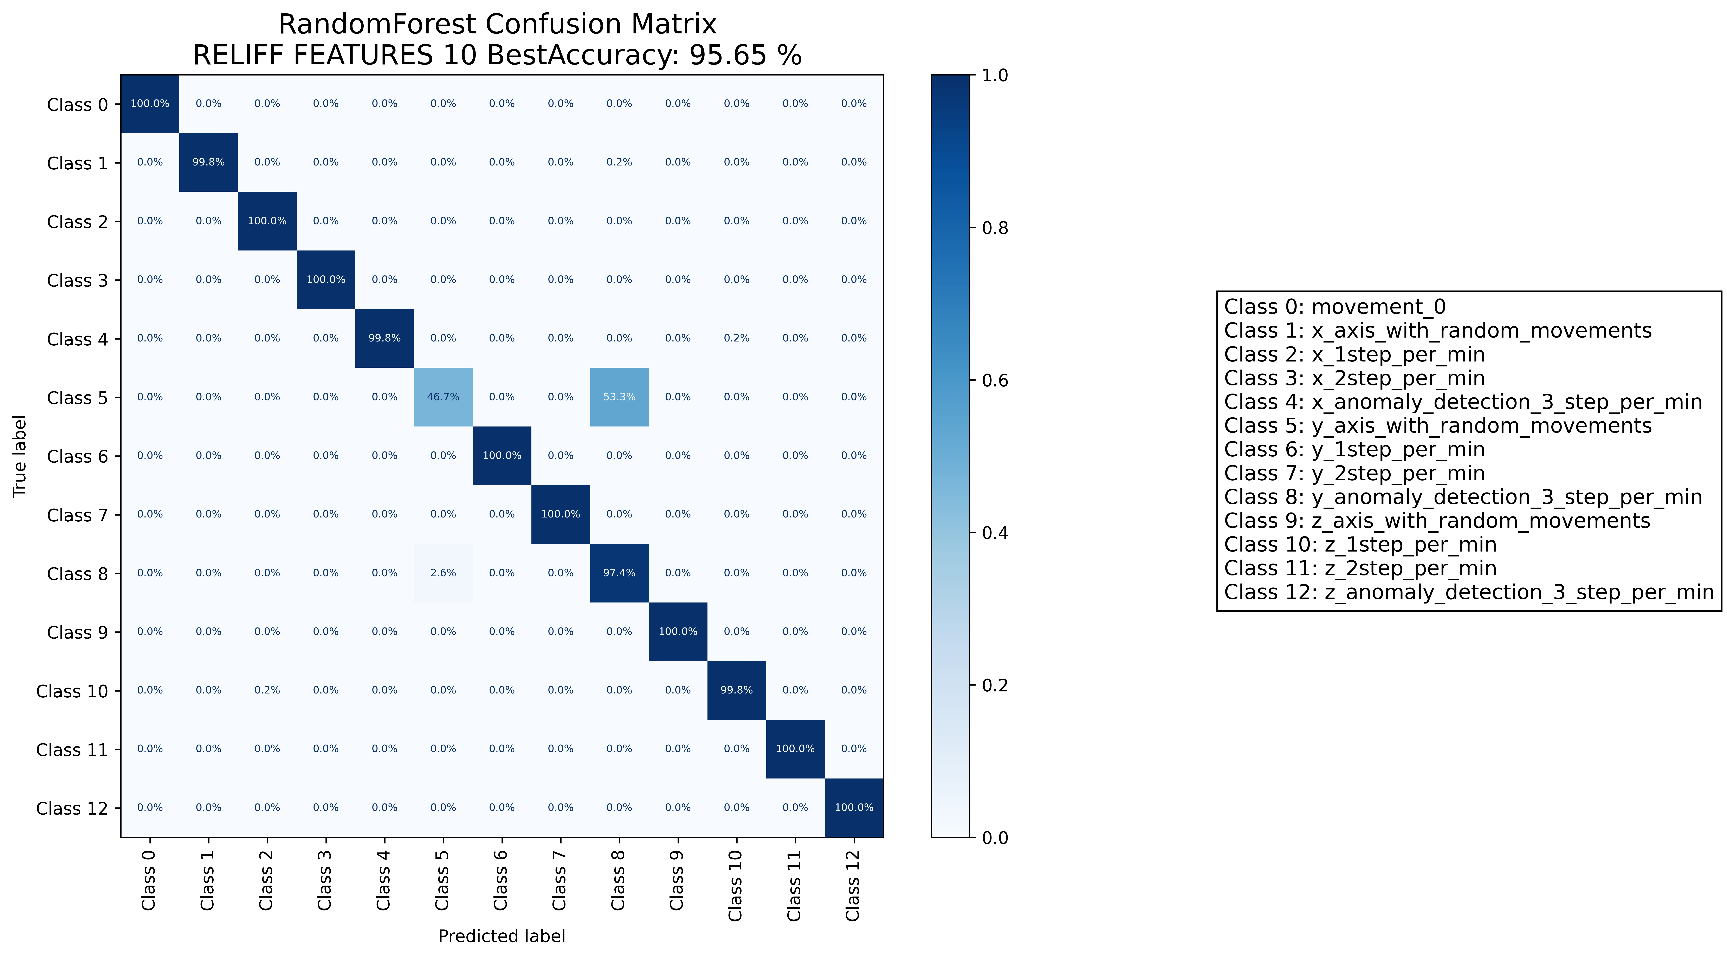

======================================================================

======================= CLASSIFICATION RESULTS =======================  
CLASSIFIER: DecisionTree  
Accuracy: 93.30 %   
Feature used : ALL FEATURES  
Classification Time: 0.009 seconds

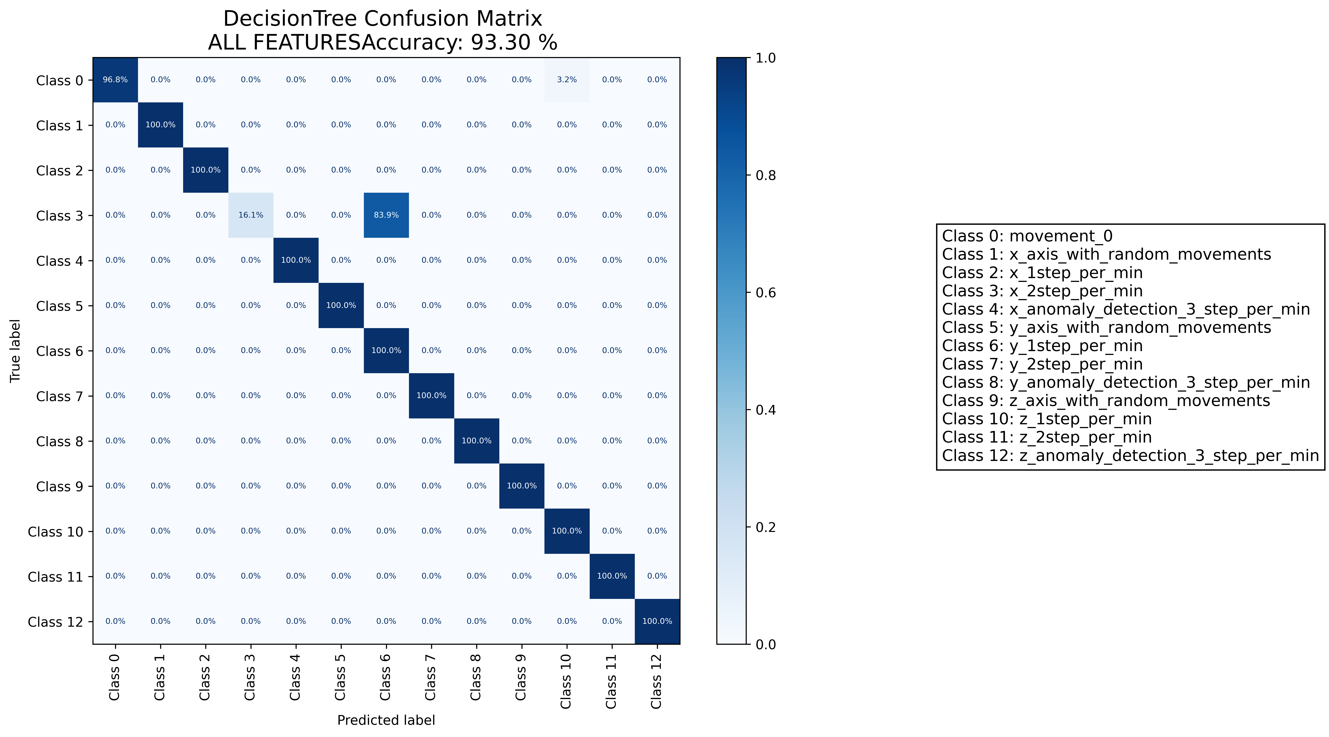

======================================================================

======================= CLASSIFICATION RESULTS =======================  
CLASSIFIER: DecisionTree  
Accuracy: 87.59 %   
Feature used : RELIFF FEATURES 10 Best  
Classification Time: 0.002 seconds

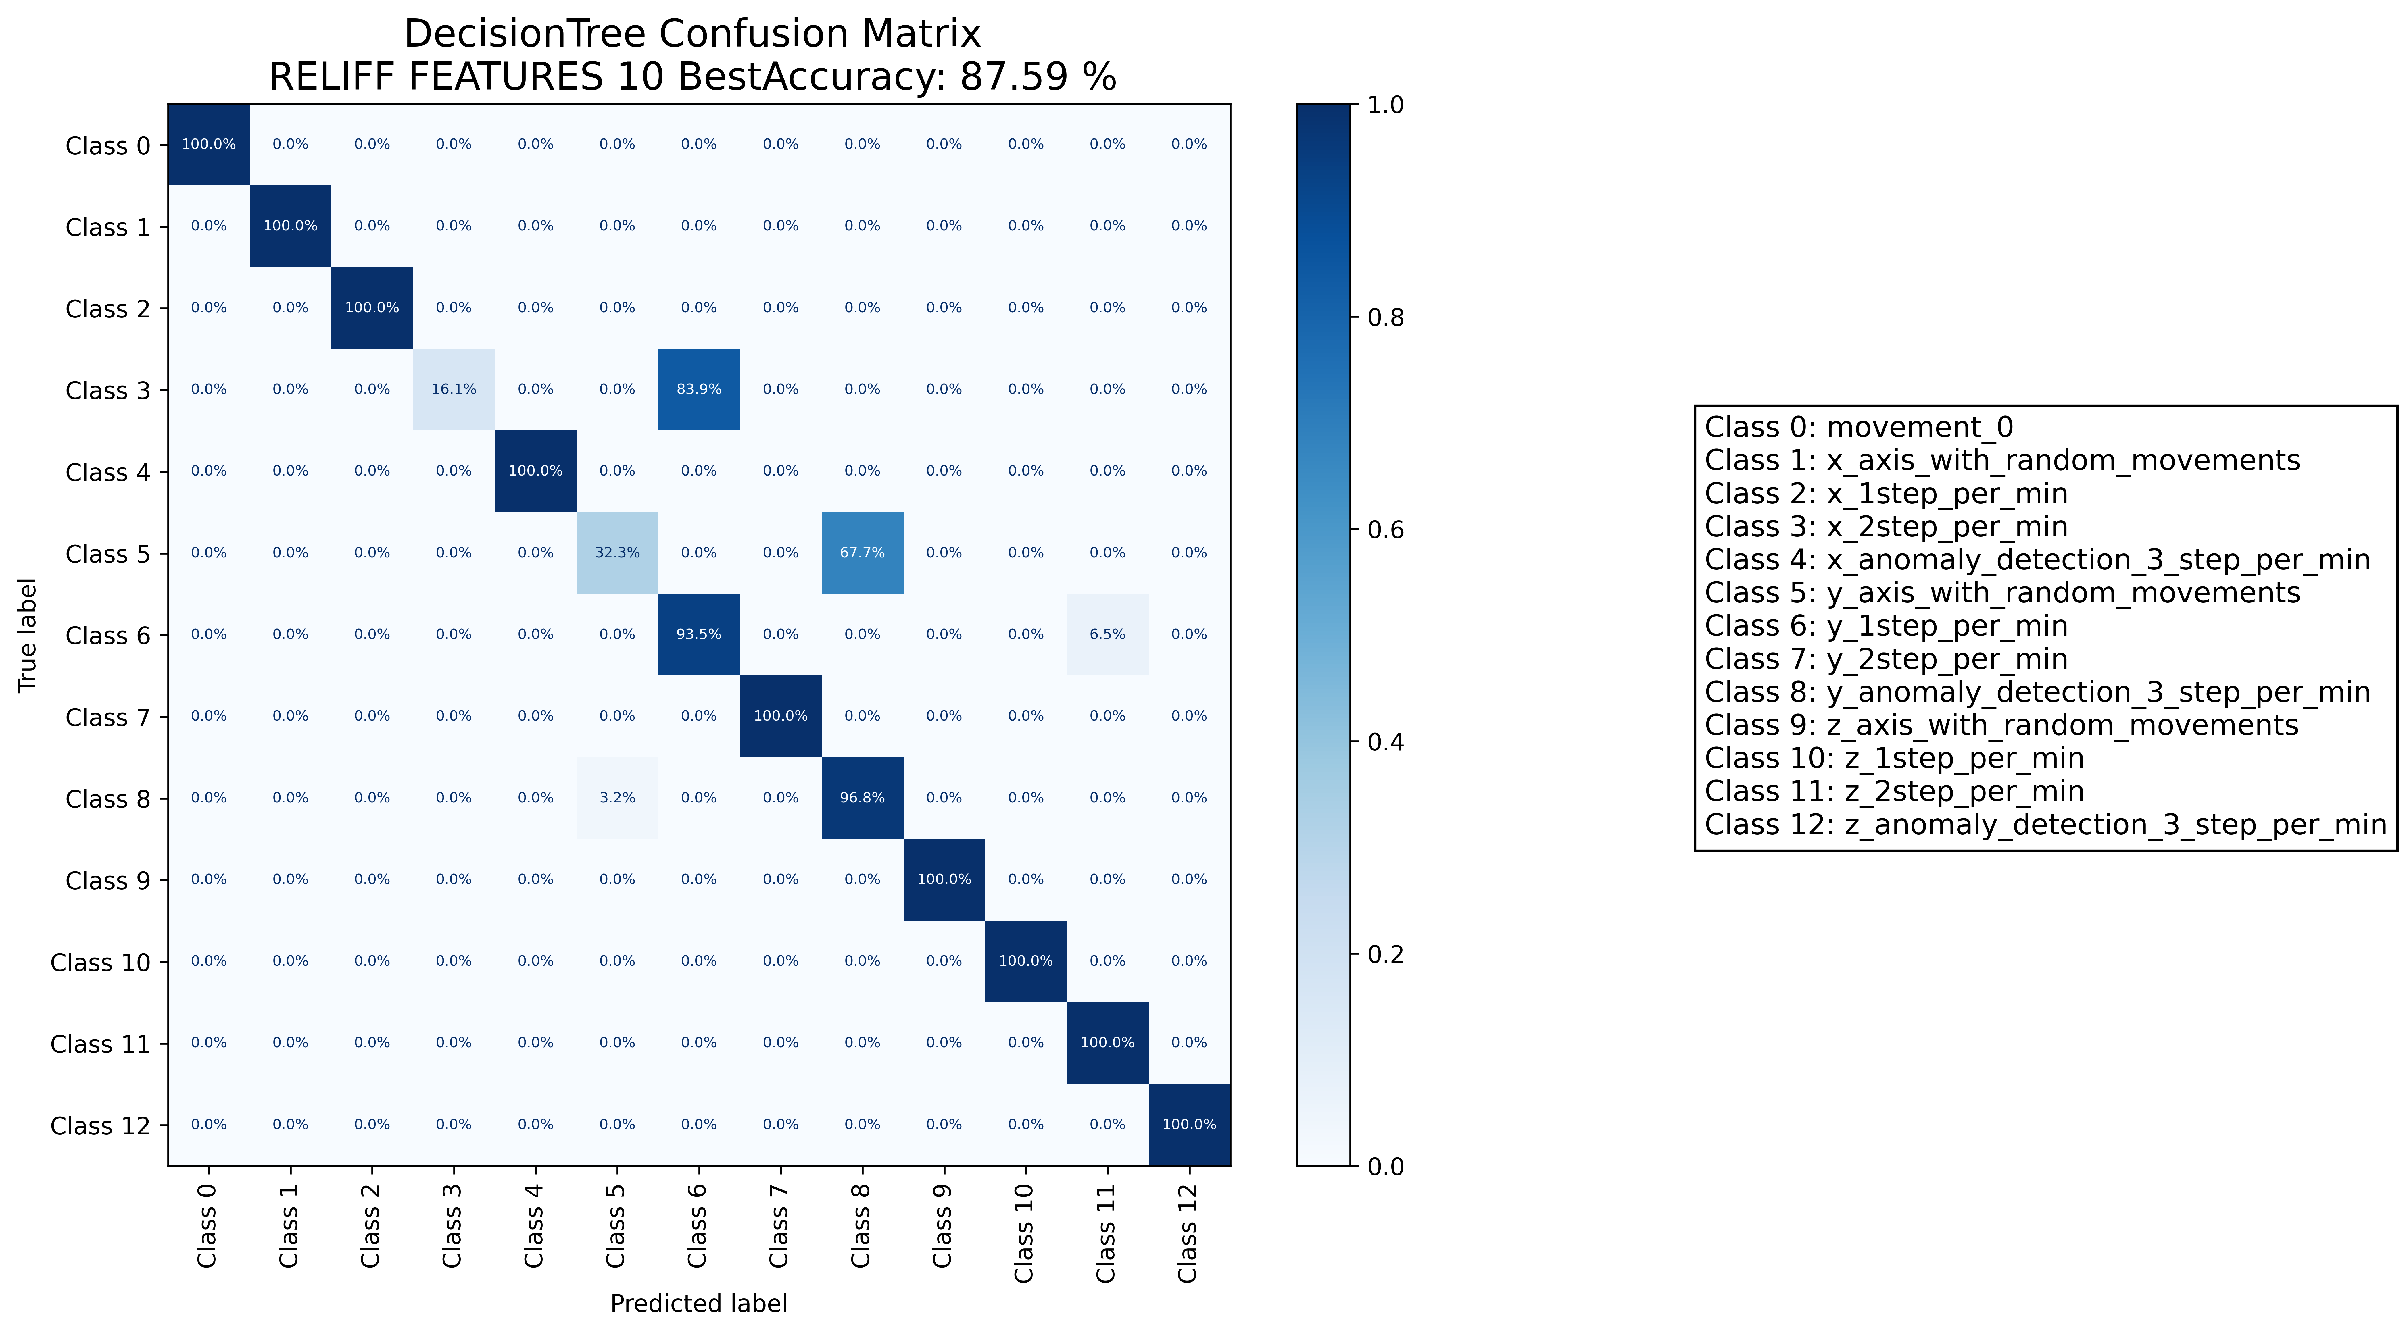

======================================================================

======================= CLASSIFICATION RESULTS =======================  
CLASSIFIER: RandomForest  
Accuracy: 95.29 %   
Feature used : ALL FEATURES  
Classification Time: 0.123 seconds

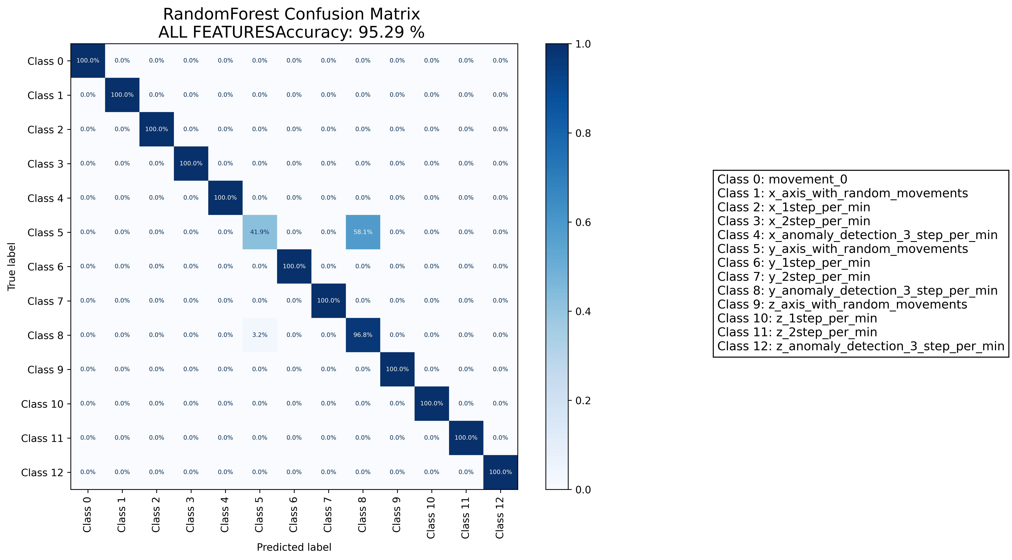

======================================================================

======================= CLASSIFICATION RESULTS =======================  
CLASSIFIER: RandomForest  
Accuracy: 99.50 %   
Feature used : RELIFF FEATURES 10 Best  
Classification Time: 0.109 seconds

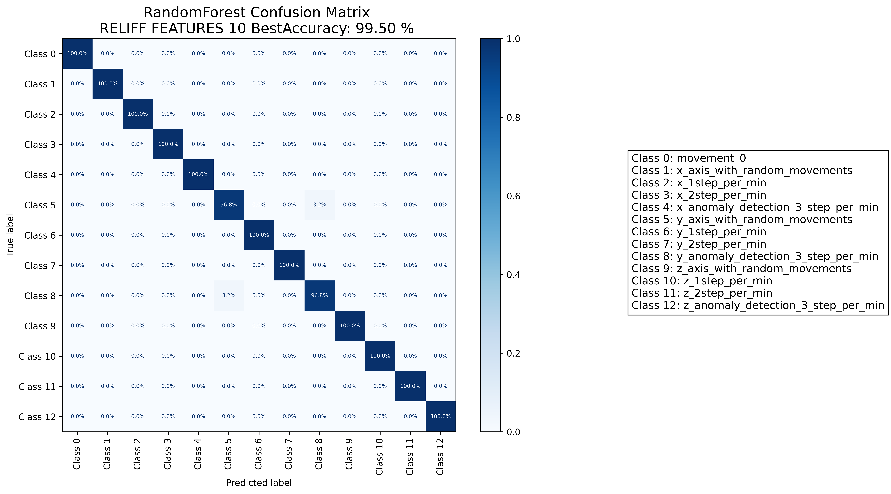

======================================================================

======================= CLASSIFICATION RESULTS =======================  
CLASSIFIER: DecisionTree  
Accuracy: 99.75 %   
Feature used : ALL FEATURES  
Classification Time: 0.0 seconds

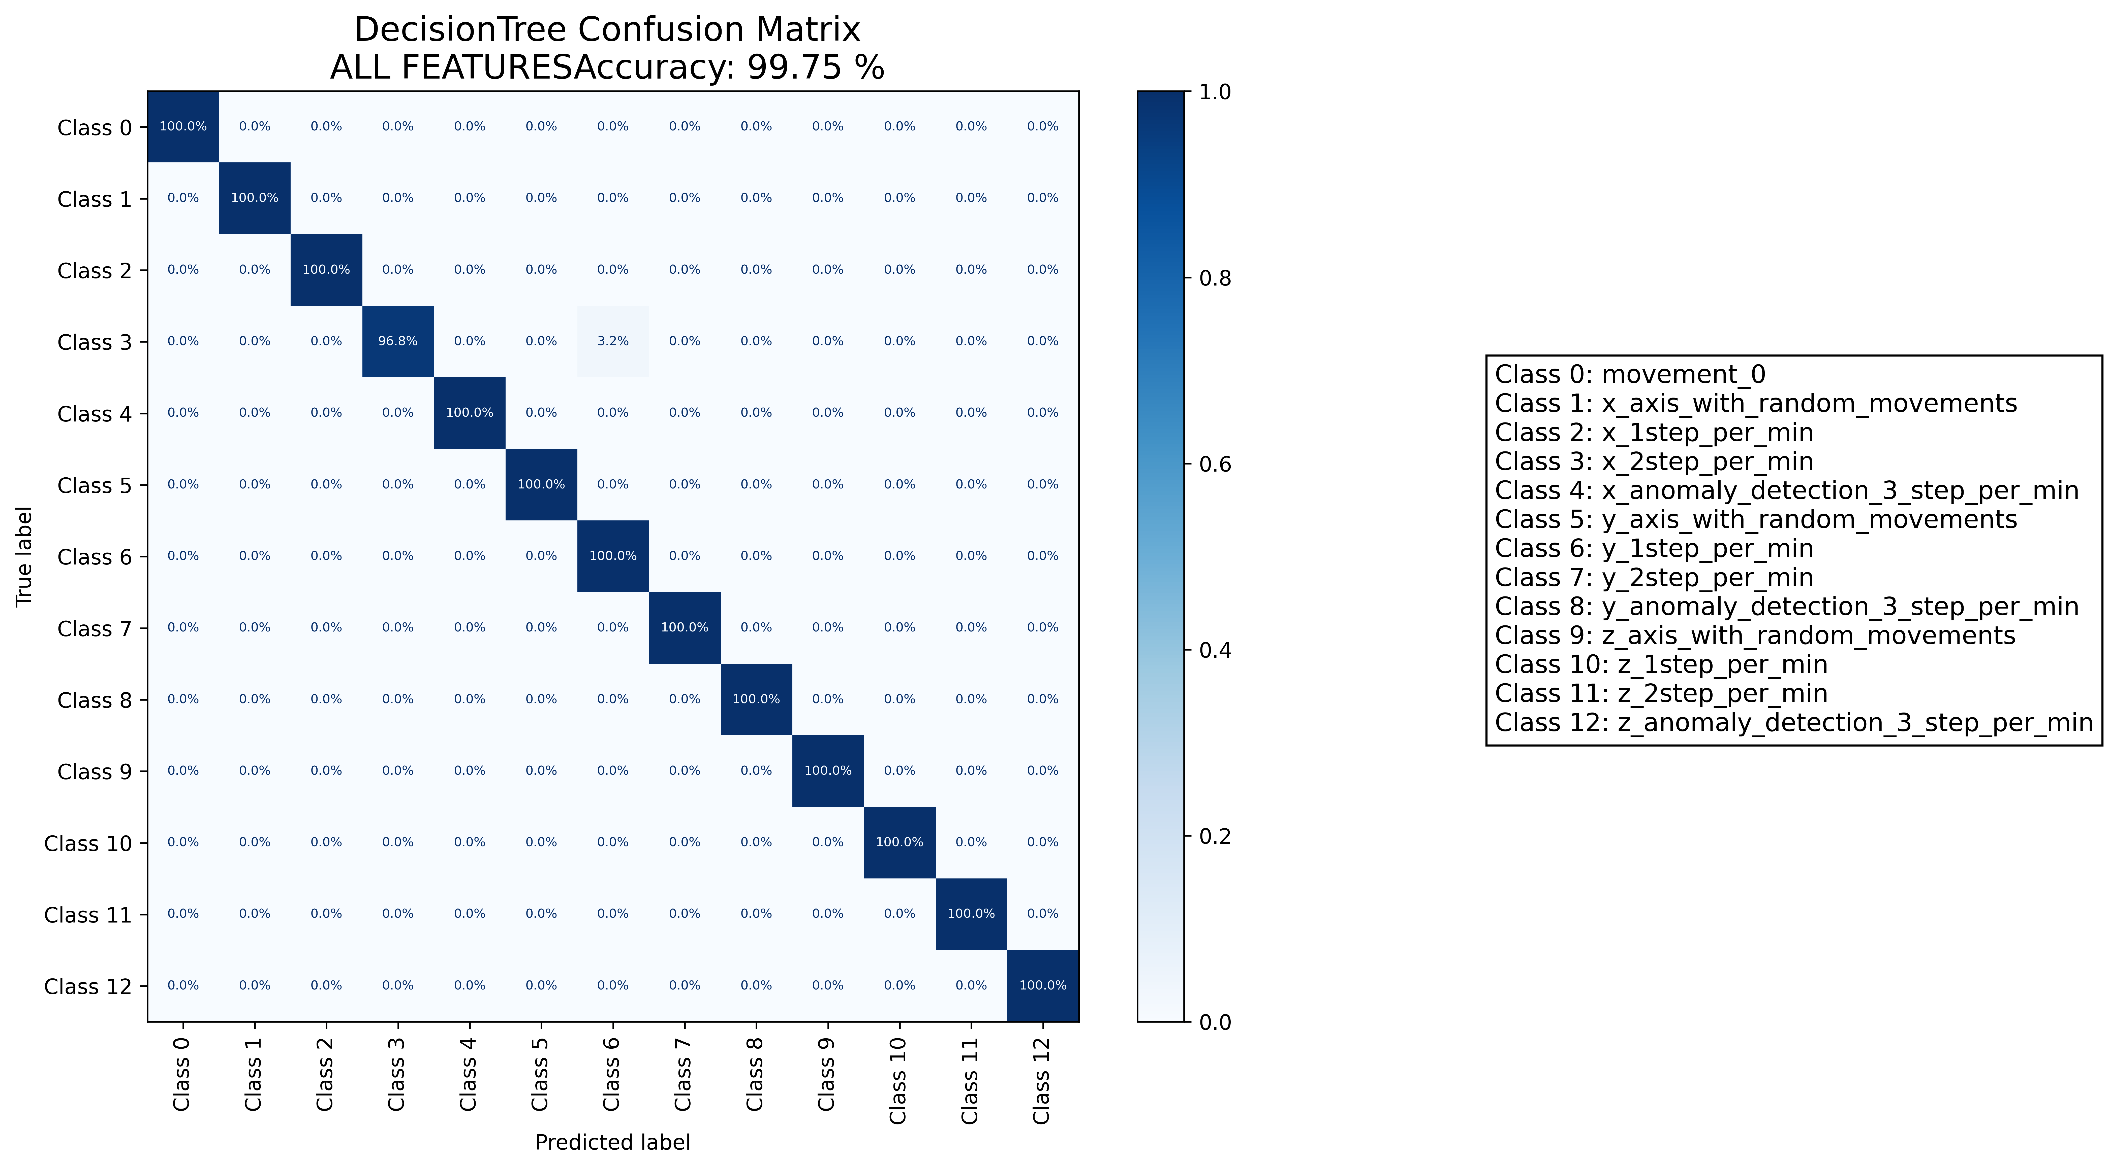

======================================================================

======================= CLASSIFICATION RESULTS =======================  
CLASSIFIER: DecisionTree  
Accuracy: 98.26 %   
Feature used : RELIFF FEATURES 10 Best  
Classification Time: 0.001 seconds

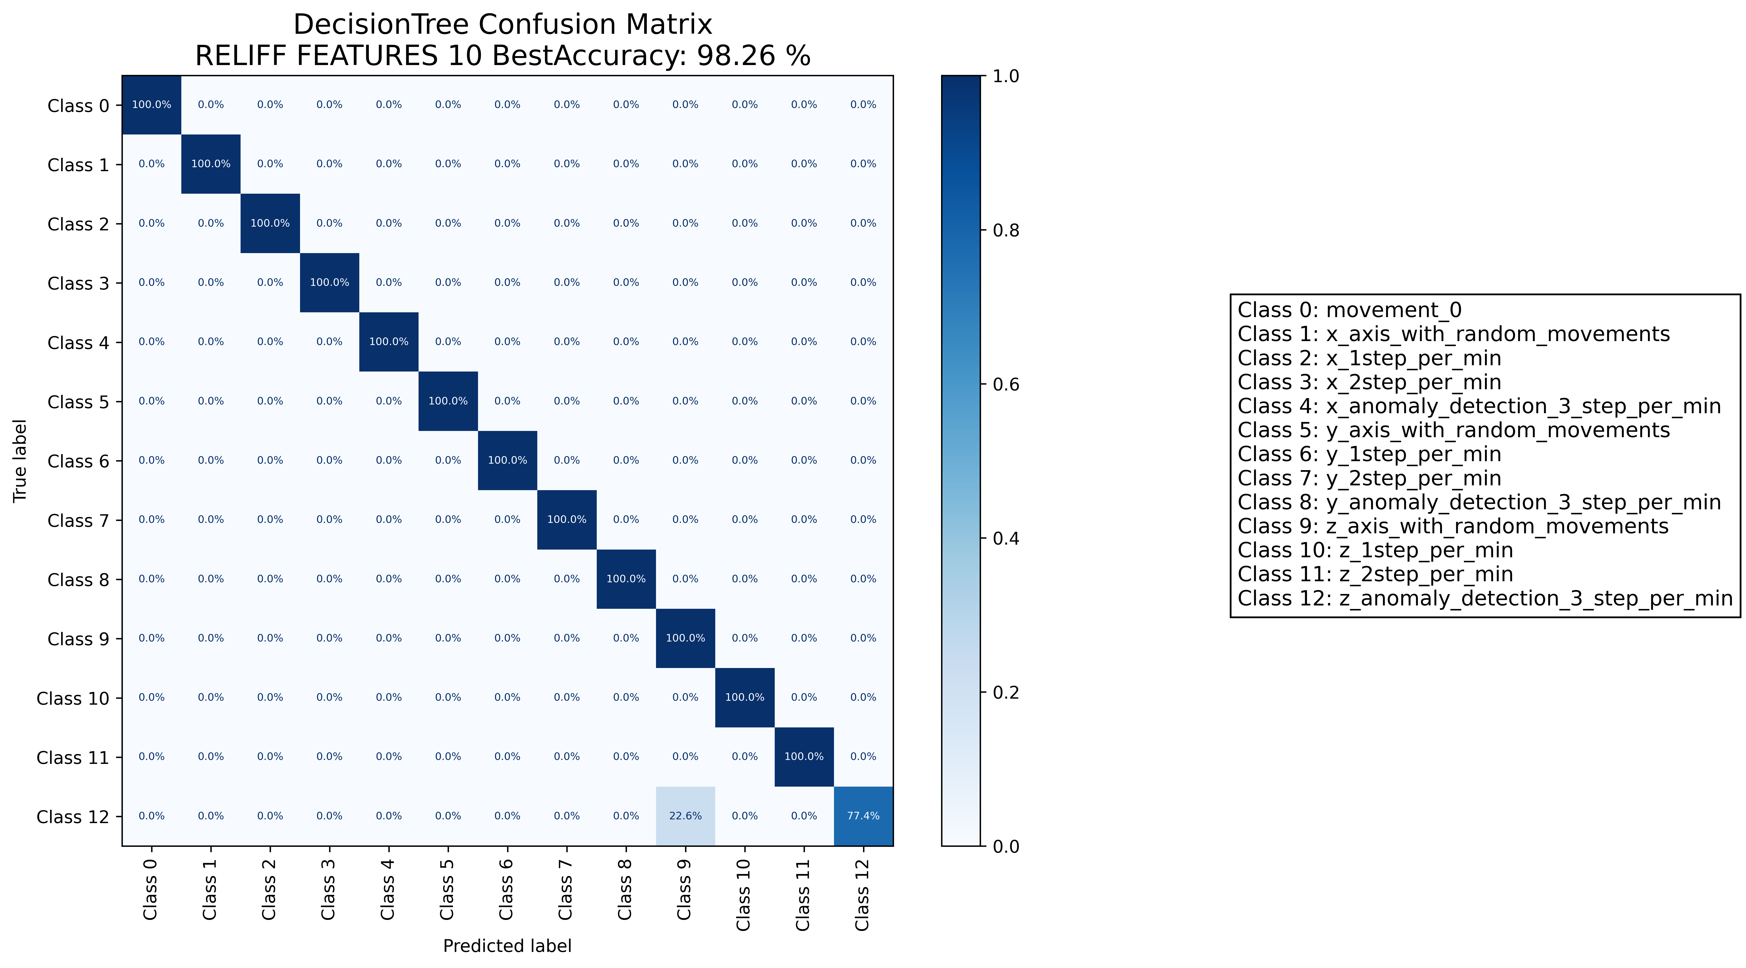

======================================================================

======================= CLASSIFICATION RESULTS =======================  
CLASSIFIER: RandomForest  
Accuracy: 95.04 %   
Feature used : ALL FEATURES  
Classification Time: 0.123 seconds

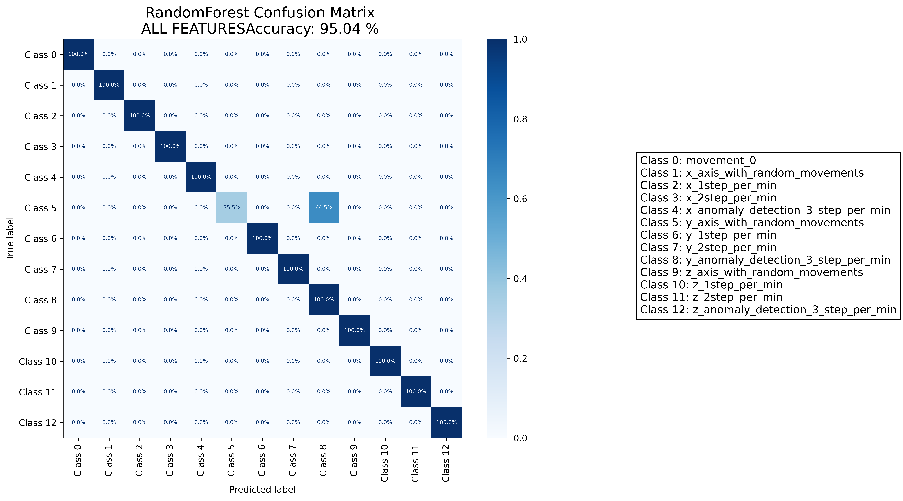

======================================================================

======================= CLASSIFICATION RESULTS =======================  
CLASSIFIER: RandomForest  
Accuracy: 100.00 %   
Feature used : RELIFF FEATURES 10 Best  
Classification Time: 0.115 seconds



======================================================================